Banquet Ideas

www.shac.org/blue-gold-theme
Most packs celebrate Scouting Anniversary Week in February with a birthday party called the blue and gold banquet; some packs do end of the year banquets. It brings families together for fun and cheer. The purpose of a banquet is to celebrate the Scouting, thank leaders and volunteers, and inspire the leaders, Scouts, and parents.

The banquet can be like a regular pack meeting with songs, skits, stunts, and awards, or it can be something different and a little more special. The pack committee may decide to bring in an entertainer such as a mad scientist or magician and have a video or slide show of what the pack did over the past year.

A good banquet needs lots of careful planning at least two months in advance to be successful. The pack committee should recruit a banquet chair, who in turn may select others to carry out the responsibilities of the program, such as making physical arrangements, promotions, inviting special guests, decorations, choosing a theme, ordering food, etc. A detailed plan for banquets, including a planning calendar, sample agenda, and suggested program activities, is available in the Cub Scout Leader How-To Book, No. 621165.

Banquet Planning: www.skcscouts.org/wp-content/uploads/2013/06/Blue-Gold-Planning-Guide.pdf
Banquet Planning: www.ocbsa.org/wp-content/uploads/2011/06/Blue-Golf-Banquet-for-Website.pdf

Content  (Sources: Baloo’s Bugle: Baloo and Gold, It's a Scouting Celebration, Happy Birthday, B.S.A.  www.cubroundtable.com/assets/pdf-sundry/Blue-and-Gold-Ceremonies-Heart-of-America-Council.pdf,  http://www.macscouter.com/ceremony/cub_opening.asp,  www.ocbsa.org/wp-content/uploads/2011/06/Blue-Golf-Banquet-for-Website.pdf  Sample Meeting  Program Agenda  Podium Script  Cheers  Banquet Handout  Placemats  Additional ideas  Gathering Activities  Opening Ceremonies  Invocation  Audience Participation  Advancement Ceremonies  Leader Recognition  Songs  Run-ons & Jokes  Skits  Cubmaster Minute  Closing Ceremonies  Cub Grub  Games  Decorations  Social Media Poster  Theme Related Stuff | Placemats / Activity Sheet  Free, customizable placemats are available for packs to use during banquets to help promote day camp. Download the placemats at shac.org/blue-gold-theme.
Pinterest
Find additional ideas on the SHAC Pinterest page: www.pinterest.com/samhoustonbsa
Scouting Anniversary Dates

Boy Scouts began in England on January 24, 1908.

Cubbing became an offical part of Scouting in England in 1916.

Boy Scouts began in the US on February 8, 1910.

Cub Scouts began in the US in 1930.

BANQUET AGENDA

Welcome

Opening Pre-select a den to lead the opening ceremony and have the den leader practice with the Scouts for several meetings prior. Additional opening ceremonies can be found here.
Blue and Gold Banquet Opening: Preparation: Print large block letters with permanent markers on 8” x 10” sheets of white cardstock---the word BLUE in Blue, AND in black, and GOLD in red. Add silver stars to the letters. Print script on back of each card. Action: 10 Cub Scouts hold up cards and read their part printed on the back. Make sure to practice ahead of time. Haven them emphasize the bold word. Teach them to look up to the audience (don’t hide their mouth behind the card), read slowly and loudly, and to talk to the audience members in the back of the room. Note: If you don’t have Den Chiefs – change to Devoted parents
B is for Baden Powell — the founder of Scouting
L is for Leaders — the Cubmaster who guides us
U is for Understanding —We learn to help others
E is for Excellence — we try to “do our best”
A is for Anniversary — Cub Scouting’s __^{th}
N is for Neighborhood — where dens meet each week
D is for Den Chiefs — Scouts who help us in many ways
G is for Goals — for which Cub Scouting stands
O is for Opportunities — for boys and girls to learn and do
L is for Liberty — in the years to come
D is for Den Leader — who loves and helps us

Pledge Pre-select a den to lead the plege and have the den leader practice with the Scouts for several meetings prior. Can be same den that does opening.

Invocation (if food is served). Additional invocations can be found here.
Cub Scout Parent's Prayer: Look down upon my child. This smiling Cub Scout of mine.
Please take their hand along the way, So that they may never stray. Bless my child tonight and help them walk with Thee. Give them comfort, warmth and love; They’re all the world to me. Bless their daily efforts, And make them strong and true; for life's a heavy burden, And we're all in need of you.
Dinner

Friends of Scouting (FOS) Presentation

Special Program / Guest

Song Pre-select a den to lead a song in the banquet handout. Additional songs can be found here.

Leader Recognition. Leader recognition ceremonies can be found here.

Skits (optional). Have a den leader select a skit and practice for several meetings prior.

Audience Participation (optional). Audience participation skits can be found here.

Advancement Ceremony. Additional advancement ceremonies can be found here.

Meaning of the Colors Blue and Gold
Optional: Have 2 yellow and 3 blue candles to light.
CM: This month we are celebrating the __^{th} annual birthday of Boy Scouting in America and Cub Scouting 20 years later, February 22, 1930. Cub Scouts traditionally hold the Blue and Gold Banquet to celebrate this birthday. Blue and gold, the Cub Scout colors stand for some of the good things Cub Scouts gain through the process of advancement as they make progress towards the ranks.
Gold stands for good cheer. The Lions here tonight are beginning to learn the basics of Cub Scouting and are full of the good cheer of Cub Scouting. (Call up the Lion den, present awards and lead cheer.)
Gold stands for happiness, and no one seems to be more full of happiness than the bright young Tiger Scouts. (Call up Tiger den, present awards and lead cheer.)
Blue, the other color of Cub Scouting stands for truth. Truth shines through strong on the faces of the Wolf Scouts as they have learned that the truth is always the best. (Call up the Wolf den, present awards and lead cheer.)
Blue also stands for honor and the Bear Scouts have learned that Cub Scout honor really is important. (Call up the Bear den, present awards and lead cheer.)
The other meaning for the color blue is loyalty. This is one of the most important traits a Cub Scout can learn in the process of becoming a man. Loyalty to family, God, country, friends, and the most important, loyalty to their beliefs and convictions. There are many adults who do not display this trait, but the Cub Scouts who have progressed to the rank of Webelos Scouts have developed or are developing this trait of loyalty. (Call up Webelos Scouts, present awards and lead cheer. Honor any Arrow of Light recipients with more ado than the activity badge recipients.)

These Cub Scouts honored tonight have been true to the gold and the blue by showing the traits represented by our Cub Scout colors.... good cheer, happiness, truth, honor and loyalty.
Game (optional). Select a game. These can be good only if the banquet doesn’t run too long.

Cubmater Minute: Additional CM minutes can be found here.

A Hundred Years from Now (Have a Cub Scout in uniform stand at the front of the room.)
A hundred years from now, It will not matter at all what your bank account was, whether large or small.
The kind of house you lived in will be immaterial too, as will the kind of car you drove and the famous folks you knew.
But the world may be a better place because you gave your time to Scouting. Guiding future leaders down life's trail on each and every outing. So, keep that Scouting light shining as a beacon for each Cub Scout. Then in years to come you'll see them as adults who fill you with pride and joy.Yes, Scouting is (shine flashlight on Cub) that Cub Scout!

Closing Pre-select a den to lead the closing ceremony and have the den leader practice with the Scouts for several meetings prior. Additional closing ceremonies can be found here. Can be same den that does opening/pledge.
Thank You Parents
Personnel: Eight Cub Scouts
Equipment: Large poster divided into eight, when put together has a heart on it with the words THANK YOU in it.
Setting: Each Cub Scout has a piece of the heart. After all lines have been read, the first four stand in a line and hold their cards while the second four kneel in front and hold up their cards so that the heart is formed.
# 1: Our leaders are grand, the best in the land
# 2: They deserve a thank you, and a big hand, too.
# 3: This celebration's the time and the place, to tell them we think so, right to their face.
# 4: So thanks to the den leaders, committee and Cubmaster, that making Scouting fun, they're truly the masters.
# 5: But there's someone special we don't want to leave out, after all, they're a big part of what Scouting's about.
# 6: We want to say thank you, Mom and Dad, and tell you that we are really glad.
# 7: To have you as parents, yes, it's true, because of your help and all that you do.
# 8: To help us through Scouting's achievements and ranks you truly deserve our heartfelt thanks.

Podium Script: Invocation

Would the audience please rise? (pause).

A Cub Scout Parent's Prayer:

Look down upon my child.

This smiling Cub Scout of mine.

Please take their hand along the way,

So that they may never stray.

Bless my child tonight and help them walk with Thee.

Give them comfort, warmth and love;

They’re all the world to me.

Bless their daily efforts,

And make them strong and true;

for life's a heavy burden,

And we're all in need of you.
Opening Ceremony: Print for back of posters

Blue and Gold Banquet Skit
Preparation: Print large block letters with permanent markers on 8” x 10” sheets of white cardstock---the word BLUE in Blue, AND in black, and GOLD in red. Add silver stars to the letters. Print script on back of each card.
Action: 10 Cub Scouts hold up cards and read their part printed on the back. Make sure to practice ahead of time. Haven them emphasize the bold word. Teach them to look up to the audience (don’t hide their mouth behind the card), read slowly and loudly, and to talk to the audience members in the back of the room.
Note: If you don’t have Den Chiefs – change to Devoted parents

#1 B is for Baden Powell — the founder of Scouting

#2 L is for Leaders — the Cubmaster who guides us

#3 U is for Understanding —We learn to help others

#4 E is for Excellence — we try to “do our best”

#5 A is for Anniversary — Cub Scouting’s __^{th}

#6 N is for Neighborhood — where dens meet each week

#7 D is for Den Chiefs — Scouts who help us in many ways

#8 G is for Goals — for which Cub Scouting stands

#9 O is for Opportunities — for boys and girls to learn and do

#10 L is for Liberty — in the years to come

#11 D is for Den Leader — who loves and helps us

Podium Script: Advancement Ceremony

Meaning of the Colors Blue and Gold
CM: This month we are celebrating the __^{th} annual birthday of Boy Scouting in America and Cub Scouting 20 years later, February 22, 1930. Cub Scouts traditionally hold the Blue and Gold Banquet to celebrate this birthday. Blue and gold, the Cub Scout colors stand for some of the good things Cub Scouts gain through the process of advancement as they make progress towards the ranks.

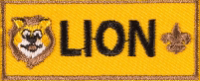
Gold stands for good cheer. The Lions here tonight are beginning to learn the basics of Cub Scouting and are full of the good cheer of Cub Scouting. (Call up the Lion den, present awards and lead cheer.)

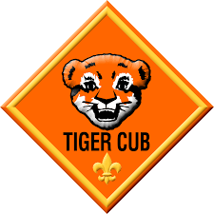
Gold stands for happiness, and no one seems to be more full of happiness than the bright young Tiger Scouts. (Call up Tiger den, present awards and lead cheer.)

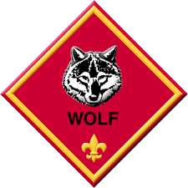
Blue, the other color of Cub Scouting stands for truth. Truth shines through strong on the faces of the Wolf Scouts as they have learned that the truth is always the best. (Call up the Wolf den, present awards and lead cheer.)

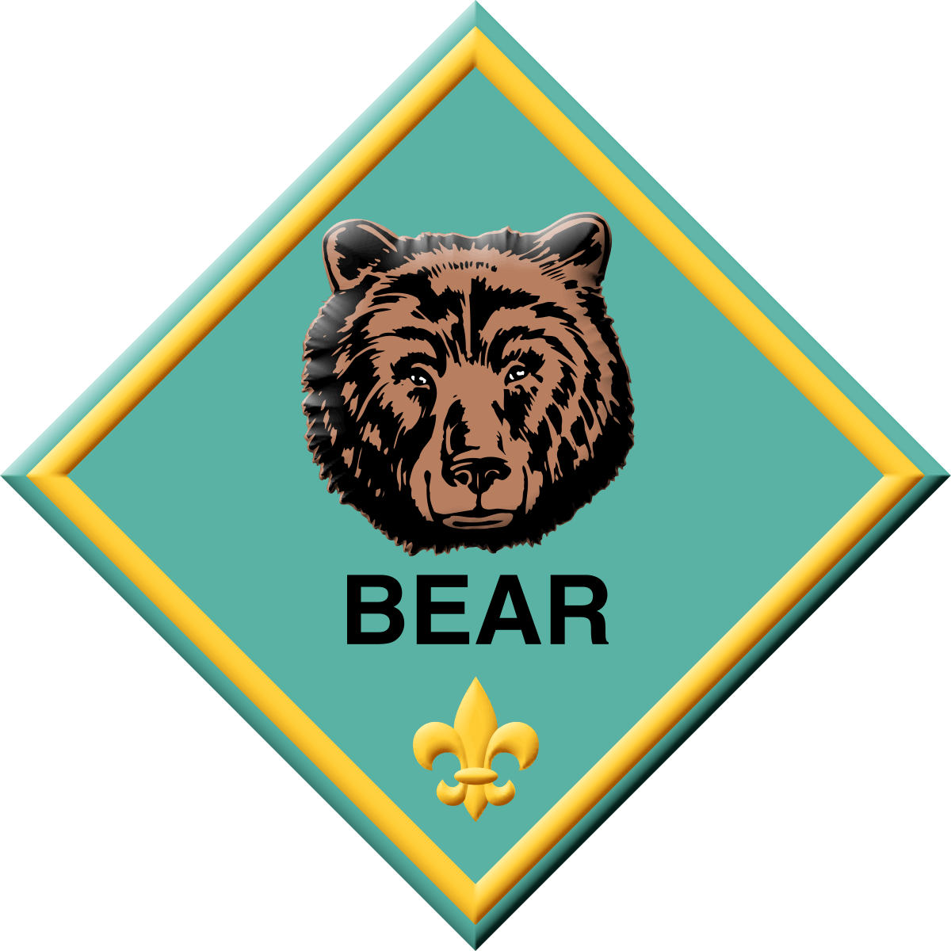
Blue also stands for honor and the Bear Scouts have learned that Cub Scout honor really is important. (Call up the Bear den, present awards and lead cheer.)

The other meaning for the color blue is loyalty. This is one of the most important traits a Cub Scout can learn in the process of becoming a man. Loyalty to family, God, country, friends, and the most important, loyalty to their beliefs and convictions. There are many adults who do not display this trait, but the Cub Scouts who have progressed to the rank of Webelos Scouts have developed or are developing this trait of loyalty. (Call up Webelos Scouts, present awards and lead cheer. Honor any Arrow of Light recipients with more ado than the activity badge recipients.)

These Cub Scouts honored tonight have been true to the gold and the blue by showing the traits represented by our Cub Scout colors.... good cheer, happiness, truth, honor and loyalty.
Podium Script: Cubmaster Minute

A Hundred Years from Now
(Have a Cub Scout in uniform stand at the front of the room.)

A hundred years from now,

It will not matter at all what your bank account was, whether large or small.

The kind of house you lived in will be immaterial too, as will the kind of car you drove and the famous folks you knew.

But the world may be a better place because you gave your time to Scouting.

Guiding future leaders down life's trail on each and every outing.

So, keep that Scouting light shining as a beacon for each Cub Scout.

Then in years to come you'll see them as adults who fill you with pride and joy.

Yes, Scouting is (shine flashlight on Cub) that Cub Scout!

Closing Ceremony: Print for back of posters
Thank You Parents
Personnel: Eight Cub Scouts
Equipment: Large poster divided into eight, when put together has a heart on it with the words THANK YOU in it.
Setting: Each Cub Scout has a piece of the heart. After all lines have been read, the first four stand in a line and hold their cards while the second four kneel in front and hold up their cards so that the heart is formed.

# 1: Our leaders are grand, the best in the land

# 2: They deserve a thank you, and a big hand, too.

# 3: This celebration's the time and the place, to tell them we think so, right to their face.

# 4: So thanks to the den leaders, committee and Cubmaster, that making Scouting fun, they're truly the masters.

# 5: But there's someone special we don't want to leave out, after all, they're a big part of what Scouting's about.

# 6: We want to say thank you, Mom and Dad, and tell you that we are really glad.

# 7: To have you as parents, yes, it's true, because of your help and all that you do.

# 8: To help us through Scouting's achievements and ranks you truly deserve our heartfelt thanks.

CHEERS

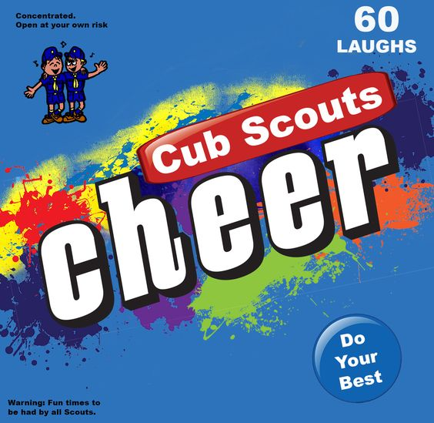
Cheers add fun to meetings and campfire programs. Use cheers during Cub Scout den meetings, pack meetings, or campfires. The cheer graphic can be printed and attached to a blue bag or a box wrapped in blue construction paper. Stuff the cheer box with themed cheers written on strips of paper before each meeting. Someone (e.g., assistant Cubmaster) should be assigned to jump up and enthusiastically lead cheers throughout the meeting (e.g., after a skit or advancement ceremony). Download the graphic at www.shac.org/Data/Sites/1/media/resources/leader-guides/Cheer-Box-1200x1170.jpg.

Applause stunts are a great way to recognize a person or den in a pack meeting for some accomplishment they have performed. Be sure before you start that everyone knows and understands the applause stunt and how to do it. Applause stunts serve more than one purpose -- they not only provide recognition but also help liven up a meeting. Applause stunts need to be fun. Strive for quality of performance in your stunts. Another important side effect of Applause stunts is they provide” wiggle time” for all the Scouts and siblings during the ceremonies so they sit still during the serious moments. It is a lot easier and a lot less stressful to lead a cheer and have fun than to be constantly reminding the Scouts to sit quietly.

Print: Cheers and Applause's (cut into strips and put in Cheer box)

After Dinner Applause: "Plop, plop, fizz, fizz, oh what a relief it is!"
Applause and Cheer: When leader holds up the right hand, everyone cheers; When the left hand is held up everyone claps; When both are held up, do both!
Baden-Powell Applause: Stand with hands behind back in parade rest position; Smile, and then nod head as if saying "Yes".
Blue and Gold Cheer: Divide the room in half. As you point to one side they say "Blue"¨ and When you point to the other side, they say "Gold." When you point to both sides They both say, "Blue and Gold." Vary the speed and direction you point.
Brownsea Island Applause: "Camping! Yeah!"
Do a Good Turn: Have the group stand up to applaud. They clap once, turn a 1/4 turn and Clap again, turn another 1/4 then two more 1/4 turns and claps until they have completed a full turn.
Grand Howl: This old ceremony to honor someone starts with the Cub Scouts in a circle around the honoree.
  - They touch the floor between their legs with the forefinger and middle finger of both hands.
  - Then, wolf like, they raise their heads and howl, "Ah-h- kay-y-la! W-e-e-e'll do-o-o- ou-u-r-r best!"
  - At the word "best," they jump to their feet with both hands high overhead, making the Cub Scout sign.
  - While hands are held high, a den chief or other leader yells, "Dyb, dyb, dyb, dyb," meaning "Do Your Best".
  - On the fourth "dyb", each Cub Scout drops their left hand smartly to their side, make the Cub Scout salute with their right hand, and shouts,"We-e-e'll dob, dob, dob, dob!" meaning "We'll Do Our Best."
  - After the fourth "dob", the Cub Scouts drop right hands smartly to their sides and come to attention.
Great Job: Group stands and says "GREAT JOB GREAT JOB, GREAT JOB," getting louder each time.
Lost in the Fog Applause: Divide audience into two groups. First group yells (as if lost): "Hello! Hello!" Second group answers: "I'll help you, sir!"
Guest Cheer: Have everyone stand where they are and say, "We're glad you're here with Pack !"

Overeater's Applause: Looking uncomfortable, rub stomach and slowly say "I can't believe I ate the whooole thing."
Pack Cheer: The Cubmaster says, "Clap your hands.": (Everyone claps.) "Stomp your feet." (Everyone stomps.) Then everyone yells together, "Pack can't be beat."
Pack cheer. "Who's the best in Blue and Gold? Pack ____ so we've been told!"
Way Back Applause: Make a fist but point your thumb backward like a hitchhiker does. Move your arm from front to back as you say "Way back!"
When I Do - You Do Tell the group that when you applaud so should they, and when you don't, they shouldn't either. Use false starts several times to try and trick them up.
Bobcat. Pretend to lick the back of your hand and wipe your face, like a cat does, and say meow, meow, meow.
Lion Applause: Begin to make a growling sound, but then change at the end to "Meow".
Wolf Make fists out of your hands and place at the side of your head, like wolf ears, then howl.
Wolf Applause: Turn head towards ceiling and let out a howl.
Bear Hold your hands up like bear paws with your claws out and growl.
Bear Applause: Start with low pitched growl, and gradually get louder and louder. At the end of growl, do quick clawing motion with hand.
Webelos Scouts: Shout "Who's the best, everyone knows, WE-BE-LOS, WE-BE-LOS."
Webelos Applause: Make Scout sign and say "We'll Be Loyal Scouts".
Arrow of Light: Hold your hands out to your left side. Make an arc by moving your hands over your head to your right side while you say, "WHOOOOOSH."

BANQUET PROGRAM

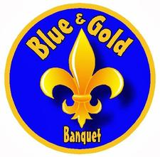
Edit the text boxes in the next two pages (insert Scout’s names, upcoming events, pack number, agenda and date). An editable, word version of this document is available at www.shac.org/blue-gold-theme.

Print one copy per person (of next 2 pages), front to back.

Pack 72
Blue and Gold
Banquet
Lions  Johnny Lion  Susy Lion  William Lion  Tigers  Sally Tiger  Jimmy Tiger  Benjamin Tiger  Emma Tiger  Wolves  Juan Wolf  Mary Wolf  Tom Wolf  Jacob Wolf |  | Bears  Cameron Bear  Isabella Bear  Cindy Bear  Noah Bear  Webelos Scouts  Cindy Webelos  Olivia Webelos  Sophia Webelos  Michael Webelos

Upcoming Events
February 19, 2019
February 23, 2019 Pinewood Derby
March 26, 2019 Pack Meeting
April 6, 2019 Scout Fair (shac.org/scout-fair)
April 23, 2019 Family Campout
May 18, 2019 Pack Meeting
June 11-14, 2019 Day Camp (shac.org/day-camp)

The Cub Scout Pack
Tune: You're A Grand Old Flag

We're a Cub Scout pack, we're a high-flying pack;
Down the trail of Scouting we go.
From Lion to Tiger, to Wolf and Bear,
Then to Webelos Scouts we grow.
Every Scout is true to the gold and the blue.
And they never forget the fact
That all the fun a kid could want
He can find in a Cub Scout pack.

Banquet Time
Tune: On Top of Old Smoky

Our blue and gold banquet’s,
The best in the town,
We celebrate Scouting,
While gulping food down,
Cub Scouting’s a pleasure,
And eating is too!
Do pass the fried chicken,
Yea, the gold and the blue.

Cub Scout Saga
Tune - Battle Hymn of the Republic

Our shirts have seen the coming of another Scout award,
The Lion first, the Tiger next and soon the Webelos,
We’re proud to wear them ‘cause we’ve earned them
Now the question is,
How do we stick them on?
Chorus
Glory, glory, hallelujah,
Do we pin them, do we glue them?
Gee, I got to hand it to ya,
Thanks, Mom, you got it on.

Gathering

Opening

Invocation

Dinner

Friends of Scouting Presentation

Advancement Ceremony

Song

Leader Recognition

Cubmaster Minute

Closing

www.facebook.com/pack72tomball
www.facebook.com/orionbsa
www.facebook.com/shac.bsa
www.orion.shac.org
www.shac.org

GATHERING ACTIVITIES

B&G Gathering Activities
  - Provide a “Photo Op” as Cub Scouts and parents arrive. Have a scene. Choose a typical Scouting activity such as hiking, sketching, cooking around the campfire – cut out the face area so that Cub Scouts, siblings or even adults can stick their head through and be photographed as if they are in the scene.
  - Have a variety of games and activities available for everyone to try as they arrive. Marbles, driving hoops, making tops, practicing making different shadows using your hands would all be fun activities. You could even make an indoor “Nerf-type” version of Croquet to play!

Baden-Powell
Give each family a sheet of paper with Baden Powell written across the top. Have each family see how many words of three or more letters they can make from: BADEN POWELL. Set a time limit like 3 to 5 minutes.

Baloo and Gold Word Search
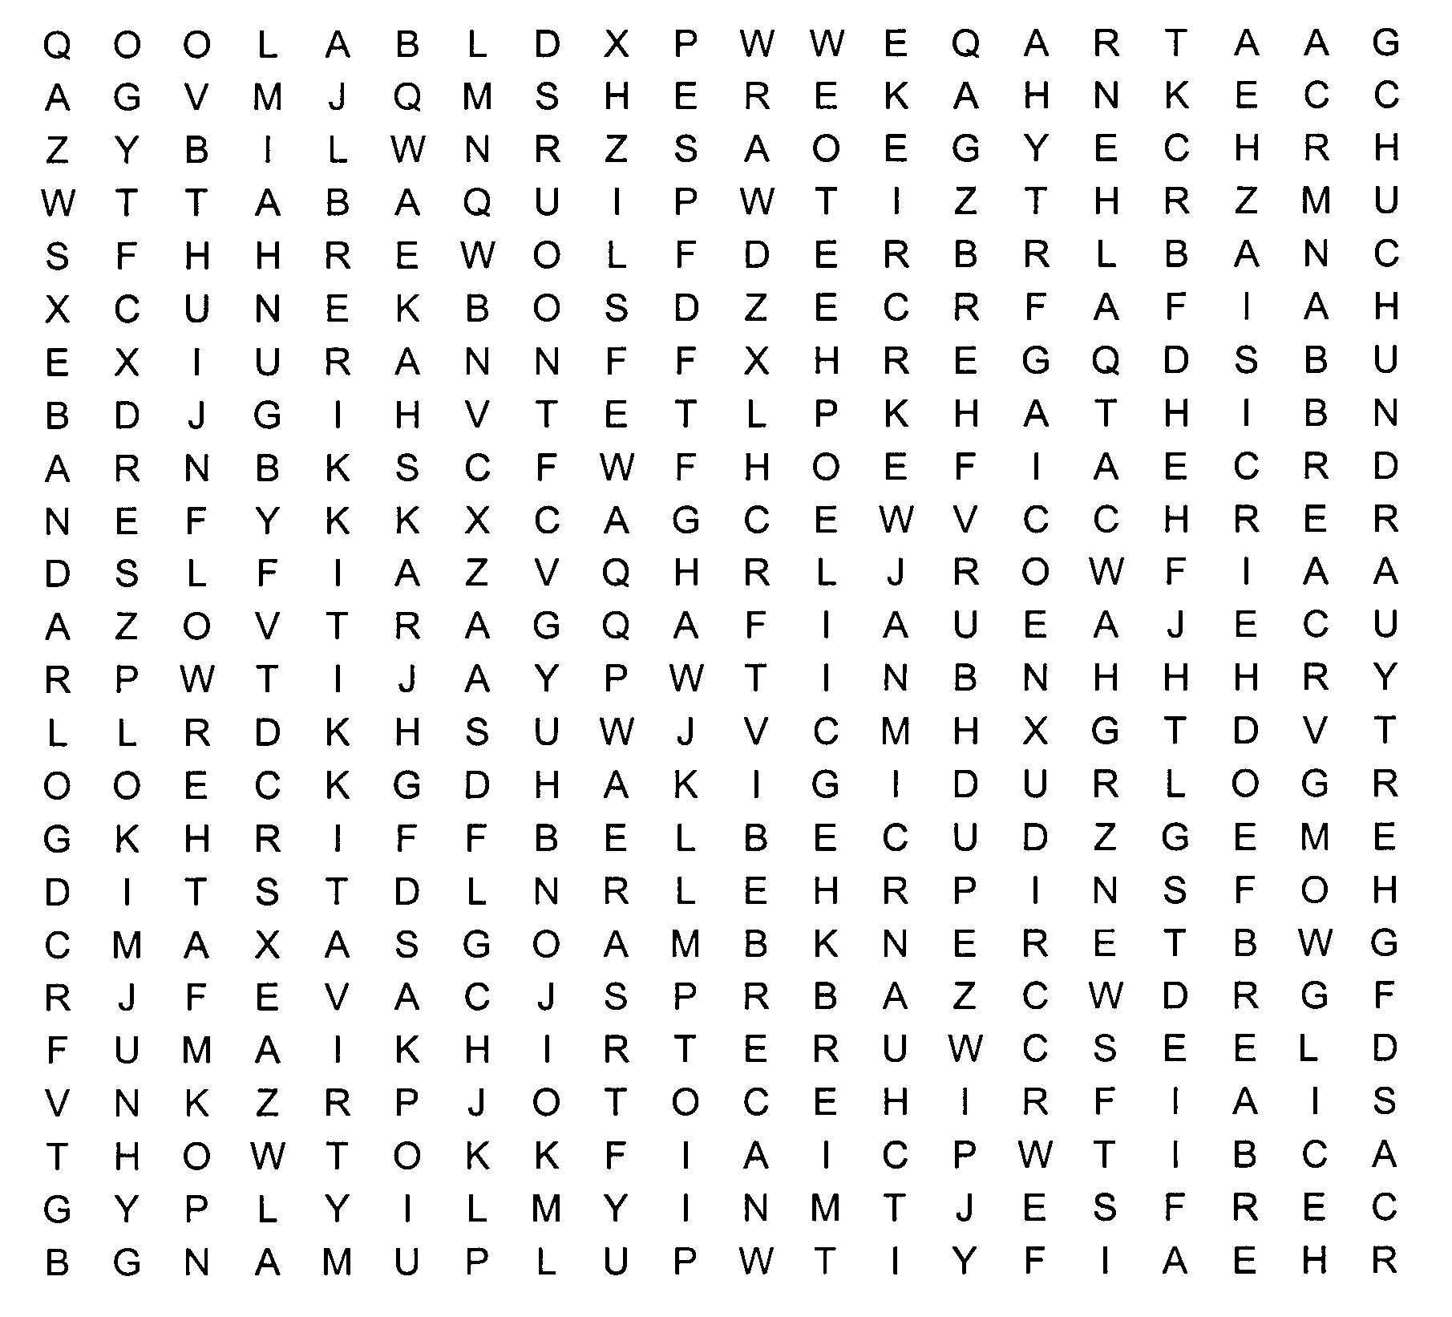
This puzzle contains words and phrase related to Cub Scouting.
Shere Khan Bagheera Mowgli
Red Flower Rann Mang
Father Wolf Tabaqui Mother Wolf
Gidur-log Law of the Jungle Raksha
Council Rock Mao Akela
Bagheera Baloo Bandar-log
Kaa Lost City Hathi
Rikki-tikki-tavi Chuchundra Darzee
Chua
Banquet Quiz
This is a gathering activity to be completed before the start of the meeting. When you find someone who fits the descriptions in # 1-10, have him or her sign in the blank provided. A person may only sign your form once, so choose wisely!
1. Someone who earned the rank of Eagle Scout __________
2. Someone with a daughter in Scouts __________
3. Someone who drives a red car __________
4. Someone who has a birthday in February__________
5. Someone who has a child who has earned the rank of Eagle Scout __________
6. Someone who has been to the Philmont Training Center __________
7. Someone who wears size 8 shoes __________
8. Someone who was born in another state __________
9. Someone who was a Cub Scout as a youth __________
10. Someone who has attended day or twilight camp _______.__________

Bonus Questions:
1. Who was the founder of Scouting? __________
2. The words DEN, PACK, AKELA and LAW OF THE PACK come from a book by an English author. The book was _________________ written by _____________
3. Three men are generally regarded as the fathers of Scouting in the US. They were…__________

History of Cub Scouting
Identify the correct decade (1930, 1940, 1950, 1960, 1970, 1980, 1990) in which the following events occurred in Cub Scout history:
- Tiger Cubs introduced
- First Pinewood Derby
- Cub Scouting officially approved in the U.S.
- Garfield the Cat named National Cub Scouting “spokescat.”
- First Blue and Gold banquet. Packs sell war bonds and war stamps
- National Summertime Pack award introduced
- Five ranks established: Bobcat, Wolf, Bear, Webelos, Arrow of Light
Answers: 1-1980 (1982), 2-1950 (1953), 3-1930, 4-1990 (1999), 5-1940 (1943), 6-1960 (1964), 7-1970 (1978)

Jungle Book Characters Matching Quiz
How well do you know you’re The Jungle Book characters?
1. Shere Khan a. Monkey People
2. Bagheera b. Rat
3. Mowgli c. Black Panther
4. Red Flower d. Teacher of the Law
5. Rann e. Kite
6. Mang f. Tailor-Bird
7. Tabaqui g. Bat
8. Gidur-log h. Wild Elephant
9. Raksha i. Rock Python
10. Mao j. Tiger
11. Akela k. Lone Wolf
12. Baloo l. Peacock
13. Bandar-log m. Jackal
14. Kaa n. Fire
15. Hathi o. Jackal People
16. Rikki-tikki-tavi p. Boy Cub
17. Chuchundra q. Musk-Rat
18. Darzee r. Mongoose
19. Chua s. Demon
See how well everyone did in putting the right animals with the names Kipling gave them in his book
Answers: 1– j, 2 – c, 3 – p, 4 – n, 5 – e, 6 – g, 7 - m, 8 – o, 9 – s, 10 – l, 11 – k, 12 – d, 13 – a, 14 – i, 15 – h, 16 – r, 17 – q, 18 – f, 19 – b
Name Bingo
Each Cub Scout has a sheet of paper marked off in a grid (six across, six down). The Cub Scouts then go around to other guests and ask them to sign a square. At a designated time, everyone stops and puts their own name on a piece of paper and puts them in a "hat". The leader pulls names out of the hat and reads them out loud. If a guest has that name on their paper, they put an X on that square. The object is to get a straight line, horizontally, vertically or diagonally.

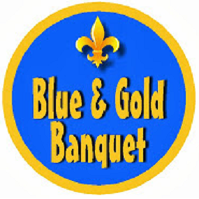

Play Gifts & Talents Bingo
Give each person a Board. They are to go around and meet people. After meeting someone and learning their name, they are to ask them to sign a box. Each person can only sign one box!!! This is not a speed contest; there should be discussion and introduction before signing!! Here is a sample board- boxes may be changed to suit your group
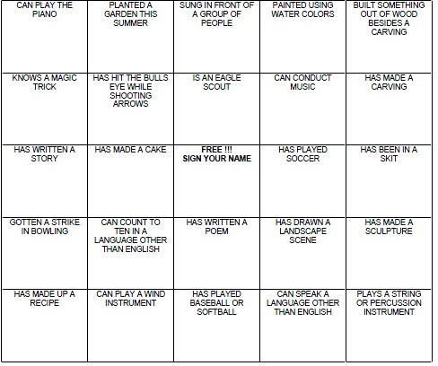

Be sure to enlarge the BINGO Board to fill a sheet of paper and put some directions on the sheet, too.

Roman Numerals
Roman numerals are often used in marking the anniversary of special events (i.e. the Olympics, The Super Bowl, etc.). Can you write the Roman numeral for our 75th birthday of Scouting?
Here are some helps if you need them.
The basic symbols are:
I= 1, V= 5, X= 10, L= 50, C= 100, D= 500, M= 1000.
And there are two rules to remember. Put a number of lesser value before one of greater value to decrease the amount of the second letter by the amount of the first.
Put a number of lesser value after one of greater value to increase the amount of the first letter by the amount of the second.
Here are some examples:
1= I 8= VIII
2= II 9= IX
3= III 10= X
4= IV 40= XL
5= V 94= XCIV
6= VI 1,770= MDCCLXX
7= VII 1,999= MCMXCIX
Now write the Roman numeral for 75: _______
For extra practice, write the Roman numerals for the following:
98: 301: 1,240:
47: 532: 2,945:
(Answers: 98:XCVIII 47:XLVII 301:CCCI 532:DXXXII 1,240:MCCXL 2,945:MMCMXLV)
Oh yes – 75 = LXXV

Search for Blue and Gold
Directions: Go around the room and ask people if they have the following objects or fit the descriptions asked for. Have the person sign his or her name next to the statement that fits them.
- Do you have a gold watch on?
- Are you a child wearing a blue shirt?
- Are you an adult wearing a blue shirt?
- Do you have glasses with gold rims?
- Are you wearing gold socks?
- Do you have blue eyes?
- Do you have golden hair?
- Is your last or first initial “B”?
- Is your last or first initial “G”?
- How many electives to earn a gold arrow point?
- What does Blue and Gold mean?
- Are you wearing gold earrings?
- Do you have gold braces?
- Are you wearing a gold ring?
- Does your belt have a gold buckle?
- Is your belt blue?
- Are your shoes blue?
- Are you wearing a Blue ribbon?
- Are you wearing gold shoes?
- Are you wearing blue socks?

Trivia Gathering Challenge
Register arriving Cub Scouts and their families. Use one set of name tags (shaped like a campaign hat) for adults and a different set (shaped like Cub Scout ball cap) for Cub Scouts.

Scouting Trivia
Hand out a sheet of paper with the 10 questions before the meeting. Give out the answers just before closing.
- On the Scout badge, what does the knot at the bottom of the scroll represent?
- Has the Cub Scout Promise changed and if so, how?
- Multiple choice: In the BSA 1911 Handbook for Boys, which was a first class requirement?
a. Swim 75 yards.
b. Capture a reptile and tell how you would cook it to survive.
c. Use an ax for felling light timber.
d. Take a hike at night of at least one mile using the night stars to navigate.
4. Why was the first National Jamboree in 1935 called off?
5. What current merit badge is earned the most?
6. Name a patch that had to be earned in the past, and can now be worn by everyone. What was the requirement for this patch?
7. In which war did Baden-Powell fight? (This is when he first started formulating ideas for Scouting.)
8. Who was the first Eagle Scout to become President?
9. In the last “Indiana Jones” movie, how many more ranks did young Indy need to become an Eagle Scout?
10. What Cub Scout rank was eliminated in 1967?
Answers:
1. Reminder to “Do a Good Turn Daily”
2. Yes. It used to say “and to be square”, but in the 1970’s “square” became associated with a negative meaning, so it was taken out.
3. (c), Use an ax for felling light timber.
4. An epidemic of polio in this country.
5. First Aid.
6. World Crest patch. You had to spend an overnight with an international Scout.
7. The Boer War.
8. Gerald Ford
9. Indiana Jones was a Life Scout, but in 1910 Life Scout came before Star; thus “two more ranks” is the answer.
10. The Lion rank was dropped from Cub Scouts in 1967.
Think Fast
Assign people to groups as they arrive. Have them complete the following questions. Review answers during Roundtable (or Pack Meeting) Ice Breaker time or score and award prizes for most correct, fastest, …
- What letter is a beverage?
- What letter is a body of water?
- What letter is a bid?
- What letter is a sheep?
- What letter is a vegetable?
- What letter is a slang expression?
- What letter is a question?
- What letter is a verb of debt?
- What letter is a clue?
- What letter is an insect?
Answers: (T, C, I, U, P, G, Y, O, Q, B)

Who Am I?
Have a topic pre-selected such as PARTY. Come up with about 20 related items associated with that topic, example: horn, party hat, favor, balloon, candy, cake, punch, ice cream, music, games, invitations, presents, fireworks, napkins, plates, cups, forks, piñata. Write each item on a slip of paper and as the Scouts arrive, tape a slip with an item on their back (they aren't supposed to see their item). The object of this activity is for each Cub Scout to ask questions to determine what they are.

Who Is Who? - Who Was Who?
Find 10 people here who fit the descriptions in #1 - #10. have him/her write their name in the blank provided. As you are meeting new people discuss the other questions and see if you can complete them.
Someone who:
- wears size 8 shoes:
- has blue eyes:
- plays a musical instrument:
- has red hair:
- has a younger sister:
- likes liver:
- speaks a foreign language:
- was born in another state:
- has a birthday in January:
- was a Cub Scout as a youth:
Who was the founder of Scouting?
When was the BSA incorporated?
Three men are generally regarded as the “fathers of’ Scouting in the United States. They were:
- E T S
- D C B
- J E W
When did Cub Scouting begin in the U.S.?
The words PACK, DEN, AKELA and the LAW OF THE PACK come from a book by an English author
The book is
It was written by

Word Scramble
Have the Cub Scouts unscramble these words pertaining to Cub Scouts

EULB NAD DGLO QBAUENT (Blue and Gold Banquet)
WOARR FO GITLH (Arrow of Light)
EECVETHMINA (Achievement)
FOWL (Wolf)
ABRE (Bear)
BEELOSW (Webelos)
TCEEIVEL (Elective)

OPENING CEREMONIES

Aging Time Capsule
Equipment: PVC pipe painted gray or covered with aluminum foil. Objects to be used include a pickle, raisin, cheese, dried fruit, and prunes.
Setting: Cubmaster comes forward with a large PVC pipe and announces the following.
Cubmaster: You know, Cub Scouts, all things age with time.
You have had the opportunity to learn the history of Scouting this month, and perhaps to begin creating your own history for those who will follow you. A time capsule is a container filled with things from the present like newspapers or clothing that is meant to be opened by people in the future. Sometimes people will bury a time capsules in buildings and they will be found when the building is remodeled.

I found a time capsule and have special permission to open it and share the contents with everyone. (Bring out the capsule, and pull out items as well as rank advancements for later. As items are removed, comment that while it was once something else, now it is something different with a little age, as our Cub Scouts have worked and are now a different rank.)
  - Raisin (was grape) – Lion rank
  - Pickle (was cucumber) - Tiger rank
  - Cheese (was milk) - Wolf rank
  - Prunes (were plums) - Bear rank
  - Dried Fruit (was apricot) - Webelos Scout rank
We will learn more about these later when we present our awards. But for now, everyone rise for the presentation of the Flag. (Do your usual Flag Ceremony and Scout Oath and Law.)

Blue and Gold Birthday Opening
Have a narrator say the three verses with the Cub performing the listed actions.

We're gathered here tonight, to honor the blue and gold, and to celebrate Scouting, which is ___ years old.
Now, as we look all about us. Scouting in action we see, bringing fun and adventure, as Baden-Powell meant it to be.

Let us all join together, as our program we start, by pledging allegiance to our flag, with our hand over our heart.

Actions for Cub Scouts:
1st verse: Cub Scouts could hold up blue and gold cards for two lines and then turn them over for last two lines where the number for the Scouting birthday is printed on back.
2nd verse: As first two lines are read, the Cub Scouts place their hands over their eyes as if shadowing them and look from left to right. As the last two lines are read, each one can hold up something showing Cub Scouting fun such as pinewood derby cars, sailboats, etc.
3rd verse: Cub Scouts stand at attention and turn to face the flag and lead the pledge.

Blue and Gold Opening
Props: One large candles and 3 smaller candles (candles could be blue and gold)

Cubmaster: Tonight we will have a lot of fun at this, the 75th birthday of Cub Scouting and Pack _____’s _____th birthday. As Cub Scouts and leaders, we are following a trail blazed by millions of other Cub Scouts, men, and women, many of them who are with us tonight.

All of them have had the Cub Scout spirit, which we symbolize with the flame of this one candle. (Light the larger candle. Extinguish the room lights.) What is the Cub Scout spirit? That’s easy. It’s the three things we promise to do in the Scout Oath. We say “I promise to do my best to do my duty to God and my country.” That’s the first part. (Light one candle.)

The second part is, “To help other people.” (Light second candle.)

And the third is, duty to self.” (Light third candle.)

Now, while these candles burn as a reminder to us, please stand, and repeat the Scout Oath with me.

Blue and Gold Banquet Skit
Preparation: Print large block letters with permanent markers on 8” x 10” sheets of white cardstock---the word BLUE in Blue, AND in black, and GOLD in red. Add silver stars to the letters. Printing parts on back of each card in big letters cuts memorization to a minimum.

Action: Cub Scouts hold up cards and say their parts in turn. 10 Cub Scouts required

B is for BADEN POWELL—the founder of Scouting
L is for LEADERS--the Cubmaster who guides us
U is for UNDERSTANDING--We learn to help others
E is for EXCELLENCE--we try to “do our best”
A is for ANNIVERSARY--Cub Scouting’s 75th
N is for NEIGHBORHOOD--where dens meet each week
D is for DEN CHIEFS--Scouts who help us in many ways
G is for GOALS--for which Cub Scouting stands
O is for OPPORTUNITIES--for boys and girls to learn and do
L is for LIBERTY--in the years to come
D is for DEN LEADER--who loves and helps us

Blue & Gold Opening
Equipment: 4 candles (penlight flashlights for fire safety), (2 blue and 2 gold), candleholders, U.S. Flag, 5 Webelos or den chiefs, 4 cards each bearing one letter of the word CUBS, place candles in candleholders on the table with a lettered card behind each one. At the proper time, the Webelos Scout lights their candle and reads their part.
# 1: Friends, we welcome you to our Blue and Gold banquet. Behind the candles are the letters C-U-B-S. This represents a great event in Scouting, the start of the Cub Scouting program in 1930.
# 2: C stands for courtesy. A Cub Scout is courteous to their elders, their friends, their teachers, and especially their parents. They are courteous in all that they say and do.
# 3: U stands for unity. When a Cub Scout joins a pack they become a member of a den. They work and play with other Cub Scouts. They learn to get along with others.
# 4: B stands for bravery. The Cub Scout is courageous enough to stand up for what they think is right, honest, and fair, thereby making the world a better place to live.
# 5: S is for service. When a Cub Scout learns to serve others, God, and their country, they help spread goodwill.
# 1: Now, will everyone rise and join in the Pledge of Allegiance.

Blue and Gold Welcome
# 1: We'd truly like to welcome you to our banquet of gold and blue.
# 2: The food is great, the program grand, and everyone lent a hand.
# 3: We’re having a party to celebrate the Cub Scout birthday.
# 4: And we give our thanks to all those who have helped promote the gold and blue.
# 5: Blue and gold are our colors true No other colors would really do.
# 6: Blue is the color of the sky above. Gold is for sunshine, warmth, and love.
# 7: Come join us in our Cub Scout fun, and delight in our colors of sky and sun.
# 8: So now we'll say it loud and bold, welcome to our blue and gold.

Campfire Candle Opening
Equipment: ‘Campfire’ built of logs around a yellow light bulb, electric candle with blue light, tape of crackling fire sounds.
Setting: Fire is dark as CM enters and ‘lights’ candle (turns bulb).
We will light our council fire tonight with this candle that represents the Spirit of Cub Scouting, and the promise to do their best.
This light is a symbol of a Cub Scout’s promise to do their duty to God and their country. This light is a symbol of a Cub Scout’s promise to help other people. This light is a symbol of a duty to stay physically strong, mentally awake and morally straight.
(CM stops, touches ‘campfire’ with the ‘candle.’ Someone off stage then plugs in the fire and starts the tape.)
I now declare this council fire open. Let the ceremonies begin! Please stand and repeat the Scout Oath.
Cub Scouting is…
Arrangement: Seven Cubs line up across stage holding up posters as indicated. Each says their line, pausing a moment after the CUB SCOUTING IS…
#1 (Holds up poster of Lion Badge) Let’s celebrate Cub Scouting. Cub Scouting is… That new Lion whose first adventure they undertake.
#2 (Holds up poster of Tiger Badge) Cub Scouting is… That Tiger who the Scout Oath and Law promise they make.
#3 (Holds up a poster of Wolf Badge) Cub Scouting is… That Wolf Scout who can tackle much more.
#4 (Holds up poster for Bear Badge) Cub Scouting is… That older Bear Scout who’s ready to explore.
#5 (Holds up poster with Webelos emblem on it) Cub Scouting is… That Webelos Scout who is Scouting’s principles to the core.
#6 (Holds up poster with word FUN on it) Cub Scouting is…All that plus much more too, giving us the reason what we’re here to do.
#7 (Holds up poster with picture of a Cub Scout) Cub Scouting is…That Cub Scout clad in gold and blue making, this meeting important to me and to you.
#8 (Holds up some type of patriotic poster) Cub Scouting is…Being a good citizen you see, so won’t you now pledge allegiance to our flag with me. (This Cub Scout leads audience in the Pledge of Allegiance.)

Flag Opening
Materials: Flag, 3 candles (red, white, blue), board or holders, narrator and three Scouts to light candles.
Have you noticed the strong bond between our flag and our Scout Oath? Let me show you.
(Scout lights white candle in center)
One of the colors of the flag is white. It is the symbol of purity and perfection. It is like the part of our Scout Oath, our Duty to God.
(Another Scout lights red candle)
The color red in our flag means sacrifice and courage, the qualities of the founders of our country. Red is the symbol of our duty to country. Men and women of the past worked to make America great, and many gave their lives for their country.
(Another Scout lights blue candle)
Blue represents our duty to other people, which we faithfully follow. We do our best to grow and learn while helping others.

Let us rise and dedicate ourselves with our Pledge to the Flag and follow with the Cub Scout Oath and Law.

The History of Scouting
In 1910, newspapers featured Model T Fords chugging along rutted roads at 8 miles an hour; Detroit's center fielder, Ty Cobb, batting .385; and Tom Swift hitting the book market with a bang. Buried deep in one newspaper, it was reported: "William D. Boyce, a Chicago publisher, incorporated the Boy Scouts of America in Washington, D.C. on February 8.” That was all it said. We can't blame reporters for missing the biggest story of the day, because who could have guessed that from such a small beginning, Scouting would become the giant it is today? From about 2,000 Boy Scouts and leaders in 1910, Scouting in the United States has grown to nearly 6 million strong. Although changes have been made in Scouting over the years, the ideals and principles have remained the same since its beginning--service to others and duty to God and country. Please join me in the Pledge of Allegiance.

Incident on a London Street -- 1908
(Lights dim, curtains open, spotlite with blue gel [to simulate night] comes on to center stage, fog fills stage)
Narrator: It was a foggy night in London, England, eighty-eight years ago, and an American businessman and publisher from Chicago, William D. Boyce, was lost. (Enter a Scout in costume--overcoat, bowler or derby, carrying briefcase).
Narrator: It had been a long day, and now here he was -- after dark, in a strange city, looking for a street address during one of London's famous heavy fogs. (Scout pantomimes the narrative)
Narrator: Mr. Boyce stopped and took out a street map and, after looking at it for a minute, scratched his head and tried to get his bearings. It looked impossible, although he knew he couldn't be very far from his destination. Mr. Boyce was almost ready to give up and hail a hansom cab for a ride...
(Enter another Scout in uniform)
Narrator: ...when a boy, wearing some kind of strange uniform, appeared mysteriously out of the fog and said, "May I help you, sir?" Mr. Boyce nodded gratefully and showed him the address he was trying to find. "A piece of cake, sir," the boy said. "It's not far. I'll be happy to show you the way."
(Scout leads "Mr. Boyce" off, and they walk slowly around the stage, pretending to talk)
Narrator: The boy led Mr. Boyce off. As they walked along, Mr. Boyce asked the boy about the uniform he was wearing, and the boy told Mr. Boyce about a new organization for boys, called Boy Scouting. It had been started the year before by a British army general named Baden-Powell. Scouting had 5,000 boys in it the first year, but now, less than 24 months later, 100,000 boys had joined.
Boy Scouts stood for something, the boy said--faith in God, love of family, friends, King and country, belief in self-reliance and personal discipline, and the value of always doing your best. Boy Scouts also believed in doing a "good turn" daily.
After a short walk, they arrived at Mr. Boyce's destination. Boyce reached into his pocket to give the boy a coin for a tip, but the Scout held up his hand and declined. "No sir," he replied, "this was my good turn today. Good night." And the boy disappeared into the fog, as mysteriously as he had appeared.
(Scout exits the stage. After a brief pause, "Mr. Boyce" exits, too. Lghts come up here)
Narrator: Boyce was deeply impressed by this incident, and the next day made an appointment with General Baden-Powell. He returned to America a few days later with a trunk full of uniforms and manuals, and a head full of ideas for starting Scouting in America.
And so, a little over a year later, on February 8, 1910, a notice appeared in a Chicago paper, announcing the incorporation of the Boy Scouts of America. Thousands of Scouts joined that first year--and the rest, as they say, is history.
Today we in this room are part of a worldwide movement, with almost 5 million boys and thousands of adult leaders in this country alone. More than 90 million American men have been Scouts since 1910.
As for the mysterious English Boy Scout--no one ever learned who he was, and his identity to this day remains a mystery. But he lives on in the memories of millions of American Scouts, past and present. And in London today, outside Gilwell, the birthplace of the world Scouting movement, is a statue of a buffalo, put there by American Scouts, to honor and memorialize that unknown English Boy Scout.
Such is the power of a single, simple good turn.
So boys, as we sit down tonight for dinner with our friends and families and fellow Scouts, it's altogether right that we remember this incident, and also remember always that we are part of something great, and important, and meaningful.
Would our color guard please present the colors.

Interpretation of the Scout Oath
Props: Each Cub Scout holding a sign with his part of the Cub Scout Oath on it.

#1: On my honor . . .By giving your word, you are promising to be guided by the ideals of the Scout Oath.

#2: I will do my best . . .Your best is giving all you’ve got when you have something to do... and working on it with all your heart and all your strength and devotion you have.

#3: To do my duty to God and my country. . .First, duty to God. Fulfill your religious responsibilities and uphold religious beliefs.

#4: and to obey the Scout Law; . . .The twelve points of the Scout Law are guidelines that can lead you toward wise choices. When you obey the Scout Law, other people will respect you for the way you live, and you will respect yourself.

#5: To help other people at all times; . . .There are many people who need you. Your cheerful smile and helping hand will ease the burden of many who need assistance. By helping out whenever possible, you are doing your part to make this a better world.

#6: To keep myself physically strong, mentally awake, and moreally straight. Take care of your body so that it will serve you well for an entire lifetime. Develop your mind both in the classroom and outside of school. To be a person of strong character, your relationships with others should be honest and open. You should respect and defend the rights of all people. The values you practice as a Scout will help you shape a life of virtue and self-reliance.

#7: Will you please stand for the flag ceremony and then repeat the Scout Oath?
Information About Baden-Powell
Assign parts to different Scouts. Have them place pictures of Baden-Powell on cards and their parts on the back in LARGE print. (or every so often during the night toss out a fact or two about BP)
- Robert Stephenson Smyth Baden-Powell was born Feb. 22, 1857. At 11 he was sent to boarding school, behind which was a wild woody area. He would skip school, hide out and camp in it, even killing rabbits for food.
- At 19 he took the exam to go to the University and failed, so he joined the army. He took a test and became an officer. He served in Afghanistan, India, and South Africa. They were peace-keeping forces most of the time and the men needed things to do to keep them occupied so he organized them into patrols and taught them Scouting principles and skills. The men liked it.
- In South Africa, he was in the town of Mafeking with 1000 men. The Boers lay siege to the town with 9000 men. He kept them away by fooling them into thinking he had many more men and unlimited supplies. He let them watch him bury ‘mines’ all around the town and once in a while one would explode. Actually, they did not have dynamite in them as they didn’t have any, but the Boers thought they did and it kept them away.
- He would ‘test’ his circle of searchlights that surrounded the town at night. Actually, all they had was one on a pole that they would carry around and light it up once in a while. He held the town for 217 days.
- At night, he would walk around the countryside and sketch the Boers positions. When they captured him he had a sketchbook of butterflies. On the wings were the maps but they didn’t know it. He was a very good artist.
- He came home on sick leave and people in England were already organizing themselves into patrols and were using his Scouting handbook. He was decommissioned and became the leader.
- On Oct. 30, 1912 he married Olave Soames, she was 22 and he 54, they had 3 children. They also started the Girl Scouts.

In the Shadow of our Founders
Set up: Prepare silhouettes on black paper – for “head shots” you can use large construction paper. For “whole body” silhouettes, use a roll of black paper available to use as table cloths.
Version #1:
Set Up: Make or print out silhouettes of the founders and important Scouters of your choice – spotlight each one in a dimmed room as a short history of their accomplishments is read. (You could use actual silhouettes by making shadow versions of photos or even sketches of real people, or pose the Cub Scouts as real people) Start with Baden-Powell, go through the early years, then include other world-changing events, such as a silhouette of an astronaut, representing Eagle Neil Armstrong, first man on the Moon.
Narrator: Welcome to the __^{th} Anniversary of BSA! Tonight, we will look back at the history of Scouting in America.
#1: Baden-Powell founded Scouting to help young men become more physically fit, learn how to be good citizens and develop strong character through service – and he wanted it to be Fun – Fun with a Purpose! (can use BP’s own sketch of himself for your model)
#2: William Boyce, an American publisher, was so impressed with the helpful guidance of a young Scout, who guided him through a thick London fog, that he decided to bring Scouting to America. (e.g, trace around the figures in the Norman Rockwell painting of Daily Good Turn)
#3: Ernest Thompson Seton developed a program for young men to learn outdoor skills following the example of American Indians – and changed from a bounty hunter to a passionate protector of Wolves. (e.g., silhouette of an American Indian and/or the outline of a wolf)
#4: Daniel Carter Beard founded “Sons of Daniel Boone” to teach outdoor skills to Cub Scouts, but became a co- founder of Scouting and was beloved by millions of Scouts. (e.g., side view of Daniel Boone with his famous coonskin cap)
#5: James E. West was Chief Executive for many years, pushed to add three parts to the “brave, clean, and reverent” to the Scout Oath, and purchased Boy’s Life magazine. (e.g., silhouette hand showing the Scout sign). Trace around the figure and the flag for this silhouette). Add in other silhouettes as needed, but last silhouette should be that of a young Scout.
#6: Astronaut Neil Armstrong was the first man to walk on the moon, but his early training as a Scout helped him to reach Eagle and learn how to set worthy goals for himself.
Narrator: “What shadow will the Cub Scouts of today lay down as examples in future years? The possibilities are endless, the potential unlimited! Join us now as we celebrate 100 Years of Scouting!”
Version #2:
Set Up: During the month, pose Cub Scout’s on large black paper, using their whole body to make silhouettes of Scouts doing various activities familiar to Scouting – flying a kite, sitting by a campfire, fishing, playing a game, blowing out candles on a cake, saluting the flag – Use a roll of black tablecloth paper, trace around Cub Scout’s bodies posed as it they are doing various Scouting activities; add appropriate props, such as a kite or the silhouette of a cake with candles, cut out silhouettes and tape on the wall all around the room as decorations.
For an opening, have each Cub Scout stand in front of their silhouette while they say a sentence about the activity portrayed and how it fits with Scouting.
Save the birthday cake till last, then finish with a quick review of the __^{th} Anniversary of BSA, and have everyone sing “Happy Birthday..to Scouting, Happy Birthday to US”

The Light of Scouting’s History
Personnel: Four readers (or prerecord narration on tape)
Equipment: Flashlight, four candles on a table.
Setting: The room is completely darkened except for the flashlight held by the first reader, who passes
it to the next reader, etc.
FIRST READER: In 1907, when Lord Robert Baden- Powell conducted an experimental camp for boys
on Brownsea Island in England, the Scouting movement began as a tiny spark of light. (Lights the first
candle.)
SECOND READER: On February 8, 1910, the Boy Scouts of America was born when William D. Boyce
filed incorporation papers in Washington, D.C. (Lights the second candle with the first.)
THIRD READER: On June 15, 1916, the Boy Scouts of America was granted a federal charter by
Congress. This was also the year when Baden-Powell introduced Wolf Cubbing in Europe. Fourteen
years later, Cub Scouting began officially in the United States. (Lights the third candle with the second.)
FOURTH READER (lighting the fourth candle with the third): Just as the light in this room has grown as
it was passed from one candle to the next, so the Scouting movement grew throughout the world.
Today, it has millions of members in hundreds of countries. Let us take this light and spread it outward
to others through our goodwill.
Will all Cub Scouts and former Cub Scouts please rise and repeat with me the Cub Scout Promise?
(Lead the Promise.) Will everyone now please rise and repeat the Pledge of Allegiance?

Lord Baden-Powell
Equipment: 15 Cub Scouts, each holding a large square of paper. On each square is one of the letters that spells out "Lord Baden Powell." When it is the appropriate Cub Scout's turn, they flip the square over, and reads the following which is printed on the back (in LARGE letters) of the square for him to read as the audience views their letter.

Tell each Cub Scout to emphasize the word that is underlined.

L - A Scout Loves the outdoor.
O - Cub Scout Obeys Akela.
R - A Scout Respects others.
D - A Scout Does theirbest.
B - A Scout Believes in God.
A - A Scout is Always prepared.
D - The Den is where fun begins.
E - Everyone grows in Scouting.
N - Scouting Needs your support.
P - The Pack helps the Cub Scout grow.
O - Scouting teaches the Outdoor Code.
W - Webelos Scout transition to Scouts BSA.
E - Eagle Scout is the highest award in Scouting.
L - Scouts Learn skills.
L - A Scout Leads others.
Magic Candles
You will need white candles, approximately 8” long, blue and yellow crayons, a drill, block paraffin Drill _” holes every inch down opposite sides of the candle. Put the crayons, one color at a time, in a plastic bag or between two pieces of waxed paper, and crush with a mallet or wooden spoon. Fill the holes in the candle with blue crayon bits on one side and yellow on the other side. Melt a block of paraffin and remove from the heat. As the paraffin starts to cool, whip with a fork or whisk (something you don’t mind getting wax on), much like you are beating eggs or cream. As the paraffin cools, it will get the appearance of whipped cream. Working quickly, cover the sides of the candle with the whipped paraffin to hide the holes (use the fork or wear rubber gloves to protect your hands from the hot wax). If desired, sprinkle the candle with blue and gold glitter before the wax completely cools. As the candle burns, it will drip blue and gold. Magic!

Magic Candle Opening Ceremony #1
#1 We will open the Blue and Gold banquet by lighting this candle (light the Magic Candle). Most candles are nothing but wax and string. They can mean many things to each of us – truth, warmth and loyalty. This is a special candle because in it we have mixed the colors of the Blue and Gold of Cub Scouting.
#2 The white represents a well-planned Cub Scout program
#3 The blue represents the Cub Scouts – full of un, mischief and curiosity
#4 The gold represents the well trained leaders – helpful and interested in the Cub Scouts
#5 The flame which draws from all three represents the spirit of Cub Scouting. Will you please rise and join me in the Cub Scout Promise?

Magic Candle Opening Ceremony #2 – The Magic Light of Scouting
Cub Scouts hold magic candles while the poem if being read, then candles are placed on each of the banquet tables so everyone can watch the blue and gold colors appear as they burn. Our candle stands tall, straight and white. It burns and gives forth inspiring light. As it’s light shines forth, you will see Our colors blue and gold are regal as can be. As the blue appears, think of truth and loyalty The sky so blue, steadfastness and spirituality. When the gold shines forth, be of good cheer And think of the happiness and the sunlight so clear. As our candle’s flame reaches toward the sky so blue Let us ask the Lord to give us wisdom to lead each Cub Scout straight and true. Hold each of us to be like our candles, straight and tall And to be inspired to give to God and our country, our all.
Make America Proud of You
Divide the following poem up into parts. Assign each part to a Cub. Have each Cub make a large card with a picture about America on front and their part in LARGE print on the back.
Make America proud of you,
In everything you say and do.
Make America proud to say
That you’re a son or a daughter of the USA
In America you are free,
To write your name in history.
But now it’s up to you,
So what are you gonna do,
To make America proud of you.
Whatever the game you choose to play, play fair!
Whatever you are or hope to be—be square!
Whatever the road you choose to take—take care!
Walk it straight with your head up in the air.
Have the Cubs all repeat first 8 lines and the have the Cubmaster (or someone lead the Pledge of Allegiance.

Meaning of Blue and Gold
Personnel:
Eight Cub Scouts line up holding large cards that are blank on one side. The first four carry blue cards and the second four have gold cards. As they speak their lines they turn over their cards spelling out BLUE and GOLD. The letters on the cards should be in the opposite color, such as blue on the gold cards and gold on the blue cards.
B - Boys and girls that are clad in blue and gold, you see,
L - Live up to their promise, good Cub Scouts to be
U - Under the sky above, striving for truth and spirituality.
E - Each Cub Scout learns a steadfast loyalty.
G - Giving good cheer as part of the pack.
O - Obeying the Scout Law, never to be slack
L - Living under warm sunlight, seeking joy in each day,
D - Doing and learning, in the Scout way.

Opening
Scouting was started by Lord Baden Powell of yore,
To teach young Cub Scouts hunting and tracking lore.
Our Cub Scouts learn to have pride in all that they do,
Whether it be daily activities, crafts, or what have you.
So, wear the Blue and Gold for truth and spirituality,
Also for sunshine, happiness, and steadfast loyalty.

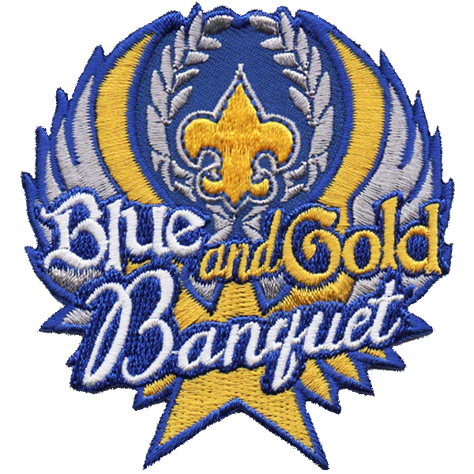
Scouting Is…
# 1: As we prepare to join together in a banquet to celebrate the birthday of Scouting, it is important to remember why we chose to join the Scouting movement.
# 2: Scouting is a program for young men and Cub Scouts, which is much bigger than just the people who are Scouts. When we join together, we are able to do more and be more than just ourselves.
# 3: Scouting is a sea of blue and gold uniforms. Scouting is a shirt full of patches. Scouting is a new neckerchief slide that you made yourself.
# 4: Scouting is a new pocketknife and bandaged finger. Scouting is a picnic and a sack lunch. Scouting is learning a new game. Scouting is putting the worm on the fishhook yourself. # 5: Scouting is a hike in the park. Scouting is learning a new game. Scouting is picking sides and being chosen first.
# 6: Scouting is all of these things and many more. To each of us it is a different experience. Most importantly, Scouting is caring parents and leaders who bring Scouting to each of us each and every week.
All: Scouting is the Blue and Gold we celebrate here tonight. May we be grateful for past good fortune.

Story of the Blue and Gold
Personnel: 8 Cub Scouts
Equipment: Blue felt board, cards for felt board: TRUTH, STEADFAST LOYALTY, SPIRITUALITY, WARM SUNLIGHT, GOOD CHEER, HAPPINESS, yellow sun for
flannel board.
# 1: Back in the good old days the waving of school colors gave people a feeling of school pride and loyalty. Today, the blue and gold of Cub Scouting helps to build this spirit among Cub Scouts.
# 2: (pointing to the blue flannel board), The blue reminds us of the sky above. It stands for truth, spirituality and steadfast loyalty.
# 3: (placing TRUTH card in upper left corner of board) Truth means we must always be honest.
# 4: (placing SPIRITUALITY in the upper right hand corner), Spirituality means a belief and faith in God.
# 5: (placing STEADFAST LOYALITY card across the bottom). Steadfast loyalty means being faithful and loyal to God, County and your fellow man.
# 6: (placing Sun in the center of board). The gold stands for the warm sunlight (places WARM SUNLIGHT card across the top of sun).
# 7: Gold also stands for good cheer and happiness. We always feel better when the sun is shining and so with those to whom we give good will. (places GOOD CHEER and HAPPINESS cards on each side of sun).
# 8: As we wear our Cub Scout uniforms, may the meaning of the blue and gold colors make us remember Scouting ideals… the Scout Oath and Law.
Story of Cub Scout Colors
Arrangement: As curtain opens, three Cub Scouts dressed in American Indian costume are seated around an artificial campfire. One wears a chief's headdress; the other two are braves. Hanging on a tripod over the fire is a kettle that has a small can of dry ice and a blue and gold Cub Scout neckerchief concealed in it.

Narrator (Cub Scout or Den Chief): Many, many moons ago, the great chief Akela called a council to see what could be done to make theirtribe the best of all tribes.

He told the first Indian brave to climb the mountain and tell the eagle to fly high into the sky and bring back part of the beauty of the sun. (One brave exits)

He told the second brave to go into the forest and tell the sparrow to fly high into the sky and bring back part of the beauty of the sky. (Second brave exits)

After a while, both braves returned. (Both braves enter. One is carrying a bottle of blue water, the other a bottle of gold water. They hold up the bottles to show everyone)

Narrator: Akela told one brave to pour some of the beauty of the sun into the council mixing pot. (The brave pours some of the gold water into the can in the pot, causing smoke)

Narrator: Then he told the other brave to pour some of the beauty of the sky into the council mixing pot. (The brave pours some of the gold water into the can in the pot, causing smoke. Akela, the chief, raises hands toward the sky.)

Narrator: Akela says that from this day forward, blue will stand for truth and loyalty and the sky above. Gold will stand for warm sunlight, happiness, and good cheer. (Akela reaches into the pot and pulls out Cub Scout neckerchief)

Narrator: And that's why the Cub Scout colors are blue and gold. We’re gathered here tonight, To honor the Blue and Gold, And pay a tribute to Scouting, Which is more than 100 years old.

Action for Cub Scouts: Cub Scouts could hold up blue and gold cared for the first 2 lines and then turn them over for the last 2 lines where the # is printed on the back.

Now, as we look all about us, Scouting in action we see,
Brining fun and adventure, As Baden-Powell meant it to be.

Action for Cub Scouts: As the first 2 lines are read they place hands over eyes as if shading them and looking from left to right. As second 2 lines are read, each one can hold up something showing Cub Scout fun such as Pinewood Derby cars, sail boats, etc.

Let us all join together, As our program we start,
By pledging allegiance to our Flag With our hand over our heart.

Action for Cub Scouts: Cub Scouts stand at attention and turn to face the Flag and lead the Pledge

INVOCATIONS

Akela, Make Me An Eagle
by Harlan G. Metcalf, Adapted by Merl Whitebook
Give me the strength to stand for right
When other folks have left the fight,
Give me the courage of the eagle
Who knows that if he will, he can.
Teach me to see in every face
The good, the kind, and not the base.
Make me sincere in word and deed,
Blot out from me all shame and greed,
Help me to guard my troubled soul
By constant, active, self-control.
Clean up my thoughts, my speech, my play,
And keep me pure from day to day.
0, Akela, make of me an Eagle!

Blessed Are the Cub Scouts
Blessed are the Cub Scouts who are taught to see beauty in all things around them.
For their world will be a place of grace and wonder.
Blessed are the Cub Scouts who are led with patience and understanding...
For they will learn the strength of endurance and gift of tolerance.
Blessed are the Cub Scouts who are provided a home where family members dwell in harmony and close communion. –
For they shall become the peacemakers of the world. Blessed are the Cub Scouts who are taught the value and power of truth...
For they shall search for knowledge and use it with wisdom and discernment.
Blessed are the Cub Scouts who are guided by those with faith in a loving God...
For they will find Him early and will walk with Him through life.
Blessed are the Cub Scouts who are loved and know that they are loved...
For they shall sow seeds of love in the world and reaps joy for themselves and others.
AMEN.

Cub Scout Parent's Prayer
Look down upon my child.
This smiling Cub Scout of mine.
Please take their hand along the way,
So that they may never stray.
Bless my child tonight and help them walk with Thee.
Give them comfort, warmth and love;
They’re all the world to me.
Bless their daily efforts,
And make them strong and true;
for life's a heavy burden,
And we're all in need of you.

Cub Scout’s Prayer
0 Lord, that I will do my best,
I come to Thee in prayer.
Help me to help others every day.
And teach me to be fair,
To honor my Mother and Father,
And to obey the Cub Scout Law, too.
This I ask, that I may be a loyal
Cub Scout true. Amen

Invocation
Dear God, bless all the Scouts around the world. Help us to remember that we are all working together to help make our world a better place. Guide our words and our actions so that we set the kind of example you want us to set. Amen.

Invocation
We fold our hands and bow our heads; And than thee Lord for our daily bread; For home and school and family, WE give thanks O Lord to thee. Teach us to be both brae and true; And bless our banquet, Gold and Blue.

Invocation:
Our God and God of our fathers, we gather as loyal members of our Cub Scout Pack, and we pray for Thy blessings. Give us the vision to see our duty and the courage to perform it. Teach us to walk together in the spirit of brotherhood, so that we are true to Thee, who art Father of all. Guide us and guard us so that we shall be faithful sons of the righteous God, who is from everlasting to everlasting.

Invocation
Our dear Heavenly Father, we ask your blessing on the families in our Cub Scout Pack. We ask a special blessing on each Tiger Cub, Cub Scout, and Webelos as they give service to other people. Guide their steps as they grow into men, and help them as they do their duty to You and our country. Bless our food and the people who have prepared it.

Invocations and Blessing for the Blue and Gold Banquet
Our God and God of our fathers, we gather as loyal members of our Cub Scout Pack, and we pray for Thy blessings. Give us the vision to see our duty and the courage to perform it. Teach us to walk together in the spirit of brotherhood, so that we are true to Thee, who art Father of all. Guide us and guard us so that we shall be faithful sons of the righteous God, Who is from everlasting to everlasting.
Our dear Heavenly Father, we ask a special blessing on the families in our Cub Scout Pack. We ask a special blessing on each Tiger Cub, Cub Scout, and Webelos as they give service to other people. Guide their steps as they grow into men, and help them as they do their duty to You and our country. Bless our food and the people who have prepared it. Amen

Philmont Grace
For food, for raiment,
For life, for opportunity,
For friendship and fellowship,
We thank thee, Oh Lord. Amen

A Reflection on the Philmont Grace
FOR FOOD: For food of combined thought from all around the world, to help us grow wiser in Scouting FOR RAIMENT: For our Scouting uniform, which we have not only the blessing to wear, but the duty to honor FOR LIFE: For a life of freedom in these great United States, a nation unsurpassed anywhere on this fragile planet, where we are truly free to live the aims of Scouting FOR OPPORTUNITY: For the opportunity of Scouting itself – to be here with you – some of the finest people in Scouting FOR FRIENDSHIP: For those we have met through Scouting and grown to love through that common interest – our love for ideals that we offer to the Cub Scouts who mean so much to us. AND FELLOWSHIP: To share a laugh, to help a friend in some small way. To share a sunrise, a sunset. To climb a mountain and reach the stars. WE THANK THEE, O LORD: The one to whom we owe so much. Amen.

Roundtable Prayer
“We are grateful for this opportunity to look back over the past 100 years of the Boy Scouts of America. We hank those who brought Scouting to America and helped the BSA make a difference in the lives of youth for a century. Help us in our effort to carry on the mission of the BSA. Bless those who will continue on in the next century.”

100th Psalm of Scouting
Make a joyful noise unto the world, all ye Scouters; Serve Scouting with gladness, and join the circle of Scouting with singing.
Know that Scouting is the way;
Its lessons have made us and we are grateful;
We are its leaders, guiding young Scouts.
Enter its programs with a cheerful spirit, and offer Cub Scouts your praise.
For Scouting is good!
Its lessons endure forever, and its truths to all generations.

POEMS

A Cub Scout in Blue
Blue and gold are the colors tonight,
Cub Scouts in uniform shiny and bright;
With smiling faces to left and right,
We pay tribute to our Cub Scouts tonight.
A Cubmaster who is loyal and true,
Who works with parents and Scouts in blue,
In hopes that these Cub Scouts will grow up to be
Better citizens than you and me.
Den leaders, too, in uniforms blue,
Teaching Cub Scouts the need to be true,
And working, singing, and playing with them;
Striving real hard to make better women and men.
So, all of you Cub Scouts in gold and blue,
The door to Scouting - has been opened to you,
And I as a leader in Pack_,
Hope someday you’ll join up with me.

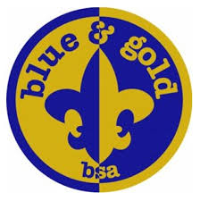

A Lone Scout Leads the Way
Scouter Jim, Bountiful UT
Sometime during 1909, William D Boyce, a wealthy newspaper publisher in London England, during a stop in London on his way to the British East Africa for a safari, lost his way in the city. An unknown young man offered to help and lead him to his hotel. As was probably his habit, Mr.
Boyce offered a tip to the young man who had come to his aid. The young man refused the tip, explaining he could not take money for doing a “good turn,” because he was a Scout. Mr. Boyce must have asked questions about this organization as he was given the address to the Scout Headquarters. Later on a return trip to London, William D Boyce went to the Scout Headquarters and collected information about the Scouting program founded by Lord Baden-Powell. Once back in the United States W D Boyce incorporated the Boy Scouts of America on 8 February 1910.
The Boy Scouts of American owes its roots to several groups, including Baden-Powell’s Scouts as well as the Sons of Daniel Boone formed in 1905 by Daniel “Uncle Dan” Beard and the Woodcraft Indians formed by Ernest Thompson Seton about 1901 to 1902. Even Baden-Powell based his organization on an earlier organization know as the Boys’ Brigade formed by William Alexander Smith in 1883, who was influenced by the YMCA..
After the Boy Scouts of America was incorporated, they began to absorb the other similar groups, including the Sons of Daniel Boone and the Woodcraft Indians. W D Boyce included others in the Boy Scout movement to help it grow. That included Daniel Beard, Ernest Thompson Seton, William T. Hornaday, and James West. There was disagreements among the principals and W D Boyce created the Lone Scouts of America (LSA) and the Rhode Island Boy Scouts, (RIBS). Joseph Lane, a member of RIBS started the Boys Life in 1911, which was purchased a year later by BSA. The LSA and RIBS were later absorbed into BSA. The RIBS exist today and the Narragansett Council of the Boy Scouts of America.
No one may ever know who that lone Boy Scout was that dark night in 1909 who helped William D Boyce. But there is no doubt he was the match that struck the fire to the
carefully prepared foundation that would become the Boy Scouts of America. As we look back, we must be thankful for that “divine spark” that continues to burn one hundred years later. Happy Birthday Boy Scouts of America, and Thank you Lone Scout.

Scouting’s Bottom Line
(can make a ceremony)
What happens to a Scout? For every 100 Cub Scouts who join Scouting, records indicate that:
- Rarely will one be brought before the juvenile court system
- Two will become Eagle Scouts
- Seventeen will become future Scout volunteers
- Twelve will have their first contact with a church
- One will enter the clergy
- Five will earn their church award
- Eighteen will develop a hobby that will last through their adult life
- Eight will enter a vocation that was learned through the merit badge system
- One will use their Scouting skills to save their own life
- One will use their Scouting skills to save the life of another person
Scouting’s alumni record is equally impressive. A recent nation-wide survey of high schools revealed the following information:
- 85% of student council presidents were Scouts
- 89% of senior class presidents were Scouts
- 80% of junior class presidents were Scouts
- 75% of school publication editors were Scouts
- 71% of football captains were Scouts
Scouts also account for:
- 64% of Air Force Academy graduates
- 68% of West Point graduates
- 70% of Annapolis graduates
- 72% of Rhodes Scholars
- 85% of FBI agents
- 26 of the first 29 astronauts

Ten Needs of a Cub Scout
To climb a mountain and look afar.
To sit around a campfire with good friends.
To test their strength and their skills on their very own.
To be alone with their own thoughts and with their God.
To be ready to reach out and find the hand of an understanding man ready and willing to help.
To have a code to live by – easily understood and fair.
A chance to play hard just for the fun of it –
And to work hard for the thrill of it.
To have a chance to fail – and know why.
To have and to be a good friend and a chance to prove both.
To have a hero – and a vision to measure them by.
After the tenth need is said, the following could be said:
In Cub Scouting these needs are not always filled for each Cub Scout. What Cub Scouting does is to put each Cub Scout on a path where they can travel the world in theirbackyard and fulfill theirneeds with confidence in himself and others.
Options: Break into parts and use it for an Opening Ceremony. Adults, each holding a white candle and when each speaks, he or she lights theircandle from the Spirit of Scouting Candle.

Thoughts on The Scouting Experience
We must depend upon the Cub Scout Scout Movement to produce the MEN of the future. Daniel Carter Beard
"The goodness of a person and of the society he or she lives in often comes down to very simple things and words found in the Scout Law. Every society depends on trust and loyalty, on courtesy and kindness, on bravery and reverence. These are the values of Scouting, and these are the values of Americans." President George W. Bush
"In the 30 years that I've been doing this for a living, I've never had a parent say to me, I regretted the time I spent with my son or child in Scouting. Roy L. Williams, Chief Scout Executive, Boy Scouts of America
"The Boy Scouts of America stands for a set of principles. These principles have a lot of staying power. The values you learn as a Scout are like a compass. They can help you find your way through difficult and sometimes unchartered terrain. The principles of Scouting give you a sense of what's important. I feel I owe the Boy Scouts a great deal, both personally and professionally." Bill Bradley, former U.S. senator, New Jersey
"I assure you of my own personal appreciation of Scouting as a magnificent experience and form of social and religious commitment." His Holiness Pope John Paul II, the Vatican
"One of the proudest moments of my life came in the court of honor when I was awarded the Eagle Scout badge. I still have that badge. It is a treasured possession. I am the first Eagle Scout president. The three great principles which Scouting provides -self discipline, teamwork, and moral and patriotic values - are the basic building blocks of leadership. I applaud the Scouting program for continuing to emphasize them. I am confident that your ability to bring ideals, values, and leadership training to millions of our young people will help to bring about a new era - a time in which not only our republic will progress in peace and freedom, but a time in which the entire world shall be secure, and all its people free." Eagle Scout Gerald R. Ford, 38th President of the United States
The generation now being shaped by Scouting will be strengthened by deserved self-confidence and molded with its own history of kindness, bravery, honesty, and its all-out pursuit of excellence. Earl G. Graves, Publisher, Black Enterprise magazine
Following the Scout Law sounds like a game plan that would give us all a better chance for success in life—and I mean every area of life.
Zig Ziglar, Author and Motivational Speaker

100 Years Ago...
It May Be Hard to Believe That A Scant 100 Years Ago...
- The average life expectancy in the United States was forty-seven.
- Only 14 percent of the homes in the United States had a bathtub.
- Only 8 percent of the homes had a telephone. A three-minute call from Denver to New York City cost eleven dollars.
- There were only 8,000 cars in the US and only 144 miles of paved roads.
- The maximum speed limit in most cities was ten mph.
- Alabama, Mississippi, Iowa, and Tennessee were each more heavily populated than California. With a mere 1.4 million residents, California was only the twenty-first most populous state in the Union.
- The tallest structure in the world was the Eiffel Tower.
- The average wage in the U.S. was twenty-two cents an hour. The average U.S. worker made between $200 and $400 per year.
- A competent accountant could expect to earn $2000 per year, a dentist $2500 per year, a veterinarian between $1500 and $4000 per year, and a mechanical engineer about $5000 per year.
- More than 95 percent of all births in the United States took place at home.
- Ninety percent of all U.S. physicians had no college education. Instead, they attended medical schools, many of which were condemned in the press and by the government as "substandard."
- Sugar cost four cents a pound.
- Eggs were fourteen cents a dozen.
- Coffee cost fifteen cents a pound.
- Most women only washed their hair once a month and used borax or egg yolks for shampoo.
- Canada passed a law prohibiting poor people from entering the country for any reason, either as travelers or immigrants.
- The five leading causes of death in the U.S. were:
- Pneumonia and influenza
- Tuberculosis
- Diarrhea
- Heart disease
- Stroke
- The American flag had 45 stars. Arizona, Oklahoma, New Mexico, Hawaii and Alaska hadn't been admitted to the Union yet.
- Drive-by-shootings, in which teenage boys galloped down the street on horses and started randomly shooting at houses, carriages, or anything else that caught their fancy, were an ongoing problem in Denver and other cities in the West.
- The population of Las Vegas, Nevada was thirty. The remote desert community was inhabited by only a handful of ranchers and their families.
- Plutonium, insulin, and antibiotics hadn't been discovered yet.
- Scotch tape, crossword puzzles, canned beer, and iced tea hadn't been invented.
- There was no Mother's Day or Father's Day.
- One in ten U.S. adults couldn't read or write.
- Only 6 percent of all Americans had graduated from high school.
- Punch card data processing had recently been developed, and early predecessors of the modern computer were used for the first time by the government to help compile the 1900 census.
- Eighteen percent of households in the United States had at least one full-time servant or domestic.
Author Unknown

AUDIENCE PARTICIPATION

Grandma and Grandpa’s Vacation
Divide audience into three parts. Assign each part a word and a response. Instruct them they are to say the response whenever they hear the word. Practice as you make assignments.

Grandma "I can't wait."
Grandpa "Here we come."
Vacation "My, what fun."
Country/countries (ALL DO THIS) (or the name of a country.)

"Wow" GRANDMA and GRANDPA worked very hard for a living and were very tired. GRANDMA and GRANDPA decided to go on a well-deserved VACATION. On their VACATION they wanted to visit all of the COUNTRIES they had lived in as children before finally moving to the united stated. GRANDMA had lived in FRANCE, SPAIN, JAPAN, AFRICA, and GREENLAND. GRANDPA had lived in GERMANY, ENGLAND, AUSTRALIA, MEXICO and COLUMBIA. GRANDMA and GRANDPA spent several weeks making plans for the VACATION. They called the travel agency to make reservations.
The day came for them to start their VACATION and they were off visiting all those COUNTRIES. GRANDMA and GRANDPA were so glad they were going to visit all the COUNTRIES they had lived in when they were children - FRANCE, SPAIN, JAPAN, AFRICA, GREENLAND, GERMANY, ENGLAND, AUSTRALIA, MEXICO and COLUMBIA. Once GRANDMA and GRANDPA returned from the VACATION, they decided that it would be a long time before they took a VACATION again. You see, they were so tired from visiting all of those places on their VACATION, that they needed VACATION from their VACATION!

Great Cub Scout
Break audience into four groups assign each group a part and a motion. Have everyone respond on CUB SCOUT Practice responses as you are assigning parts. Have ach group give the Cub Scout sign as it says its part.
FOLLOW - A Cub Scout Follows Akela (Give sign)
HELP - The Pack Helps the Cub Scout Grow (Give sign)
GIVE - A Cub Scout Gives Goodwill (Give sign)
PACK - A Cub Scout Helps the Pack Go (Give sign)
CUB SCOUT - Do Your Best (Give sign)
This is the story of a CUB SCOUT who wanted to do something to HELP his neighbor. She was a widow, and much too old to do very much for herself.
This CUB SCOUT wanted to FOLLOW the advice of his PACK leaders, who asked every CUB SCOUT to find some way they could GIVE HELP to someone else.
The best way he could think of to HELP his neighbor would be to shovel the snow off her driveway for her. But it was such a big driveway and he was such a little CUB SCOUT.
So he thought some more and decided he would go and talk to his PACK leaders and see if they could think of a way to HELP him. The PACK leaders said they would ask if any other CUB SCOUTS would like to HELP.
So what started with only one CUB SCOUT was soon being done by two CUB SCOUTS then three CUB SCOUTS then four CUB SCOUTS then five CUB SCOUTS.
(Continue adding CUB SCOUTS until the audience starts to laugh.)
The moral of this story is that if you FOLLOW the advice of your PACK leaders, and GIVE HELP to those around you; you too could be a great CUB SCOUT.

The Story of a Pack, Like Ours?
Divide audience into six parts. Assign each part a word and a response. Instruct them they are to say the response whenever they hear the word. Practice as you make assignments.
PACK: We're number one (everyone)
LIONS: Roar
TIGERS:
WOLF: Your Best Wolf Howl
BEAR: Grrrr, Grrrrrr!
WEBELOS: To the top!
PARENTS: I'll help, I'll help
Once upon a time there was a pretty good PACK who did a lot of things and had a lot of fun. The PACK has a few new LIONS who had just joined the PACK. There were also a few WOLF Cub Scouts, who were eight years old. Most of the Cub Scouts in the PACK were BEARS, who were 9 years old and some of these BEARS were almost 10 years old.
After a Cub has been a LION, TIGER, WOLF, or BEAR, and has turned 10 years old, they becomes a WEBELOS. WEBELOS means, "We'll be loyal Scouts". The WEBELOS program differs from the BOBCAT, WOLF, and BEAR because WEBELOS prepares the WEBELOS Scout to be a Boy Scout. The WEBELOS uniform is different too.
The WOLF and BEAR Cub Scouts work on achievements and electives for gold and silver arrows with their PARENTS. The WEBELOS work toward activity pins. These awards are presented at the PACK meeting for all the PARENTS to see.
The PACK was going along real well until summer came and a few PARENTS moved. The PACK is now in great need for PARENTS of the BOBCAT, WOLVES, BEARS, and WEBELOS to help the PACK. The PACK needs the help from the PARENTS so the PACK can grow and continue to provide lots of fun for the BOBCATS, WOLF and BEAR Cub Scouts and the WEBELOS Scouts too! The PACK can't do a good job with only a few PARENTS doing everything, so PARENTS help your BOBCAT,
WOLF and BEAR Cub Scouts and your WEBELOS Scouts get a better program of fun and adventure in our PACK. PARENTS help us now.
What do you say PARENTS?

Very Special Birthday Party
Divide audience into four groups to respond with the following:
DEN LEADER: “Oh boy!”
CUB DEN 1: “Oh boy, oh boy!”
BIRTHDAY CAKE: “Happy birthday to you” (sung)
BIRTHDAY PARTY: “Yippee!”
This is a story of a DEN LEADER, CUB DEN 1, and a BIRTHDAY CAKE. One Thursday afternoon, as CUB DEN 1 was meeting at the home of their DEN LEADER, Mrs. Reid, the boys overheard her on the phone say “It will be a very special BIRTHDAY PARTY. “
“BIRTHDAY PARTY?” they said, to each other, “whose BIRTHDAY PARTY?” “That’s a neat idea, “ said Johnny. “Let’s have a BIRTHDAY CAKE, “ said Mike and Ike. “Swell, “ they all said.
So each went home and made special plans for the next Den meeting and the special BIRTHDAY PARTY for their DEN LEADER.
Den Meeting day dawned bright and sunny. At 3:30 all five boys arrived at their DEN LEADER’S house. Mike and Ike brought a BIRTHDAY CAKE. Jimmy brought paper hats, Johnny brought balloons and Billy brought ice cream for the BIRTHDAY PARTY.
As they trooped in the door, they all yelled, “Surprise! We’re having a BIRTHDAY PARTY”. Mrs. Reid, their DEN LEADER looked shocked. “My BIRTHDAY PARTY? Why? It’s not my birthday. “
But we heard you talking about a special BIRTHDAY PARTY on the phone last week, said Jimmy. “Oh,” said their DEN LEADER, and smiled. “It’s Cub Scouting’s birthday,” she said. “Cub Scouting is 75 years old this month. But I think this is a wonderful idea. We’ll just celebrate a little early. “
And so they did. And that is how CUB DEN 1 and their DEN LEADER had a very special BIRTHDAY PARTY!

ADVANCEMENT CEREMONIES

Advancement ceremonies should be reviewed and modified to suit the specific awards being giving at the meeting.

Ideas for Banquet Advancement Ceremonies
● Make a large papier-mâché birthday cake. Use whipped soapsuds to ice the cake. Before soapsuds harden, insert candles (one for each year). Candles can be lit before the awards presentation and blown out after the ceremony.
● Insert Cub Scouts’ award into birthday balloons (yellow for Lions, orange for Tiger Cubs, green for Wolves, blue for Bears, and red for Webelos Scouts) before blowing them up. Write each Cub Scout’s name on the outside of their balloon with a marker. All Cub Scouts pop them at once. (Do not use balloons if anyone in the pack is sensitive to balloons being popped).
● Package individual awards in small boxes wrapped in blue paper and tied with gold ribbons. Ask Cub Scouts to wait until all awards have been presented before opening their package. Then, while Cub Scouts open their packages, the rest of the pack sings “Happy Birthday.” (Make sure that it’s clear that the Cub Scouts earned these awards, they are not gifts).
● For more ceremony ideas, see Cub Scout Ceremonies for Dens and Packs.

Baden-Powell Advancement Ceremony - All ranks
You can have one person read this or divide it into sections and have several people present. Minimizing the reading (memorization) always enhances a ceremony.
Tonight, we are celebrating the birthday of Scouting and the __^{th} anniversary of Cub Scouting. Many of you know that Scouting started in England in 1907 when Lord Baden-Powell took seven boys to Brownsea Island for a camping experiment. But the roots go even farther back. In 1899, Baden-Powell was a Colonel in the British Army fighting the Dutch Boers in South Africa. Colonel Baden-Powell was in charge of a town called Mafeking. It was under siege by the Boers. The Boers shelled the town every day except Sundays. When that happened, everyone had to hide in trenches until the shelling stopped. Baden-Powell noticed that the last ones into the trenches and the first ones out were the young boys. He needed to keep these young lads from doing risky things and getting wounded. So, he organized them into a Boys Corps. They ran messages from Headquarters to the troops and citizens, and they practiced Army Scouting skills. This helped him enforce discipline on them in a way that they could accept.

The food was running out, the Boer force was ten times the size of the British force, but Baden-Powell used his cunning to hold the town for 217 days, until British reinforcements could arrive and rescue the town from the Boers. When he got back to England, he found himself a National hero and a small book he had written for the Army, “Aids-to-Scouting”, was being used by British boys to play games of Scouting. He remembered those boys in Mafeking and what his Boys Corps did for them. He rewrote his book in 1908 and Scouting was born.

The tradition Baden-Powell started in Mafeking, we are continuing tonight. When the boys in Mafeking learned their Scouting skills, they were rewarded with a promotion in rank. So too, do Cub Scouts, after showing their abilities in learning certain skills, earn awards towards the ranks of Lion, Tiger, Wolf, Bear and Webelos Scouts. (Call up each den, present awards, and lead a cheer).
Blue and Gold Advancement
Props: All awards have been individually wrapped in blue and gold paper and ribbon as birthday gifts.
Setting: Narrator presents ceremony from front of room with three stacks of birthday gift awards on a table in front.
CM: Tonight, being Cub Scouting’s __^{th} Birthday Party,
Tt’s time to give presents so we won’t be tardy.
Our first presents go to Cubs that are new.
So, we would like present Lion advancements to these few.
(Call up Lion den, present awards, lead cheer)

Tigers

To celebrate their efforts and time
we’d like to present Wolf awards to these Cubs combined.
(Call up Wolf den, present awards, lead cheer)

This next group of Cubs to be recognized tonight,
Richly deserve this gift by right.
The Bear badge they’ve earned take time and attention,
And work on their part too numerous to mention.
(Call up Bear den, present awards, lead cheer)

(After names have been read and gifts given, present Webelos badges in much the same fashion, and then give the closing thought below:)
Enjoy these small gifts from Scouting
that you have worked to achieve.
But, remember, a gift is much richer by far
when you give instead of receive.
So please give what you have learned of Scouting
to others, tonight when you leave.

Blue and Gold Traditions
EQUIPMENT: blue, white, red and yellow candle
CUBMASTER: The Blue and Gold Banquet is the time to celebrate the birthday of Scouting. Tonight, as part of our celebration, some of our Cub Scouts will be recognized for their accomplishments.
(Light the blue candle). The blue candle represents the spirit of Cub Scouting.
(Call Cub Scout candidates and parents forward). You have promised to do your best and to do your duty. That is what you have done by completing the requirements to advance in rank. You have earned the badge.

(Use the blue candle to light the yellow candle). The yellow candle glows representing the warm sunlight. These Scouts have lived up to the Scout Oath and Law and completed the requirements to earn the badge.

The red candle stands for good cheer. These Scouts do not do anything half-heartily. They will be awarded the badge tonight.

The light of the white candle is the guiding light on the Cub Scout Trail. The light radiates happiness. The following Cub Scouts have been guided by the light and are on their way to the top of the Cub Scout Trail.
Cub Scout Birthday Box
The Cubmaster enters the room with a very large box wrapped as a birthday present. Usually it is on a wagon or a cart so it can easily be pulled. There is a large bow and card on top of the birthday present. The card reads: HAPPY BIRTHDAY CUB SCOUTS! Inside the large box are several smaller boxes, each wrapped as birthday presents. The boxes have cards and bows on the tops. These boxes have the den numbers on them and read: HAPPY BIRTHDAY CUB SCOUTS IN DEN 1, etc.
Inside the den boxes are several smaller boxes or packages. Each package or present is labeled with the Cub Scout's name, one for each member of that den. Inside the presents are the Cub Scouts' awards! NOTE: Make sure every Cub Scout in the pack gets a package.
Cubmaster: Since today we celebrate the birthday of Scouting, it is only appropriate that we have a birthday present. This present has Happy Birthday Cub Scouts on it. Let's see what is inside.
(The Cubmaster opens the box, calls up each den one at a time. With the help of the den leaders, presents awards to each Scouts, leads cheer.)

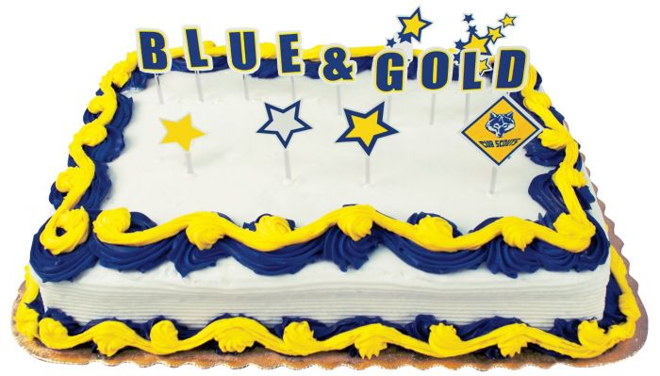
Cub Scout History Advancement Ceremony – needs updating
Set up rank posters on the table with a blue candle in the center. The Cubmaster gives the Cub Scout sign for silence while the Assistant Cubmaster lights the candle.
Cubmaster: This is the light of Cub Scouting. It has been burning in the United States for almost __ years. Over thirty million Cub Scouts in blue and gold uniforms have been helping other people and having fun together for a long time.
When Cub Scouting began in 1930, the animals in Rudyard Kipling's "Jungle Book" were used to represent the ranks. Just as the jungle animals live in dens and belong to a pack, so do our Cub Scouts.

Add Lion
Assistant CM: There was no Tiger badge when Cub Scouting began. Instead, the Cub Scout got their official uniform as soon as they passed a few entrance requirements. They were much like today's Cub Scout, except that they wore blue knickers or shorts with knee stockings.
Cubmaster: Now our Cub Scouts buy their uniforms and learn what Scouting is all about to earn their Tiger Badge. (Calls up Tiger den, present awards and lead cheer.)
Assistant CM:
Cubmaster: (Calls up Cub Scouts for the Tiger Badge.) The Tigers work on their badges with their adult partners. (Present awards and lead cheer.)
Assistant CM: Tigers go out to search, discover, and share their expanding world.
Cubmaster: (Call up Cub Scouts and parents for the Wolf Badge.) Second grade Cub Scouts work on the Wolf Badge after completing the Bobcat requirements. Every Cub Scout tries to do their best as they work in their Wolf book (Present awards and lead cheer.)
Assistant CM:

Cubmaster: Cub Scouting is for the entire family. The help and encouragement of your family is a very important part of Cub Scouting.
Cubmaster: The Bear Badge requires a lot of work. We have several Cub Scouts here tonight who have completed the Bear requirements. Would the following Cub Scouts please come forward with an adult who has helped you earn this badge. (Call up Cub Scouts and parents for the Bear Badge.) There may have been times when you wanted this badge so much you gave up something else you wanted to do to work on this badge. (Present awards and lead cheer.)
Assistant CM:
Cubmaster: You boys and your families have certainly earned the badges which we are about to present to your family. As you gaze upon the light of Cub Scouting, think about what you have accomplished and what lies ahead for you in Scouting. I would now like to present your badge to your family while the Assistant Cubmaster presents each of you with a reminder that the light of Scouting will always be there to guide you.
History of Cub Scouting – needs updating
We all know that the Boy Scout movement in America was started by William Boyce after he was directed to an address in London by a boy who refused a tip because he was a Scout. Mr. Boyce was so impressed by his talk with Lord Baden-Powell that he helped incorporate the Boy Scouts of America of February 8, 1910. It is this date that we celebrate each year with our Blue and Gold Banquet.

Almost as soon as Scouting began, youth started clamoring for a chance to participate in Scouting. This resulted in the Wolf Cub program being started in England in 1916. It wasn't until August 1,1929 that the first demonstration Cub units were started. By 1933, it was felt the time had come for promoting Cub Scouting as a part of the Scouting program.

Tonight, we would like to recognize our Lions who have been clamoring to join Scouting. (Call up Lion den, present awards and lead cheer).

As we read in the Wolf book the basis for much of the program came from THE JUNGLE BOOK by Rudyard Kipling. In this book is the story of two wolves who find a man cub who is being hunted by SHERKAN, the tiger. They take in the boy, whom they name Mowgli, (which means frog) and raise him as part of their family.

The wolves are part of a pack, which is led by Akela, the great gray Lone Wolf. Once a month, the new cubs are presented to the pack for acceptance. If two members of the pack do not accept them, they are turned out. When Mowgli was presented to the council, none of the other wolves would speak for him. Just as Mother wolf was ready to give up. Baloo, the kindly brown bear who taught the wolf cubs the Law of the Jungle stood up and said, "I will speak for the man cub." When no one else spoke, Bagheera, the black panther rose and offered to pay one bull if the man cub would be accepted into the pack. And so it was that Mowgli became a part of the Wolf Pack, for the price of a bull and on Baloo's good word.

Tonight, we are going to present our Lions to the pack. (Call up Tiger den, present awards and lead cheer).

Just as the Wolf Cubs learned about the world around them by taking short trips into the woods, so have our own Cubs grown in their understanding of nature and of their families. (Call up Wolf den, present awards and lead cheer).

Just as Baloo the kindly Bear, taught the young Wolves the secret names of the trees, the calls of the birds and the language of the air so must each of you help others in you den in order to meet the requirements for Bear. (Call up Bear den, present awards and lead cheer).

In 1967, the Webelos program expanded and activity badges were added. A new Webelos Badge was also created and the original Webelos badge was retained as the Arrow of Light.

The Webelos rank is the transition between Cub Scouting and Cub Scout Scouting. To become a Webelos requires a further expanding of one's horizons. Advancements must be earned and involvement in church and civic activities are encouraged. (Call up Webelos Scout den, present awards and lead cheer).

The Arrow of Light is the highest award in Cub Scouting. It can also be worn on the Scouts BSA uniform in recognition of your achievement. To be standing here tonight, means that you have reached the highest point along the Cub Scout trail. Do not stop here for the trail leads on to Scouting and great new adventures that can only be dreamed about for now. (Present Arrow of Light awards and lead cheer).

Jungle Book Ceremony
NARRATOR: This month we are celebrating the __^{th} annual birthday of Boy Scouting in America and Cub Scouting 20 years later, February 22, 1930. Cub Scouts traditionally hold the Blue and Gold Banquet to celebrate this birthday. Cub Scouting builds character in Cub Scouts. The blue stands for truth and loyalty; and the gold, cheer and happiness. In addition, the blue and gold of Cub Scouting helps to build spirit in the pack. And so, you can see how society over the years has benefited from Scouting. Let us all, through our efforts, make this the best celebration yet.

CUBMASTER: Who will speak for the Lions?
LION GUIDE: I, Lion leader will speak for the Lions. These are the young ones, but they have already begun to show skills. These young ones are ready to be recognized. (Call up Lion den, present awards, lead a cheer).
CUBMASTER: Now it is time for the Tigers. Who will speak for the Tigers?
BAGHEERA: I, Bagheera, will speak for the Tigers. These are learning many new Scout skills. I present them to the pack. (Call up Tiger den, present awards, lead a cheer).
CUBMASTER: Now it is time for the wolves. Who speaks for the wolves?
MOTHER WOLF: I, mother wolf, speak for the Wolf Cubs. I have nurtured them and watched them grow as they learn the skills of the wolf. I present them to the pack. (Call up Wolf den, present awards, lead a cheer).
CUBMASTER: Next, we are ready for the bears, who speaks for the bears?
BALOO: I, Baloo, will speak for the bears. I have taught them well the Scout Oath and Law. They have come far and are ready to be recognized by the pack. (Call up Bear den, present awards, lead a cheer).
CUBMASTER: Now we are ready for the maturest members of the pack to be recognized. Who speaks for the Webelos Scouts?
WEBELOS LEADER: I speak for the Webelos Scouts. Recite the meaning of Webelos. (Call up Webelos den, present awards, lead a cheer).
CUBMASTER: I have looked over the members of the pack and I am proud to be their leader; would all of the members of the pack come forward and join in all a Grand Howl.

Let’s Celebrate
Props – Party decorations, streamers, boxed gifts
Awards – Wrap the awards like presents. Have a large gift-wrapped box in which you put all the presents.
Cubmaster “We’re here to celebrate the advancement of (Cub Scout’s name(s) to the rank of (rank). As their efforts to advance has been a gift to us, we present them now with their awards. Let’s all join in singing (to the tune of Happy Birthday)
Happy (actual rank earned) Lion to you!
Happy Lion to you!
Happy Lion dear (name of Cub)
Happy Lion to you!
(Might be fun to have party noisemakers instead of cheers so the audience can raise the roof)

Meaning of the Colors Blue and Gold
CM: This month we are celebrating the __^{th} annual birthday of Boy Scouting in America and Cub Scouting 20 years later, February 22, 1930. Cub Scouts traditionally hold the Blue and Gold Banquet to celebrate this birthday. Blue and gold, the Cub Scout colors stand for some of the good things Cub Scouts gain through the process of advancement as they make progress towards the ranks.

Gold stands for good cheer. The Lions here tonight are beginning to learn the basics of Cub Scouting and are full of the good cheer of Cub Scouting. (Call up the Lion den, present awards and lead cheer.)

Gold stands for happiness, and no one seems to be more full of happiness than the bright young Tiger Scouts. (Call up Tiger den, present awards and lead cheer.)

Blue, the other color of Cub Scouting stands for truth. Truth shines through strong on the faces of the Wolf Scouts as they have learned that the truth is always the best. (Call up the Wolf den, present awards and lead cheer.)

Blue also stands for honor and the Bear Scouts have learned that Cub Scout honor really is important. (Call up the Bear den, present awards and lead cheer.)

The other meaning for the color blue is loyalty. This is one of the most important traits a Cub Scout can learn in the process of becoming a man. Loyalty to family, God, country, friends, and the most important, loyalty to their beliefs and convictions. There are many adults who do not display this trait, but the Cub Scouts who have progressed to the rank of Webelos Scouts have developed or are developing this trait of loyalty. (Call up Webelos Scouts, present awards and lead cheer. Honor any Arrow of Light recipients with more ado than the activity badge recipients.)

These Cub Scouts honored tonight have been true to the gold and the blue by showing the traits represented by our Cub Scout colors.... good cheer, happiness, truth, honor and loyalty.

Scouting History
Equipment: Awards for the Cub Scouts.
Arrangement: Cubmaster in front of the audience.
CM: Robert Baden-Powell was a British army officer who was stationed in India. He found his men didn't know basic first aid or elementary means of survival outdoors. He felt a need to teach his men resourcefulness, adaptability, and the qualities of leadership demanded by the frontier. He wrote a small military handbook called "Aid to Scouting." Boys in England started using the book play the game of Scouting, and in 1907, Robert Baden-Powell took 20 boys and 2 men to Brownsea Island, off the coast of England. This was the beginning of Scouting.
Later Baden-Powell wrote a book that set in motion the movement that brought on the beginning of Scouting. The Lion program starts the beginning of the Cub Scout trail. (Call up the Lion den, present awards, lead cheer.)

In 1909 a Chicago businessman, William Boyce, was lost in a London fog. A boy appeared and helped Boyce to his destination. When Boyce tried to tip the boy for his kindness, the boy refused; he said he was a Scout and could not accept money for a good turn. Boyce asked the boy questions about being a Scout and asked to see Lord Baden- Powell. Mr. Boyce was eager to meet Lord Baden-Powell and learn about Scouting. Just as our Tigers are eager to do things and learn about Scouting. (Call up the Tiger den, present awards, lead cheer.)

After the visit to England, Boyce returned to America, captured by his dream and in 1910 Boyce incorporated the BSA. William Boyce brought Boy Scouting to the United States. He took the next step in bringing Scouting to our Cub Scouts. The next step on the Cub Scout trail is the Wolf badge. (Call up the Wolf den, present awards, lead cheer.)

Back in England, the younger boys were eager to join the older Boy Scouts. Baden-Powell designed a program based on Rudyard Kipling's "Jungle Book." The Jungle Book helped to bring the Scouting program to the younger boys, creating Cub Scouts. In 1930, Cub Scouting was formally launched in America. This was the third step in spreading the Scouting movement around the world. The next step on the Cub Scout Trail is the rank of Bear. (Call up the Bear den, present awards, lead cheer.)

The American style of the Cub Scouting program is home- and-neighborhood-centered. The program suggests a wide variety of interesting things for a Cub Scout, his den, and his family to do. The thrust of the entire Scouting program, including Cub Scouting, is to help promote citizenship, character development, and physical fitness, all the while being done in the spirit of fun. Tonight, we have Cub Scouts who have done all kinds of activities in the Cub Scout program and who have grown from their experiences. (Call up the Webelos Scouts, present awards, lead cheer. Honor any Arrow of Light recipients with more ado than the activity badge recipients)

After the death of Baden-Powell, a letter was found that he had written to all Scouts. It said: "Try and leave this world a little better than you found it." These words are a fitting epitaph setting a great example for all of us to follow.

LEADER RECOGNITION
& INSTALLATION

Adult Recognition
February is the traditional month for thanking those people who have helped your Pack throughout the year. Here are a few ideas:
- Give them a "pat on the back" A hand-shaped award
- For "smooth sailing" through the year A sailboat
- For making it all "bearable" A bear-shaped cutout or a small teddy bear
- For being a "life saver" A roll of Life Savers
- Rescue Award Band-aid glued to a board
- "Always Prepared" Award Quarter glued to board
- For "picking up our spirits" Pick up sticks
- For being a "high flyer" A Kite
- The Super Star Award Big silver star
- "You Got Suckered Into This" Award A big sucker
- The spark that keeps us going A spark plug
- You're a joy to be around Almond Joy candy bar
- You energize our Pack Energizer battery
- You're worth a mint York Mint Peppermint
- You're worth a million Play money
- You're work a grand 100,000 Grand candy bar
- For giving a big hunk of your time Big Hunk candy bar
- For your immeasurable support Ruler
- For colorful ideas A box of crayons
- For being number one #1 birthday candle
- You're a star in our eyes Starburst candy
- For making the pieces fall in place Puzzle
- For guiding us in the right direction Compass
- You deserve a big kiss A giant chocolate kiss
- You deserve a big hug A giant Hersey Hug

Fun Awards
- Our eyes are on you -- For the leader who sets the example (button eyes on a large felt U)
- Order of the spare marble -- For the person who's lost 'em (a marble glued to a small piece of wood or to a string)
- Spark plug award -- For the person who is the spark of a project (a spark plug mounted to a piece of wood)
- Berry good job -- For the person who did a "Berry good Job" (a wax or plastic berry (any kind) mounted to a piece of wood)
- Heads up award -- For the person who is heads above the rest (a plastic head mounted above a piece of wood using a piece of wire to keep the head above the wood)
- Measure up award -- Your performance sets the standard (a ruler mounted to a piece of wood)
- Bonafide award -- for the person who needs an award! (a dog bone mounted to a piece of wood)
- Nuts about the job award -- for the person who had to be nuts (2 or 3 peanuts glued to a piece of wood) Order of the bear -- For those that bear up under pressure (a plastic bear with a tire gauge)
- Kiss award -- for those who deserve a kiss (a Hershey’s kiss - silver foil)
- Gold Kiss award -- for those who REALLY deserve a kiss (a Hershey’s pecan kiss - gold foil)
- Lifesaver award -- for that person who saved you (a Lifesaver on a string)
- Banana Award -- for the person with great appeal (a wax or plastic banana mounted on a piece of wood)
- Bright Idea award -- For those who had a bright idea (a light bulb mounted to a piece of wood)
- Helping hand award -- For those who were willing to help (trace a hand on construction paper mounted to a piece of cardboard
- Hat's off award -- For someone we take our hats off to (an old hat mounted on a piece of wood)
- Right foot award -- For those who got us off on the right foot (Trace a RIGHT foot --use caution some may not know left from right)
- A note to start on -- For those who got us going (a musical note mounted on a piece of wood)
- Big heart award ----- For those who always seem to have one (heart shaped craft material of any kind then decorated)
- Udderly Ridiculous award -- Blown up latex glove
- Well Done -- Burnt slice of toast Nuttiest -- A bag of nuts
- Corniest -- An ear or can of corn
- Expanded our knowledge -- Elastic band or large rubber band
- Best foot forward -- 12" ruler or a sock with the toe cut off
- Heartfelt thanks -- Large heart cut from felt
- You banded us together -- A bunch of rubber bands Fan-tastic -- A fan (use your imagination)
- Thanks a million -- Million $ in play money
- Covered the topic -- A plastic lid
- Right-on target -- A target pasted to cardboard with "writing" on it
- Kept us in stitches -- A needle and thread
- Marbleous job -- A bunch of marbles Worked like a dog -- A mounted dog biscuit or bone
- Tee-rific -- A mounted golf tee or tea bag
- The coveted dime and pin award -- Glue a pin to a dime
- Plunged right in award -- Small sink plunger
- Give out a "rais-in" pay -- a pyramid of raisins glued to a backing
- Rose to the occasion -- an artificial or ribbon rose
- N'ice Job -- A box of N'ice cough drops
- Welcome aboard -- A 2 x 4 with the word "welcome" printed on it
- Knocked yourself out award -- Mount a small hammer or mini bat
- A real card -- Mount a playing card
- A real cut up -- Mount a plastic knife or pair of scissors or a cookie cutter
- For those with a stake in the Scouts future -- A tent stake (or if you really mean it a 2 inch thick TBone)
- You charged us up -- A battery
- You tickled our funny bone -- A feather mounted to a bone
- Shining Example -- A small flashlight
- The right arm award -- Cardboard arm with the hand in the Scout sign
- Cheerleader award----Mount a stiff wire through a box of Cheer laundry soap and add pom-poms to the wire
- Do-re-me Award----For your song leader -- mount a note or cleft
- Ringy Dingy Award----Mount a plastic phone or two cans on a string This is for those who are your phone call addicts.
- The band-aid Award----For those who can fix anything ----For someone who got a boo-boo
- The Alka Seltzer or Fizzy Award ----- For those who add fizz to the group or meeting
- The Rope Award ----- For those who always tie up the loose ends
- The Crutch Award----For those who you can lean on Key to Success-----For those who were key to making it happen
- Whale Award ----- For those who did a whale of job
- Football Award----A small football to the person who always is willing to tackle a job
- Cone Award-----Mount an ice cream cone for the person who can lick any job I've even seen one of those street cones be used
- Flower arrangement or house plant: We’re glad you were planted in our pack. Thank you for blooming in Cub Scouting.
- Mint candies: You’re worth a “mint” to our pack. Thanks for adding flavor to Cub Scouting.
- Firefighter’s hat: Thanks for coming to our rescue.

Thank You to All Unit Leaders
Personnel: Scouting coordinator, head of chartered organization, pack committee chair, pack committee members, den leaders, Cubmaster, assistant Cubmaster, Webelos Den leader, Scout master, Den Chiefs and Webelos
Scouts for escorting each leader to be recognized, operators for lights.
Equipment: Ladder with proper emblems, table, two candles, and flashlight, certificates of appreciation, or "Thanks" badges, or plaques.
Arrangement: Stage is set, room light dimmed.
Scouting Coordinator: Tonight we honor the leaders of Pack for the outstanding work done during the past year.
Webelos Scouts will now light the candles representing the Cub Scout Promise and the Law of the Pack. Will our leaders please stand? As your name is called, a Webelos Scout will escort you to the front. (The Scouting Coordinator reads names and describes the job of each leader to be recognized. A spotlight is focused on the leader. As they proceed to the front, a flashlight is focused on the appropriate emblem.)
Our pack committee chair is (name). Working with him/her on the committee are (names). We appreciate their advice, planning, and administration of our pack. They are our board of directors.
Now a group that our dens and den leaders could not be without, are our den chiefs. These Scouts give valuable leadership to our Cub Scouts and help to our den leaders.
We are proud to recognize den chiefs (name) of Troop .
Tonight we also honor our den leaders for their unselfish service. By their devotion, they help our Cub Scouts grow in stature and character. We are proud of our den leaders. (Introduce the den leaders).
Also important among our leaders are our assistant Cubmaster and Webelos Den Leader. (Introduce them.) They guide our pack meeting programs and prepare our older Cub Scouts for Scouting.
It is now my pleasure to introduce to you a man/woman we love and appreciate for his/ her example, guidance, and leadership - our Cubmaster, (name).
Many of our Cub Scouts have been graduated into troop. (Name), our Scoutmaster has helped provide our pack with many den chiefs. We appreciate his/her cooperation and are happy for our Webelos Scouts when they graduate into his/her troop. Will the den chiefs accompany Scoutmaster (name) to the front, and each Webelos Scout so assigned bring the other leaders forward.
I am happy to introduce (name), the head of our chartered organization.
Organization Head: On behalf of our organization, the Cub Scouts and their families, we are happy to present you leaders with these certificates of thanks. He/She presents certificates. We pledge ourselves to the continuing support of the pack and to the purposes and objectives of Cub Scouting. We will "Do Our Best.

SONGS

Baden-Powell
(Tune: Found a Peanut)
Found an honest man,
Found a humble man.
Baden-Powell was his name;
Started Scouting back in England
Which then led to his great fame.
First came Boy Scouts,
Then came Cub Scouts.
At first their numbers were quite small;
But they spread to other countries,
Now we're several million all.
When he died, it was sad
To lose such a man;
But his teachings have inspired us
To do the very best we

Banquet Time
Tune: On Top of Old Smoky
Our blue and gold banquet’s,
The best in the town,
We celebrate Scouting,
While gulping food down,
Cub Scouting’s a pleasure,
And eating is too!
Do pass the fried chicken,
Yea, the gold and the blue.

Birthday BSA
(Tune: On Top of Old Smokey)
We were all at the banquet
On Blue and Gold day,
The whole family came here
To eat and to play.
Then somebody told me
We’re _____ years old.
I could not believe
What I had been told.
They brought out a cake
Now how could a Cub Scout
When I get that old
Then somebody told me
An astonishing fact;
The Boy Scouts of America
Are older than that.
My Den Leader told me
That I shouldn’t fret;
That’s the age of Cub Scouting
I’m not that old yet!

Blue and Gold
Tune: Jingle Bells
While dashing all around
To prepare for Blue and Gold,
The Scouts made napkin rings
And placemats to behold.
The nut cups they were neat.
The nametags were just right.
Oh, what fun it is to have a
Blue and Gold tonight.
Chorus:
Oh Blue and Gold, Blue and Gold,
Banquet time again
Families gathered all around
Waiting to chip in.
Fried chicken and baked beans
Potato salad, too.
A piece of Birthday cake
Enough for me and you
Some people ate too much
But we all enjoyed the meal.
The friendship here tonight
Was warm and true and real.
Chorus

Blue and Gold Traditions
(Tune: Jingle Bells)
While dashing all around
To prepare for Blue and Gold
The kids made napkin rings
And placemats to behold.
The nut cups, there were neat;
The nametags were just right.
O what fun it is to have
A Blue and Gold tonight

Chorus:
Blue and Gold, Blue and Gold,
Banquet time again.
Families gather all around
Ready to pitch in.

Fried chicken and baked beans;
Potato salad too.
A piece of birthday cake;
Enough for me and you.

Chorus
Some people ate too much;
But all enjoyed the meal.
The friendship that was there
Was warm and true and real.

Chorus
Blue and Gold, Blue and Gold
Banquet time is here.
Time to sing and celebrate
Cub Scouting’s 72nd year.

Chorus
Blue and Gold
(Tune: Are You Sleeping -- Round)
Blue and Gold,
Blue and Gold
We are true,
We are true.
Loyal are we Cub Scouts
Loyal are we Cub Scouts
To you.
To you.

Blue and Gold
(Tune: Clementine)
We're the Bobcats,
Wolf and Bear Cubs,
And the Webelos are we.
Altogether we're a Cub Pack
Having fun in harmony.
We're the mothers,
We're the fathers
Helping Cub Scouts as they go,
Up the ladder of achievements,
Climbing higher as they grow.
Let's celebrate on
This occasion,
True to Blue and Gold are we.
Pack ____ is the number,
representing you and me!

Blue & Gold
(Tune: Clementine)
We’re the Cubbies (Cub Scouts)
We’re the Cubbers (adults)
Here we are both young and old,
Altogether we’re a Cub Pack
Having fun at Blue & Gold.
We’re the Bobcats, Wolf, and Bear Cubs
And the Webelos are we,
Altogether we’re a Cub Pack
Having fun in harmony.
We’re the mothers,
We’re the fathers,
Helping Cub Scouts as they go,
Up the ladder of achievement,
Climbing Higher as they grow.
Let’s give thanks on,
This occasion,
To the mighty Gold and Blue,
Pack ____ is the number,
Representing me and you.

Oh Blue and Gold
Tune: Oh Tannenbaum
Oh Blue and Gold, Oh Blue and Gold,
You know it stands for truth untold
Oh Blue and Gold, Oh Blue and Gold,
The youth that wear it aren’t so old
So carry on your colors bright,
Until the whole world you will light,
Oh Blue and Gold, Oh Blue and Gold,
The memories live though we grow old.

Blue and Gold Family
Tune: Clementine
Cub Scouts: We’re the Cub Scouts.
Adults: We’re the parents.
All: Here we are, both young and old.
Here we are, both young and old.
Altogether we’re a Cub Pack
Having fun at Blue and Gold.
Cub Scouts: We’re the Bobcats
Wolf and Bear Cubs
And the Webelos are we.
Altogether we’re a Cub Pack
Having fun in harmony.
Adults: We’re the mothers.
We’re the fathers.
Helping Cub Scouts as they go
Up the ladder of achievement
Climbing higher as they grow.
All: Let’s give thanks on
This occasion
To the mighty Gold and Blue.
Pack _____ is the number
Representing me and you.

A Blue-Gold World
(Tune: Small World)
It's a world of blue and a world of gold.
It's a world of Cub Scouts and leaders bold.
There is much they endure,
With we, Cub Scouts, we're sure
But they're teaching us to grow.
We will try to do what's right.
Do our best with all our might.
Tell them thank You here tonight.
For our Blue-Gold World.

Chew, Chew, Chew Your Food
(Tune: Row, Row, Row Your Boat)
Chew, chew, chew your food
Gently through the meat.
The more you chew, the less you eat
And the better you will feel.
Cubbing’s Birthday
Tune: “Auld Lang Syne”
Should Cubbing’s birthday be forgot)
No, not by Cubbers here.
Should Cubbing’s birthday be forgot
And fun we’ve had all year.
Oh, Cubbing’s fun and learning too
For any boy and girl
Let’s keep our Cubbing light aglow
So everyone will know.
Cubbing Days
(Tune: “In the Good Ole Summertime”)
In the good ole Cubbing days, In the good ole Cubbing days.
Cubbing with your buddy friends. Gee, the fun is fine.
You join a pack and then a den, And have a wonderful time.
So give three cheers Hip, Hip Hooray, For the good ole Cubbing days.
Cub Scout Fun!
(Tune of "Jingle Bells")
Dashing down the street,
My den leader's house is near,
Lots of friends to meet,
Scouting fun and cheer!
We'll earn our whit'lin' chip,
Then tie our knots real tight,
To have some fun now here's a tip,
Den meeting is tonight!

Oh! Cub Scout fun! Cub Scout fun! Cub Scouts all the way!
Come and see what we're about, We hope that you will sta-ay!
Cub Scout fun! Cub Scout fun! Cub Scouts all the way!
Come and see what we're about, We hope that you will stay!

Always do your best
Is the motto of a Scout,
Meeting ev'ry test,
Helping others out,
We earn our Bobcat rank,
Then Tiger, Wolf and Bear,
For Webelos we give our thanks,
For Scouts we are prepared!

Oh! Cub Scout fun! Cub Scout fun! Cub Scouts all the way!
Come and see what we're about, We hope that you will sta-ay!
Cub Scout fun! Cub Scout fun! Cub Scouts all the way!
Come and see what we're about, We hope that you will stay!

Cub Scouts, Cub Scouts
Tune - New York, New York
Cubs spread the news, come join us today
I want to be a part of it, Cub Scouts, Cub Scouts
These hiking shoes, are longing for trails
Camping and outdoor fun—Cub Scouts, Cub Scouts
I want to help out in the town, I grew up in
and find I’m doing my best—spreading goodwill
These Tigers & Wolves, are going to Bears
Than on to Webelos here we go--to the Scouts
When we can make it here, we’ll make it anywhere
It’s up to you --Cub Scouts, Cub Scouts
Cub Scouts, Cub Scouts
I want to help out in the town, I grew up in
and find I’m doing my best—spreading goodwill
Helping our neighbors, service to all
These Tigers & Wolves, are going to Bears
Than on to Webelos here we go--to the Scouts
When we can make it here, we’ll make it anywhere
It’s up to you --Cub Scouts, Cub Scouts
Cub Scouts!
The Cub Scout Pack
(Tune: You're A Grand Old Flag)

We're a Cub Scout pack, we're a high-flying pack;
Down the trail of Scouting we go.
From Lion to Tiger, to Wolf and Bear,
Then to Webelos Scouts we grow.
Every Scout is true to the gold and the blue.
And they never forget the fact
That all the fun a kid could want
He can find in a Cub Scout pack.

Cub Scout Promise
(Tune: America)
Cub friendships, pure and deep
We promise we will keep
Our pledge to thee
We will honor and obey,
Akela all the way
And on our birthday
Good Scouts we’ll be!

Cub Scout Rap
(Hit lap twice and clap once - hold on count 4)
Sing:
We're the Cub Scouts of America We're the Cub Scouts of America
Chant in rhythm:
We're the number one group under the sun Our straights have been tried
We do it for fun
Across the nation we are the most We're the number one group From coast to coast.
Sing:
We're the Cub Scouts of America We're the Cub Scouts of America
Chant in rhythm:
Through personal fitness we build young lives
Through character building our cause is alive Through citizenship the pace has been set.
We're the Number one group And we haven't failed yet.
Sing: We're the Cub Scouts of America
Chant: And we haven't failed yet
Sing: We're the Cub Scouts of America
Chant: And we haven't failed yet

Cub Scout Saga
Tune - Battle Hymn of the Republic
Our shirts have seen the coming of another Scout award,
The Lion first, the Tiger next and soon the Webelos,
We’re proud to wear them ‘cause we’ve earned them
Now the question is,
How do we stick them on?
Chorus
Glory, glory, hallelujah,
Do we pin them, do we glue them?
Gee, I got to hand it to ya,
Thanks, Mom, you got it on.

Cub Scout Vespers
Tune: Oh, Tannenbaum
Softly falls the light of day
As our campfire fades away
Silently each Cub should ask
Have I done my daily task?
For my country done my best
Prayed to God before I rest
Helped a friend along the way
Have I done my best today?

Cub Scout Vespers
Tune: Oh, Tannenbaum
Softly falls the light of day,
As our campfire fades away.
Silently Cub Scouts should ask,
Have I truly done my task?
Have I helped the Pack to go?
Has the Pack helped me to grow?
Have I stood above the crowd?
Have I made Akela proud?
As the night comes to this land,
On my promise I will stand.
I will help the Pack to go,
As our Pack helps me to grow.
Yes, I’ll always give goodwill,
I’ll follow my Akela still.
And before I stop to rest,
I will do my very best.
Thanks to Ron in Marin County Council for the second verse

Do Your Best
Tune: Do, Re, Mi
DO to us means Do Your Best
RE are cheers for all the fun,
MI is what I do myself
FA means father, mom and fun.
SO what happens to our pack
LA with lots of this and that?
TI together to the top (Clap, clap)
Then that brings us back to Do…
Repeat
DO..TI.. LA..SO..FA..MI..RE..DO.. DO YOUR BEST!

Gold and Blue
Tune: Michael Row the Boat Ashore
We are true to the Gold and Blue Hallelujah
We are true to the Gold and Blue Hallelujah
The sun is gold and the sky is blue Hallelujah
The sun is gold and the sky is blue Hallelujah
Cubs are bright and Cubs are true Hallelujah
Cubs are bright and Cubs are true Hallelujah

Going Down the Valley
This is purported to be one of Baden-Powell’s favorite songs. It symbolizes the difficulties that we all encounter (going down the valley) and how if we just keep going things will eventually get better (coming up the valley)

We are going down the valley, Going down the valley.
Going down the valley one by one, one by one. We are going down the valley,
Going down the valley,
Going to the setting of the sun.
(Repeat 3 times, each time more softly)
We are coming up the valley, Coming up the valley,
Coming up the valley one by one, one by one. We are coming up the valley,
Coming up the valley,
Coming to the rising of the sun.
(Repeat 3 times, starting quietly, each time more loudly)
Happy Birthday BSA!
Tune: Surfin’ USA by The Beach Boys
Switch camp names and first city to fit your pack
Well if everyone has a trained leader, across the USA…
Then every kid would be Scoutin’ like Cal-i-forn-i-a
You’d see them wearing the badges and camp patches too
A cheery, smiley trained leader, Happy Birthday BSA.

You’d see them Scoutin’ in Salt Lake,
Raleigh North Caro-line, Santa Cruz and Philmont,
All over Camp Tracy, down to Willow Park.
Every kid’s goin’ Scoutin’, Happy Birthday BSA.
We’ll be plannin’ out a camp,
We’re goin’ go real soon.
We’re practicin’ our Scout skills,
We can’t wait ‘til June,
We’ll be goin’ this summer… Scout camps we’d love to stay! Tell Mom and Dad we’re campin’ Happy Birthday BSA!

Happy Birthday Cub Scouts
Standard Happy Birthday Tune for all following
Cub Scouting -- Hooray!
Shout it out loud and clear,
For it is our birthday,
Happy 75 years.

For Scouting we cheer,
Our birthday is here,
The meaning is clear,
HAPPY 75 years!

To the Lions and Tigers,
Wolves, Bears, and Webelos too,
We sing Happy Birthday,
Happy 75 years.

Happy Birthday Cub Scouts,
We send up this cheer,
DO YOUR BEST always counts,
Has for 75 years.

I'm A Cub Scout After All
Tune: It's a Small World
A promise of duty, promise of aid,
A promise of trying to make the grade, And I promise to share,
And to always be there, I'm a Cub Scout after all!
I'm a Cub Scout after all, I'm a Cub Scout after all, I'm a Cub Scout after all, I'm a true-blue Scout!
To follow Akela and help my Pack,
Of good will and smi-les and welcome back, And I promise to go
Where my Pack helps me grow, I'm a Cub Scout after all!
I'm a Cub Scout after all, I'm a Cub Scout after all, I'm a Cub Scout after all, I'm a true-blue Scout!
A promise of trying to do my best, Willing to work hard before I may rest,
And I promise to give of myself as I live,
I'm a Cub Scout after all!
I'm a Cub Scout after all, I'm a Cub Scout after all, I'm a Cub Scout after all, I'm a true-blue Scout!
A promise of trying to serve my God,
Respect for my country where brave men trod, And I promise to care,
Blue and Gold do I wear, I'm a Cub Scout after all!
I'm a Cub Scout after all, I'm a Cub Scout after all, I'm a Cub Scout after all, I'm a true-blue Scout!

I've got that B-P spirit
I've got the BP Spirit Right in my head Right in my head Right in my head
I've got the BP Spirit Right in my head
Right in my head to stay
Other Verses:
  - Deep in my heart
  - All round my feet
  - All over me

I've Got That Scouting Spirit
I've got that Scouting spirit up in my head, up in my head, up in my head.
I've got that Scouting spirit up in my head, up in my head to stay.
2. I've got that Scouting spirit deep in my heart…
3. I've got that Scouting spirit down in my feet…
4. I've got that Scouting spirit all over me…

Joy To The Cubs
Tune: Joy to the World
Joy to the world, our Cubs are here.
Let all the pack rejoice.
Their badges they have earned today.
Award them now without delay
Let all the pack now cheer.
Let all the pack now cheer.
For those Cub Scouts who advanced today.

Lord Baden-Powell
Tune: “Father Abraham”
Lord Baden-Powell had many friends. Many friends had Lord Baden-Powell.
I am one of them and so are you.
As we go marching thru...
Start first motion and continue while singing the song again.
After 2nd time thru add 2nd motion to 1st motion while singing song again.
By the time you get to motion #6, you should have every extremity moving and turning in a circle.
You will then be ready to SIT DOWN!
Motions:
  - Right Arm goes up and down
  - Left arm goes up and down
  - Right Foot marches
  - Left foot marches
  - Nod your head
  - Turn around
  - Sit down

My Fav’rite Cub Things
Tune: My Favorite Things, from Sound of Music
Blue and gold streamers and den centerpieces,
Fun night for parents and nephews and nieces!
Indian dancers singing and cheering--
These are a few of my fav’rite Cub things
Feasting and friendship and families together,
Red, white, and blue and lots of cold weather!
Brownies and cupcakes, birthday for Scouting--
These are a few of my fav’rite Cub things!
Recognition! Pinewood derbies!
Outings to the zoooo!
All these are a few of my fav’rite Cub things
And I hope that they’re-yours too!
Tuna with noodles, hot Chinese dishes,
Spaghetti dinners and barbeque chicken
Medals and ribbons and awards galore
These are a few of my fav’rite Cub things!

The Night They Made the First Cub Scout
Many years ago on this very night.
Some people gathered ‘round a campfire’s light Everyone was saying the world was in a mess, Not enough people trying to do their best. (So…)
Chorus
They took a little Blue and they took a little Gold They took a little kid about eight years old.
Turned him around and low and behold, That’s how it came about.
The night they made the first Cub Scout.
Now they come in every size, They come in every shape, And everywhere they are, The world’s a better place,
Every Bobcat and Bear, every Wolf, and Webelos Remembers that night many years ago. (When . .)
Chorus
Tiger Cubs are new, they aren’t very old, You know it won’t be long
Before they wear the blue and gold, To Search, Discover, Share,
With their parents in tow,
Headed down the path that started years ago (When ..)
Chorus
Leaders are the ones who make the program go, And Trainers do their best,
To put the leaders in the know, How the Promise and the Law Help the Cub Scout Grow
And Blossom on the trail that started years ago (When . .)
Chorus

Our Cubmaster Had a Pack
Tune: Old MacDonald
Our Cubmaster had a pack E-I-E-I-O
And in this pack, they had some dens E-I-E-I-O
With a Lion den here and a Lion den there,
Here a Lion, there a Lion, everywhere are little Lions.
Our Cubmaster had a pack E-I-E-I-O.
Repeat with Tigers, Wolves, Bears, Webelos and Parents

Our Cub Scout Family I
Tune: The Addams Family
Add sound effects & snap fingers between verses
Our Cub Scout pack is growin’
With lots of Cub Scouts showin’
The Cub Scout Spirit glowin’
Our Cub Scout family.
With Tigers, Wolves, and Bears
And Webelos who care
To live the Scout Oath and Law
Our Cub Scout family.
Our Cub Scout Family II
Tune: The Brady Bunch
- Adjust for # of Cub Scouts in Pack
Here’s the story
Of our Cub Scout Family
Filled with # very active girls and boys
All of them had lots of fun in their dens
Making lots of noise.
Once a month all the Cub Scouts go together
In our monthly pack meeting
With songs and games and lots of fun
With out Cub Scout Family.
Our Cub Scout Family,
Our Cub Scout Family,
Lot of fun with our Cub Scout family.

A Special Song for Scouts
Irving Berlin was a popular musician in 1910, the year Scouting began in America. He wrote a song called “God Bless America” in 1917 for his World War I show "Yip Yip Yaphank", but he didn't use it at that time. In fact, it was 20 years before he revised it and brought it out – He knew it was the kind of patriotic song that would endure, and in 1940, he gave all the royalties from the song to a fund for Boys Scouts and Girl Scouts. Every time someone sings or plays that song in a performance, the royalties go to Scouting and more than $6 million has been donated in the decades since! So remember the connection to Scouting whenever you sing this favorite American patriotic song!

God Bless America God Bless America, Land that I love.
Stand beside her, and guide her Thru the night with a light from above. From the mountains, to the prairies, To the oceans, white with foam God bless America, My home sweet home.

Taps for Cubs
As we close, each Cub knows
What it means to be fair,
To be true, to be proud
Of the gold and the blue.
Meeting through, don’t be blue
Meet again with our den
Until then Obey the Law, join the rest,
Do your best.
Sun of gold, sky of blue
Both are gone from our sight
Day is through
Do your best, then to rest Peace to you.
Woodfolk All
Tune: Brahms’s “Cradle Song”
This song, which is sung to the tune of Brahms’s “Cradle Song” was written by Ernest Thompson Seton, and early leader of the Boy Scouts of America. His Woodcraft Indians – Cub Scouts who were in an organization that preceded the BSA – sang it at their meetings.

Woodfolk all, councils o’er Stars appear, rest is here, Great Spirit, help us know, The goodness of the night.

We Belong
Tune: “Are You Sleeping”
Blue and gold, blue and gold:
That’s our song! That’s our song!
Following Akela, Following Akela:
We belong! We belong!

RUN-ONS & JOKES

Jokes & Riddles
#1: Did you hear about the birthday candle that was upset?
#2: Those birthday parties really burn him up!

SKITS

Blue and Gold Skit to Music
Tune: “I’ve Been Working on the Railroad”
Sing: Action:
I’ve been working on my Wolf patch, Hold up Wolf patch sign
All the livelong day Wipe hand across forehead
I’ve been working on my Bear patch Hold up Bear patch sign
Just to pass the time away. Pretend to look at wrist watch
Don’t you hear the Cub Scouts shouting Cup hands around ear
A Webelos we’ll soon be! Hold up Webelos sign
Can’t you hear Akela shouting, Cup hands around ear
Come and follow me! Come and follow me!
REPEAT CHORUS TWICE
(Sung by all the Cub Scouts but one who blows the horn)
Tiger, won’t you blow Blow horn
Wolf, won’t you blow Blow horn
Bear won’t you blow your horn? Blow horn

The Cub Scout Trail-Skit
Props needed: Teepee or tent, Tiger Cap, Large boxes to make store and mountain Cardboard signs that read: Tiger Treat Center, Bobcat Store, Bear Mountain, Webelos Bridge, Rugged Road
Setting: A simulated trail, with the teepee standing at the beginning, four signs held along the way by Cub Scouts, and the Den Chief and the end with the fifth sign. Blue and gold crepe paper streamers are wound around the signs marking the trail. Akela, attired in an “Indian” blanket and headband, is at the teepee. The prospective Cub Scout wears an old baggy shirt over their uniform as they step up to meet Akela.
Akela: Can I help you?
Cub Scout: I’m on my way to adulthood.
Akela: Come; let’s follow the blue and gold trail. It’s the best way. First, we’ll stop at the Tiger Treat Center. (Cub Scout goes in…puts Tiger cap on-comes back out)
Cub Scout: Wow that was a treat! I searched interesting place, discovered new things and shared with my new friends! What is next?
Akela: Yes. But Tigers just give you a little taste of what is to come. Now we need to stop at the Bobcat Store, to prepare you for a longer more challenging journey. (Cub Scout ducks down and removes old shirt, and removes Tiger cap. Returns)
Cub Scout: OK, I’m ready for the next step.
Akela: Follow the blue and gold trail. I will walk with you as your guide.
Cub Scout: (at Wolf Tunnel) I hope there aren’t real wolves here! (Ducks in and puts on the Cub Scout cap.)
Cub Scout: (comes to Bear Mountain) A mountain – WOW! Are you SURE this is the best way?
Akela: You’re doing fine (Comes to Webelos Bridge). I must go to help others now. You did very well! Good luck!
Cub Scout: (Salutes) Thanks for your help. (Crosses Bridge.) This is the end of the trail. Is this manhood?
Den Chief: No, but you’re getting there. Just follow the rugged road, to Scouting.

Happy Birthday
Five Scouts are needed with one of them selected to be the "singing telegram." This Scout needs to be sure to wear a hat with a small sign on it that says "singing telegram."
Setting: A table with a birthday cake on it that notes how old Scouting is. A bright table cloth and balloons can add color and atmosphere. The four Scouts are gathered around talking when the "singing telegram" Scout (S.T. below) enters, and starts to sing.

S.T.: Happy birthday to you! Happy birthday to you ..
# 1: Hey! What are you doing? What's going on?
S.T.: I'm delivering a singing telegram.
# 2: To whom?
S.T.: If you would listen to the end of my telegram, you'd find out. (starts to sing) Happy birthday to you! Happy birthday TO
# 3: Excuse me What's going on?
# 1: He/She's delivering a singing telegram to someone here, but he/she won't tell us who.
S.T.: If you'd just be patient a little while longer, you'd find out. (starts to sing): Happy birthday to you!...
# 4: Hey! I heard singing. Who's having a birthday?
# 2: He/She won't tell us. He/She says we have to wait.
# 3: It's not my birthday. Is it yours?
# 4: Not mine!
# 1: Not mine either!
S.T.: (exasperated) If you could just wait a moment, I'm almost done with the song. (starts to sing) Happy birthday to...
# 3: Come on, friend. Tell us who you're singing for.
# 2: Yeah, we really want to know!
# 4: Are you sure he's here tonight?
S.T.: All right! All right! I'll tell you! (All Scouts gather round and whisper.)
Now, all Scouts turn around and face the rest of the group and shout.
ALL (sing): Happy Birthday to you! Happy Birthday to you!
Happy Birthday Cub Scouting! Happy Birthday to you!
Happy Birthday to Us!
Equipment: “Birthday cake” made from a cardboard box big enough for a small Cub Scout to hide inside, a
note of paper on the top.
Personnel: Six Cub Scouts, one hidden in the cake.
Setting: Five Cub Scouts come onstage and gather around the huge cake.
# 1: Well, here we are, but where’s Matt?
# 2: It’s just like him to invite us to a surprise party and then not be here!
# 3: Does anybody know who’s birthday it is anyway?
# 4: It’s not mine. (Other Cub Scouts shake their heads.)
# 5: Who cares? Here’s a big cake, so at least we’ll all get lots of it!
# 1: No kidding! It’s big enough to feed an army!
# 2: Not with you around! I’ve seen you eat snacks at our den meetings!
# 1: I can’t help it—I’m a growing Cub Scout. The Law of the Pack says we should grow.
# 3: Yeah, but I think we’re supposed to grow up, not out!
# 4: Hey look! Here’s a note. (Picks up the note.)
# 5: Read it—maybe it will explain what this is all about.
# 4 (reading note): We’re a group of Cub Scouts true, it’s anniversary week, so let’s all sing…
HIDDEN CUB SCOUT (jumping out of the cake):
HAPPY BIRTHDAY TO US! (Everybody joins in singing “Happy birthday to us, Happy birthday to us,
Happy birthday to Scouting, Happy birthday to us!”)

The History of Cub Scouting
Staging: Grandpa (may be played by a Den Chief, Cubmaster, Den Leader, Cub Scout, or a real Grandpa) is sitting on stage in a rocking chair. A Cub Scout enters.
# 1: Grandpa, were you ever a Cub Scout?
Grandpa: Of course, I was.
# 1: What were things like back then?
(Action between Cub and Grandpa freezes while other Cubs enter and leave, giving the following facts. You may wish to eliminate some of them if you do not have enough Cub Scouts in your den. Another option would be to have the Cub Scouts to ask their own Grandfathers, or someone else, what it was like when they were Cub Scouts and then share what they have learned.)
# 2: Cub Scouting officially began in the United States in April 1930. There were, however, unofficial packs established as early as 1916.
# 3: The first Cub Scouts were simply called Cubs. The adult leaders were called Cubbers. Cub Scouts was a name given to Boy Scouts who had been Cubs.
# 4: The first Cub Scout Dens were run by Den Chiefs. Den Mothers were added in 1936. Their job was to help the Den Chiefs.
# 5: In 1930, you could buy the entire Cub Scout uniform, including shirt, pants, belt, hat, neckerchief and slide for only $6.05
# 6: The early Cub Scouts advanced in rank from Bobcat to Wolf to Bear and finally to Lion. Parents were not allowed to pass off the Cub Scouts'
achievements. The Den Chief or Cubmaster fulfilled this responsibility.
# 7: Parent-Cub dinners were being suggested as early as 1933. In the early 40's, they became known as the "Blue and Gold Banquet".
# 2: At the start of the American Cubbing program, boys had to be age 9-11 to join. In 1949, eight year old boys were allowed to join. Cub Scouting received a boost in enrollment of 150,000 that year.
# 3: The Webelos Badge was created in 1941 for boys who had already earned their Lion Badge. It was essentially what we now call the Arrow of Light.
# 4: Webelos originally stood for Wolf, Bear, Lion, Scouts.
# 5: 1967 was major revisions in all of the advancement programs. The biggest change was the addition of Webelos Scouting. The activity badges were initiated, the Lion badge was changed to the Webelos badge, and for the first time, boys began earning the Arrow of Light Award.
# 6: The Tiger Cub program for boys ages 6 and 7, started in 1982.
# 1: Boy, things were sure different then.
Grandpa: Yes, but we had a lot in common too. Cubbing was a lot of fun back then and it still is today!

Scouting Spirit
Characters:
#1 Old man with cane dressed as ghost
#2 83 year old man with a sign stating age around neck
#3 35 year old man with sign stating age around neck
#4, #5, #6 Cub Scouts in uniform
(All enter and stand in order 1 thru 6)
#4, #5, #6: Who are You?
#3: I am the father of a Cub Scout. I too was a Cub Scout
#2: I was the first American Scout. I became a Cub Scout in 1930 when Cub Scouting came to America 75 years ago.
#1: I am the spirit of the 24 boys who with Baden-Powell began the Scouting experiment on Brownsea Island.
ALL: We are the spirit of today’s Scouts and Scouting movement. We wish a happy birthday to all Scouts. Won’t all of you join us in singing Happy Birthday to Scouting.

The Spirit of Baden-Powell
Setting: The narrator is the 'spirit of Baden-Powell'. He may be a den chief in full uniform with a campaign hat. Cub Scouts dress as indicated.
Narrator: I represent the spirit of Lord Baden-Powell, the founder of Scouting. I am also the spirit of Scouting past and present. Here is our future - the Cub Scouts of America.
# 1: (E enters carrying Bible or toy church.) We take turns praying in our dens. I like to wear my uniform to church/synagogue on Scout Sunday/Sabbath. Nearly half of all packs in America are sponsored by religious bodies.
# 2: (Approaches in full uniform.) The two colors of the Cub Scout uniform have a meaning. Blue stands for truth and loyalty, gold for good cheer and happiness.
# 3: (Enters carrying Wolf Cub Scout Book and Kipling's Jungle Book) Early Cub Scout ceremonies in
England were based on Kipling's jungle tales. When Cub Scouting was organized in America in 1930, Indian themes were used.
# 4: (Enters with a woodcraft project.) Cub Scouting means fun. We have lots of fun. But I like making things we can play with or that follow our theme.
# 5: (Carries in nature collection) I like to go on hikes and collect things for my nature collection of the den museum.
# 6: (Enters with a buddy burner (Homemade stove)) I like to go on picnics. We sure do like to eat! This is the cook stove I made
# 7: (Enters with U.S. flag.) I am proud to be an American and salute our flag. I also like to see our pack flag (point to it) because then I know I am a part of Scouting. I belong! Yes, I represent the past and the present. These Cub Scouts now, are the adults of tomorrow. They will help to preserve our American heritage.
Story of Scouting Skit
Set Up: A pantomime skit with four scenes. Pantomime takes place, then curtain closes and narrator describes scene, allowing time for scenery changes.
Scene 1: Outdoor setting: artificial campfire in clearing. Several Cub Scouts in shorts and T-shirts, setting up a tent. A man stands to one side, giving directions. Cub Scouts sent selves around campfire; man faces them, gesturing with his hands as if telling a story. Curtain closes.
Narrator. The date was July 29, 1907; the place Brownsea Island, off England’s southern coast. 21 boys and 2 men had set up a makeshift camp; their home for the next 2 history making weeks. The boys came from all over England. They were the first Scouts. The man was Lord Robert Baden Powell. (Curtain opens)
Scene 2: Street scene in London-lamp posts, road signs. Man is walking down street. He glances at his paper, looks around, obvious lost. He shakes his head, discouraged. A boy appears, pantomimes questioning the man, shows him the way. Man offers boy money; he refuses, smiles and walks away. Curtain closes.
Narrator: Two years later. The place was London. The man was William D. Boyce, a Chicago businessman, lost in the fog. The boy helped him to his destination; but refused a tip; explaining that Scouts do not accept money for doing a good turn. Boyce visits with Baden-Powell and finds out about Scouting.
Scene 3: Steamship in Background. Boyce is boarding. Carries luggage. Sign nearby points to America. Curtain closes.
Narrator: When Boyce boarded the transatlantic steamer for home, he was afire with enthusiasm about Scouting. His suitcase was full of ideas. On February 8, 1910, he incorporated the Boy Scouts of America, in Washington, D.C. Four years later the B.S.A. was granted a Federal Charter by Congress. (Curtain opens.)
Scene 4: Small group of Cub Scouts with woman in old-style uniforms. They are working on a craft protect around table. U.S. map in background. Curtain closes.
Narrator: Cub Scouting began in the United States in 1930, when boys of a younger age asked for a program of their own. The first year, there were five thousand Cub Scouts registered.
Scene 5: (Curtain opens to reveal three Cub Scouts in today’s Cub Scout uniform; saluting the U.S. flag.)
Narrator: And now, 75 years later, there are more than two million Cub Scouts in our country. And Scouting continues to grow. (Curtain)

Weather Or Knots
(with apologies to Abbott and Costello)
DL: It's time for our den meeting! [Scout's name] is our denner tonight. Please give them your attention.
# 1 (Denner): OK, we're going to be doing two projects tonight. Which do we want to do first - Weather or Knots?
# 2: Whether or not what? Whether or not we're having a meeting tonight? We ALWAYS have a den meeting on Tuesday nights!
# 3: It's Knots that I want to do!
# 4: Well, if you don't want to do these two projects, what DO you want to do?
# 5: Let's do Weather. It's fair right now.
# 6: What's FAIR about doing weather? I want to do knots!
# 7: What!? We're going to the FAIR? We can't - it's too late. They're closed now!
# 8: That's IT! I just tied a bowline!
# 9: We're going BOWLING? Who decided that?
# 10: What's a squall line?
# 11: It's a type of knot - haven't you ever heard of a squall line hitch?
# 10: Are you sure it's not going to rain?
# 9: I hope not. I hate rain. You can't do anything when it rains.
# 8: Can't do anything with REINS? Of course, you can! How else do you tie your horse up to the hitching post? I'd use a COW or RING hitch.
# 7: COWERING! What are you afraid of? The weather's nothing to be afraid of!
#1: Wait a minute! Could I have your attention, please! All I'm trying to find out is whether we want to do knots!
# 6: Whether we do not do WHAT?
# 5: Do knots...
# 4: Or do weather?
# 3: Whether we do WHAT?
# 2: KNOTS!
# 1: Well NUTS to you too! I just want SOMEDODY to tell me it's WEATHER, or KNOTS!
# 2-11: It's WEATHER!
# 1: Whether we do WHAT?
# 2-11: KNOTS!!!!!!!!
# 1: (running off stage, screaming): AGHHHHHHHHH!
# 2: What's wrong with him?
# 3: I dunno. Leadership must be too much for him.
# 4: What do we want to do next meeting?
# 5: Let's go bowling. That would be fun.
# 2-11: Sounds good to us!

The Unknown Scout
Personnel: Cub Scout dressed as William D. Boyce, Cub Scout dressed as old-style Boy Scout, narrator.
NARRATOR: It’s a foggy night in London. The year is 1909. Mr. William D. Boyce, an American publisher and philanthropist, is lost. (As the curtain opens, Boyce is onstage. He wanders around stage as if looking for a house number. He comes to a street light and peers at a slip of paper in his hand.)
BOYCE: I don’t think I can find my way in this fog. (A Scout comes onstage.)
SCOUT: May I help you, sir?
BOYCE: I’m looking for this address. Can you tell me where to find it? (Shows him the slip of paper.)
SCOUT: Yes, I can. I’ll take you there (They walk to the other side of the stage.)
SCOUT (pointing): There you are, sir.
BOYCE: Thank you very much! And here you go, for helping me. (Pretends to offer him money.)
SCOUT: Thank you, sir. But I can’t accept money. I’m a Scout, and this is my Good Turn. (The Scout
waves, walks across stage, and exits. Boyce exits on other side.)
NARRATOR: Mr. Boyce was so impressed with this Scout that he found out more about the Scouting
movement in England. He brought back to America a suitcase full of ideas and information. He
incorporated the Boy Scouts of America on February 8, 1910. The Boy Scouts of America grew by
leaps and bounds. Congress granted a federal charter in 1916— an honor given to only a few
organizations. Today, Scouting is a world brotherhood, bound together by common ideals. Please
stand and repeat with me the Cub Scout Promise.

CUBMASTER MINUTES

A Badge
A badge in Cub Scouting is a piece of embroidered cloth. If you were to try to sell one of these badges, you'd find that it wouldn't bring much money. The real value of the badge is what it represents … the things you've learned to earn it … how to keep healthy, how to be a good citizen, good safety practices, conservation, and many new skills. Does your badge truly represent all these things? Were you prepared to meet each test at the time you passed it, or did you try to get by? Maybe you were prepared when you passed the test, but through laziness and neglect, you have forgotten the skill now. If this is true, then the badge you wear has little value. Don't wear a cheap badge. Wear one that has real value… one that represents what you can really do and know.

Be Prepared for Any Old Thing
What is a Cub Scout supposed to be prepared for? "Be prepared for any old thing," replied Baden-Powell, the founder of Scouting when asked that question. That's a tall order. Life holds a lot of surprises, and you probably won't be prepared for all of them. But in Scouting you're learning how to deal with most of them. You're prepared to help your family, give service to our community and the nation, help clean up our environment, and provide many other Good Turns for people. Preparing you for life is what Scouting is all about. Learn as much as you can, and you'll be ready to meet life's challenges.

Closing Thought
Those whom we seek to serve come our way but once – as Cub Scouts. Neglect none of them – for somewhere among them may be the man who will lead the world to everlasting peace.

Cubmaster's Closing Thought
Set Up: Cubmaster places a chair and a small table in front of the group. Turn the lights out. The Cubmaster lights a candle, walks across to the table and lights an oil lamp or another candle.
Let us close this evening by placing a bookmark in another chapter of our Scouting Tales. (Puts a bookmark in a large book and closes it.)
But let us in the near future, re-open our book and proceed to the next chapter.
Good Scouting to us all. (Blows out the lamp or candle and ends the banquet.)

Do Your Best
One of the most important things to learn in life is to put forth your best effort when doing something. That is why we have the Cub Scout motto. As a member of this Pack, I hope you will put forth your best effort for the good of the Pack and for your own good.
Good Hunting Closing
You have wandered through the Jungle and your eyes have been opened to see many wonderful things. Now you go forward on your journey into the greater land of Scouting, and Akela and the pack speed you on your way with a cheery call of “good hunting.” You will never forget your days with the pack, one day, it may be that you will return to it and help other Cub Scouts to open their eyes in the jungle. Good Hunting.

Honesty
Lord Baden-Powell, the founder of Scouting said: "Honesty is a form of honor. An honorable man can be trusted with any amount of money or other valuables with the certainty that he will not steal it." When you feel inclined to cheat in order to win a game, just say to yourself "After all, it is only a game. It won't kill me if I do lose." If you keep your head this way, you will often find that you win after all. It's great to win, but if you can't win, be a good loser.

Lord Baden-Powell's Farewell Message
This letter was found among Baden-Powell's papers after his death January 8, 1941.
Dear Scouts:
If you have ever seen the play "Peter Pan" you will remember how the pirate chief was always making his dying speech, because he was afraid that possibly when the time came for him to die, he might not have the time to get it off his chest. It is much the same with me, so, although I am not at this moment dying, I shall be doing so one of these days, and I want to send you a parting word of goodbye.
Remember, it is the last you will ever hear from me, so think it over. I have had a most happy life, and I want each one of you to have a happy life, too. I believe that God put us in this jolly world to be happy and to enjoy life. Happiness
doesn't come from being rich, nor merely from being successful in your career, nor by self-indulgence. One step toward happiness, is to make yourself healthy and strong while you are a Cub Scout, so that you can be useful and can enjoy life when you are a man.
Nature study will show you how beautiful and wonderful things God has made the world for you to enjoy. Be contented with what you have got and make the best of it. Look on the bright side of things instead of the gloomy one.
But the real way to get happiness is by giving out happiness to other people. Try and leave this world a little better than when you found it; and when your turn comes to die, you can die happy in feeling that at any rate you have not wasted your time but have done your best. "Be prepared" in this way to live happy and to be happy ¡V stick to your Scout Promise always even after you have ceased to be a Cub Scout
God help you to do it. Your friend,
Baden Powell

CLOSING CEREMONIES

<insert #>^{th} Birthday of Cub Scouting
(Boy Scouts began inn England in 1908 and Cub Scouts started in US 1930)
Have a small birthday candle at each Cub Scout table setting and have a larger candle on all tables. At the proper time, the Cubmaster announces that each Webelos Scout should come forward and receive a lighted candle to take to their table. After they reach the table all other lights are turned off.
CM: America’s manpower begins with Cub Scout power. As we light all our candles, you can see the room is growing brighter. (Cubs light their candles.) That is the way it is in Cub Scouting in our community as we increase our Cub Scout power. One Cub Scout may not be very big, but as our members grow we can light up all our homes and make everyone aware of our Cub Scout spirit. Let’s make Cub Scouting really shine with kid power (lights come on and candles are blown out. Do Your Best!
Cub Scouts: We’ll do your best!

Anniversary Closing Ceremony
Equipment: Candelabra with 3 candles & 1 larger candle
Personnel: Cubmaster and all present and former Cub Scouts
Cubmaster: Tonight, we have had a lot of fun at the <insert #>^{th} birthday party of Scouting and the <insert #>^{th} birthday of our own pack. As Cub Scouts and leaders, we are following the trail left by millions of other Cub Scouts and men who have been in Cub Scouting over the last three quarters of a century.
All of those Cubs have had the Scouting spirit, which we symbolize with the flame of this one candle. (light separate candle. Turn room light off.)
What is the Cub Scout spirit? That’s easy. It’s the three things we promise to do in the Cub Scout Promise. In the Promise, we say, “I promise to do my best to do my duty to God and my country.” That’s the first part. (Light first candle on candelabra.) The second part is: “To help other people.” (Light second candle.) And the third is:” To obey the Law of the Pack.” (Light the third candle.)
Now while these three candles burn as a reminder to us, all Cub Scouts, and all former Cub Scouts with us tonight, please stand, make the Cub Scout sign, and repeat the Promise with me. (Lead the Cub Scout Promise.)

Baden-Powell Closing
Baden-Powell had a vision which he made come true, So that we enjoy Scouting, and have fun while we do.
He wasn't an American, but he's famous to us.
He has earned in America, our admiration and trust.
May the Spirit of Scouting, be with both young and old. As you never forget, the blue and the gold.
May you strive for truth and spirituality,
in the warm sunlight under the sky above.
May you bring good cheer and happiness to others and have steadfast loyalty and love.

Baden-Powell Had a Vision
The following closing could be done by a den of Cub Scouts standing up front and reciting together the first eight lines or have one of them as narrator, take a few steps forward and say:
Baden-Powell had a vision,
That he made come true.
So now we can enjoy Scouting
And have fun while we do.
While he wasn’t an American,
He’s become famous to us,
Earning through America,
Our admiration and trust
Now may the Spirit of Scouting,
Be with both young and old.
As you remember again,
The meaning of Blue and Gold
May you strive for truth and spirituality.
In the warm sunlight under the sky above,
As you bring good cheer and happiness
With steadfast loyalty brought through love.
Happy 75th Birthday and Happy Scouting!

Badge Book & Candle
(Place a Cub Scout badge, a handbook, Bible, and a lighted candle on a table.)
Cub Scouts, these three things have been significant in Cub Scouting since it began in 1930. This badge is a symbol of Cub Scouting all over America. There are many books that are important to Cub Scouts. The Wolf and Bear and Tiger and Webelos handbooks help us to learn new skills. The Bible is another important book. It guides our daily lives. The candle is a symbol of the light of Scouting which penetrates the darkness of hate, prejudice and distrust. It is a light that must be kept burning in the heart of every Scout, now and as they grow into adulthood.

Closing Thought
NARRATOR: Lord Baden-Powell, the founder of Scouting, wrote: “While you are living your life on
earth, try to do something good which may remain after you.
“One writer says: ‘I often think that when the sun goes down the world is hidden by a big blanket from
the light of heaven, but the stars are little holes pierced in that blanket by those who have done good
deeds in this world. The stars are not all the same size; some are big, some are little, and some men
have done great deeds and others have done small deeds, but they have made their hole in the blanket
by doing good before they went to heaven.’
“Try to make your hole in the blanket by good work while you are on earth. It is something to be good,
but it is far better to do good.”
Think of Baden-Powell’s words when you promise to help other people.

Cub Scouts
Prior to the meeting, prepare large cards with Letters on them for each Scout. Print the accompanying lines of text on the back of each card in large print. On cue, each Scout enters the stage area and presents their letter and words. Be sure to practice ahead of time and make sure everyone reads well and loudly enough to be heard.
C stands for COURTEOUS, something that all Cub Scouts should be.
U stands for UNIQUE, something that of our Cub Scouts are.
B is for BOYS and GIRLS, without which there would be no Cub Scouting.
S stands for SPECIAL, something that every Scouting volunteer is.
C stands for CHARACTER, something developed by time in Scouting.
O stands for OUTINGS, one of our favorite parts of Scouting.
U stands for UNIFORM, we’re proud to be wearing ours.
T stands for TALENT, something that each leader shares with the boys and girls.
S stands for SPIRIT OF SCOUTING, something that lives in the hearts of everyone involved in SCOUTING.

A Hundred Years from Now
(Have a Cub Scout in uniform stand at the front of the room.)
A hundred years from now,
It will not matter at all what your bank account was, whether large or small.
The kind of house you lived in will be immaterial too, as will the kind of car you drove and the famous folks you knew.
But the world may be a better place because you gave your time to Scouting.
Guiding future leaders down life's trail on each and every outing.
So, keep that Scouting light shining as a beacon for each Cub Scout.
Then in years to come you'll see them as adults who fill you with pride and joy.
Yes, Scouting is (shine flashlight on Cub) that Cub Scout!

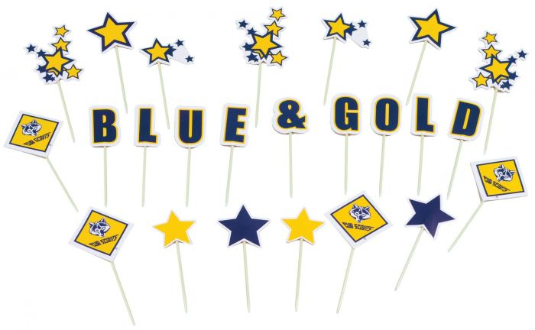

A Scout’s Pledge to Himself
Arrangement: The pack flag is placed in center of the stage. Cub Scouts in uniform, in turn come on stage, stand near the pack flag, and recite one of the statements below. Upon finishing, each Cub Scout salutes the Pack and retires to the rear of the stage, where a horseshoe is formed.
# 1: May I grow in character and ability as I grow in size.
# 2: May I be honest with myself and others in what I do and say.
# 3: May I always honor my parents, my elders, and my leaders.
# 4: May I develop high moral principles and the courage to live by them.
# 5: May I strive for health in body, mind, and spirit.
# 6: May I always respect the rights of others.
# 7: May I set a good example so that others may enjoy and profit from my company.
# 8: May I give honest effort to my work.
# 9: May I learn things that will help me make life better for every living thing in God’s beautiful world.
As the last Scout finishes their line and completes the horseshoe formation behind the Pack flag, all Cub Scouts join hands for the Living Circle and repeat the Promise.

Thank You Parents
Personnel: Eight Cub Scouts
Equipment: Large poster divided into eight, when put together has a heart on it with the words THANK YOU in it.
Setting: Each Cub Scout has a piece of the heart. After all lines have been read, the first four stand in a line and hold their cards while the second four kneel in front and hold up their cards so that the heart is formed.
# 1: Our leaders are grand, the best in the land
# 2: They deserve a thank you, and a big hand, too.
# 3: This celebration's the time and the place, to tell them we think so, right to their face.
# 4: So thanks to the den leaders, committee and Cubmaster, that making Scouting fun, they're truly the masters.
# 5: But there's someone special we don't want to leave out, after all, they're a big part of what Scouting's about.
# 6: We want to say thank you, Mom and Dad, and tell you that we are really glad.
# 7: To have you as parents, yes, it's true, because of your help and all that you do.
# 8: To help us through Scouting's achievements and ranks you truly deserve our heartfelt thanks.

GAMES

Alphabet Pong
This is a good game for a den activity. Have the Cub Scouts from a circle, with each Cub Scout holding a book (hardcover) with both hands. One player takes a ping-pong ball, hits it with the book across the circle, and calls, “A.” The person on the other side then returns it to someone and calls, “B,” and so forth. The circle works together to see how far down the alphabet then can go before they miss. There is no particular order for hitting the ball. Anyone can hit the ball when it comes to him or her, but no one may hit the ball twice in a row.

Bean Pick Up
Arrange the players around a table or kneeling in a circle on the floor. Give each a saucer with two toothpicks and 12 beans. On signal, see who can be the first to lift out five beans.

Blind Sardines
This is a good game for large groups. You will need a blindfold for each player – neckerchiefs work great for this.
To play, one person volunteers to be the sardine. The sardine may choose to wear or not wear a blindfold. All the other players wear blindfolds, and their objective is to come in contact with the sardine. As the players roam around the room, when one player touches or bumps into another, they grab the other player and asks, “Are you the sardine?” The sardine must answer, “Yes” if asked. Once a player finds the sardine, they must hang onto the sardine for the remainder of the game and becomes a sardine too. Eventually more and more players are bumping into the line of sardines and adding themselves to the chain. The game is over when everyone has become part of the sardine chain.
Blind Volleyball
Split the Cub Scouts into two equal teams. The two teams then get on each side of a volleyball court and sit down either on chairs or on the floor in rows, arranged like regular volleyball. Hang a blanket over the net so that a solid barrier is form and obstructs the view of the other team. The divider should also be low enough that players cannot see under it. Then play volleyball, using a big, light plastic beach ball instead of a volleyball. Regular volleyball rules and boundaries apply. A player cannot stand up to hit the ball.

Blue and Gold Toss
One blue team and one gold team. Have two butter dishes, one blue and one gold. Each team has a specified amount of change to toss into the dishes. Team with the most points wins.

Blue and Gold Balloon Bang!
Relay teams line up at equal distance from group of balloons. Each player races to the group of balloons in front of theirline, blows up a blue or yellow balloon, sits on it to pop it and then races back to touch off the next player.

Blue and Gold Smile
Divide the group or table into two teams and line them up, facing each other about 10 feet apart. Name one team “Blues” and the other “Golds.” Then flip a coin and call out the side that turned up, heads means Blue and tails mean Gold. If it comes up heads, the Blues laugh and smile while the Golds try to keep sober faces. The Blues, of course, try to make the Golds laugh. Any who do laugh must join the other team. Then flip the coin again.
Blue and Gold Source
This game is played in pairs. A number of pieces of colored blue and gold construction paper are scattered around the room. Cub Scouts are in pairs, some are blue and some gold. Cub Scouts are tied together as a pair at ankles with blue ribbon for blue’s and yellow ribbon ‘for gold’s. Have only as many paper pieces on the floor as you have pairs of Cub Scouts. A tape player or radio is used for music. When the music stops, each pair must find their color paper and stand on it (only one pair on each sheet of paper). During the music, the Leader removes one sheet of paper so one pair will be without a color. The pair who cannot find their “color” when the music stops is eliminated. Action is repeated until one pair remains.

Blue and Gold Stringer
People at each table form a team. Give each team a blue or gold chenille stem and several buttons (as many as will fit on the stem). At the signal, the first person strings a button on the stem and passes it to the next player, who does the same. Continue until all buttons are on the stem. First team to finish is the winner.

Bumper Box Relay
For this game, you will need a large refrigerator box for each team. Each player stands with the box over their head and the open end at their feet. At a signal, the players race to the opposite wall (or goal) and back while their team shouts directions to them from behind the starting line. The boxes can be decorated ahead of time at a den meeting.

Catch A Bear, Wolf, Or Etc.
Equipment: cup, cut out figures of bears, wolves or etc.
Cut out figures you want to use. They must fit into the cup. Place numbers on the figures. Players all toss several figures in the air and try to catch them with the cup. Add the numbers on the figures caught.

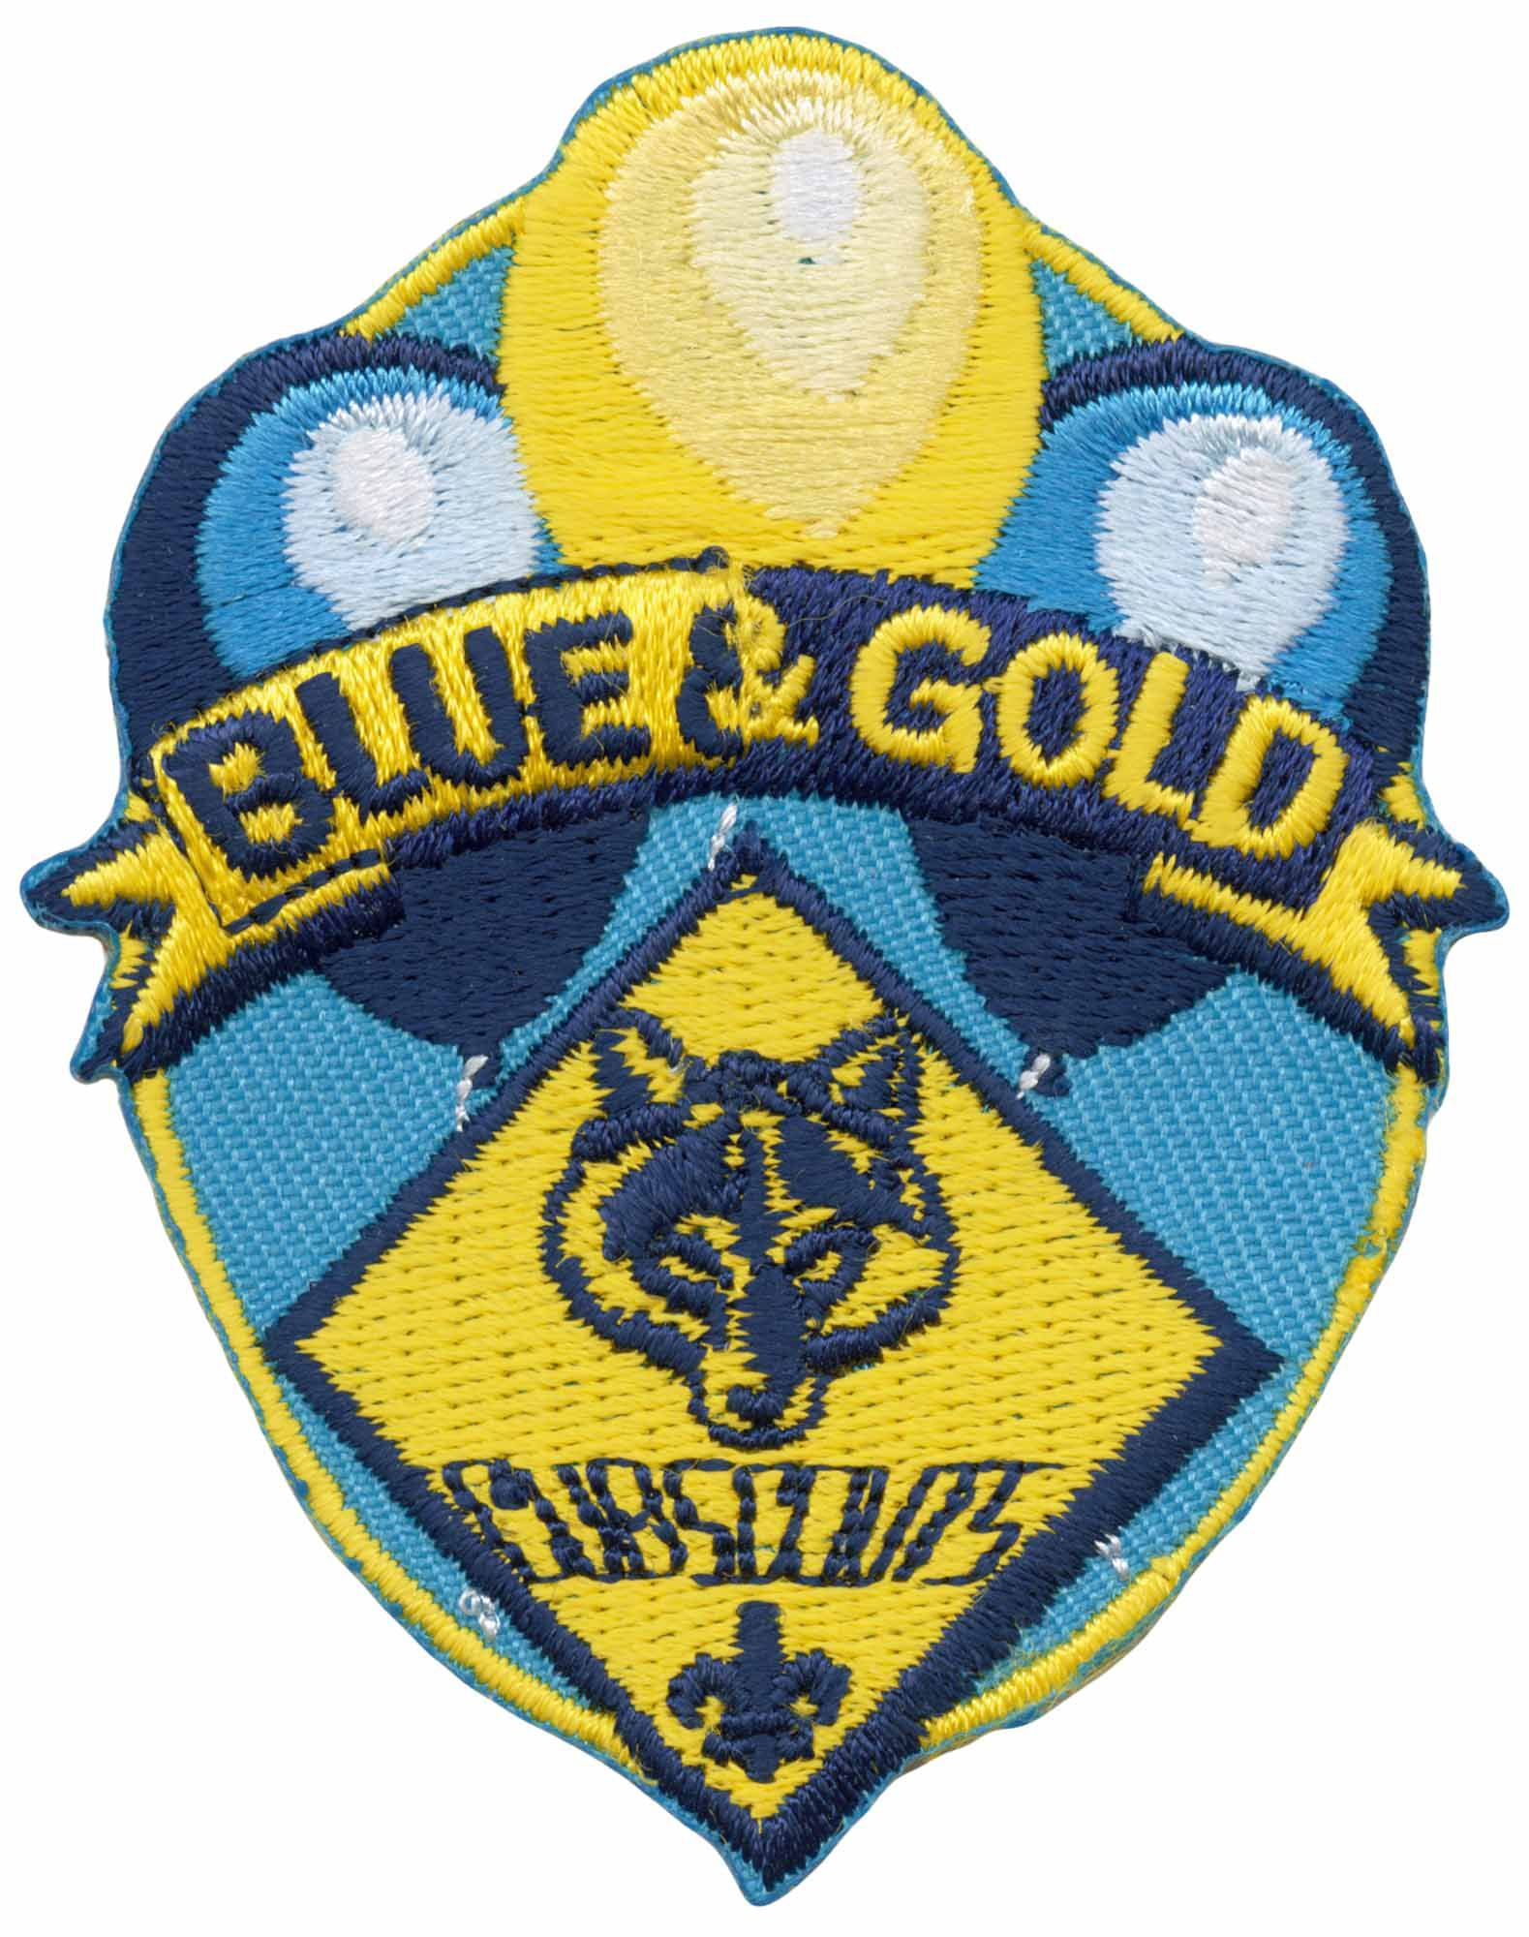
Cub Scout Dress Up Relay Race
Materials Needed: 2 sets of large or extra large Cub Scout, Scouts BSA, den leader, or Scout leader uniforms, 2 American Flags in stands
How to Play:
- Flags in stands are at one end of the playing area. The two sets of clothing are in a back pack, bag or suitcase about half-way down the playing area.
- Divide players into two teams and have them stand in lines at the beginning of the playing area.
- On the word "go" the first Cub Scout in line runs to one set of clothing. They open the container and puts on the clothing. They then run the rest of the way to the flag.
- The player salutes the flag and runs back to the clothing container. They remove the clothing and puts it back into the container making sure to close and fasten the container.
- He runs back to the beginning and tags the next Cub Scout in line. The next Cub Scout repeats the process. This continues until everyone on the team has had a turn.
- The first team finished is the winner.

Domino
This is a game that is as fun to watch, as it is to play. It’s also easy to play and requires no props.
Teams line up in single-file lines parallel to each other. The lines should have the same number of people, and everyone should be facing toward the front of the line.
At a signal, the first person in each line squats, and then each person in turn squats, all the way to the end of the team’s line. (You cannot squat until the person immediately in front of you squats first.)
The last person in line squats and then quickly stands up again, and in reverse, each person stands up in succession, instead of squatting.
The first team with the person standing at the front of the line is the winner.
This game works best with at least twenty people in each line (the more the better). Have the teams try it several times for speed.
Dressed for the Blue and Gold
Have the dens line up for a relay, each with a suitcase filled with the following clothing: old hat, trousers, shirt, jacket or overcoat and tie. On signal, the first Cub Scout in each line races with the suitcase to the center of the room, puts on the clothing, and then scrambles back with the suitcase to the starting point. They then take off the clothing and repacks it in the suitcase. The second Cub Scout repeats the performance and so on until all have finished. First team wins.

Handy Balloon Game
Materials Needed: Many balloons of various colors inflated
How to Play: On the signal "go" all balloons are tossed into the air. Players then try to keep them in the air as long as possible by batting them up with their hands. You may want to give specific directions to go with different colors of balloons. For example, red balloons may only be hit with the left hand, green balloons may only be hit with the head, all other colors must be hit with the right hand.
Any balloons that fall to the ground are considered out of play and cannot be picked up and restarted.
After 30 seconds the game director sounds the signal to "stop" and the balloons still in the air are caught and counted.
Compare how many your group has left to other groups or the last time you did it. Or do it again and try and improve.
This is really fun when done as teams.

Human Obstacle Course
Each team lines up single file behind a starting line. Ten additional team members are used as the obstacle course: a standing pole to circle around, a leg tunnel to go under, kneelers on all fours to leap over, sitters with outstretched legs to step in and among, another standing pole to circle around and back to the starting line. At the signal, the first person runs the course, then the next person, and so on. If an obstacle is missed or improperly executed, the runner must repeat that obstacle.

Lean-Too
A good game for the Pack meeting to get the parents involved. The Cub Scouts and parents stand in a circle by Dens holding hands. Everyone numbers off alternately one or two. On the signal, keeping legs and backs as straight as possible, the players who are “ones” lean forward toward the center of the circle, while the “twos” lean outward. Players counterbalance each other for support. Once the group has gotten its balance, slowly reverse the leaners. Then have the players see how smoothly they can alternate.

Long, Long, Long Jump
The object of this game is for the group of children to jump collectively as far as possible. The first player begins at a starting line and makes a jump. The next player starts their jump where the previous person landed. The players can attempt to improve their total collective distance on successive tries. This can be played indoors or outside, with a backward broad jump, forward long jump (standing or running), hop-skip-and-jump, and so forth.

Nonverbal Birthday Line-up
This game can be played with children and parents. Have all the players try to line themselves up according to the month and day of birth, without any talking. The game is a lot of fun with a large group of people.

Pass the Baton
Have the group form a circle. Give one person a baton-like item, such as a paper towel roll. Have the group members say the words of the Pledge of Allegiance, a song, cheer, prayer, etc. The first person says the first word, and pass the baton to the person on their left. The second person says the next word, and passes the baton, and so on until someone makes a mistake. If a mistake is made, that person steps out of the circle. The next person says the correct word, and play continues until only one person is left. Repeat the game with the Cub Scout Oath, or a new song or prayer.

Pass Your Instrument
Materials Needed: none
How to Play: Players sit on the floor in a circle.
Each player chooses an instrument they want to represent. They must then decide on an action that will represent that instrument.
To begin play, have everyone demonstrate their instrument's action. Then one player is chosen to be the Conductor and stands in the middle.
One player begins by making the sign of their instrument and then makes the sign of another player's instrument.
The player whose instrument's action was made must then make the sign of their instrument and then the sign of still another player's instrument and so on.
This is to be done without letting the Conductor see any of the actions. If the Conductor catches any player making the actions of an instrument that player becomes the new Conductor and the old Conductor sits in that player's place.

Ping-Pong Ball Relay
This is a good party game for a den meeting. Give the Cub Scouts a ping-pong ball and a party blower (the type that uncoils when you blow it), and have them line up at the starting line. Each Cub Scout is to push their ball across the floor using only their blower. They cannot blow directly on the ball or touch it in any way with the party blower. The first one across the finish line wins.

Table Upset
Can be played in a circle or with people sitting at tables (although this can be a little hectic). The leader stands in the middle of the circle or room and gives each person the name of something connected with a Blue and Gold banquet, such as a dish, knife, spoon, plate, place card, napkin ring, placemat, etc. More than one person can have the same name. The leader then makes up a dramatic story of a Blue and Gold Banquet. As they name each banquet item, the players with that item must rise, turn around and resume their seat. The leader may mention these items as many time as they choose. Suddenly they say: “The table turned over.” At this signal, all players must change seats. The leader sits in an empty chair and the player left standing becomes the new leader.

Toss the String
You will need a ball of yarn or string for each circle. Have the group form one or more circles of 15 or less players. The Cub Scout with the yarn starts by calling out another Cub Scout’s name in the circle and tosses the yarn to him, being sure to hold the end of the string in their own hand. The Cub Scout who catches the ball must call out another name and toss them the ball, while keeping hold of the string. The object is to include everyone and create a spider web with the yarn. The leader then asks one Cub Scout to pull on their string while everyone else holds on. Ask how many Cub Scouts can feel the string being pulled. Ask another one to let go of their string and see what happens to the web. Experiment with the web, have everybody pull or half of them pull. This would be a good time to talk to them about the importance of cooperation and team work. It is also an excellent time to discuss the need to help each other when help is needed, and doing it with a positive attitude.
Trust Tag
This game is played like regular tag, except that the players play in groups of two. One partner must wear a blindfold. Their teammate guides them by keeping their hands on their blindfolded partner’s waist and shouting directions. The object is for the blindfolded player to tag another blindfolded player.

Tug of War in the Round
Get a large rope about 24-feet in length and tie (or splice) the two ends together to form a large round rope.
Four teams line up on the four sides of a square that is drawn on the ground.
In the center square, the rope is placed opened out into a circle.
The teams should be equal in size and each team member is numbered off.
The leader then calls a number, and the four kids (one from each team) with that number grab one side of the rope and try to get back across their team’s line.
As soon as a player crosses the line (pulling the rope), they are declared the winner.
Continue the game until everyone has had a try.
You can also try calling out several numbers at once.

Wagon Wheels
A wagon wheel is created by having about seven children facing each other and joining hands to form a circle. The wheel then moves in a circular motion around the walls of gym. Two or three children (the bottom of the wheel) have their backs touching the wall momentarily as the wheel spins along the wall. The fun increases as the wheel picks up speed. Try putting the wheel into reverse or changing the speed.
The wheel can stop by turning itself into a human hubcap. One child lets go of their teammate’s hand on either side and begins to turn toward the inside of the circle, drawing the line into the center. This coiling process continues until everyone, still holding hands, is wrapped into a human hubcap.

DECORATIONS

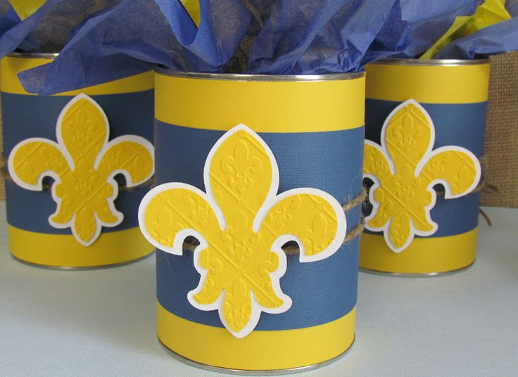

SOCIAL MEDIA POSTERS

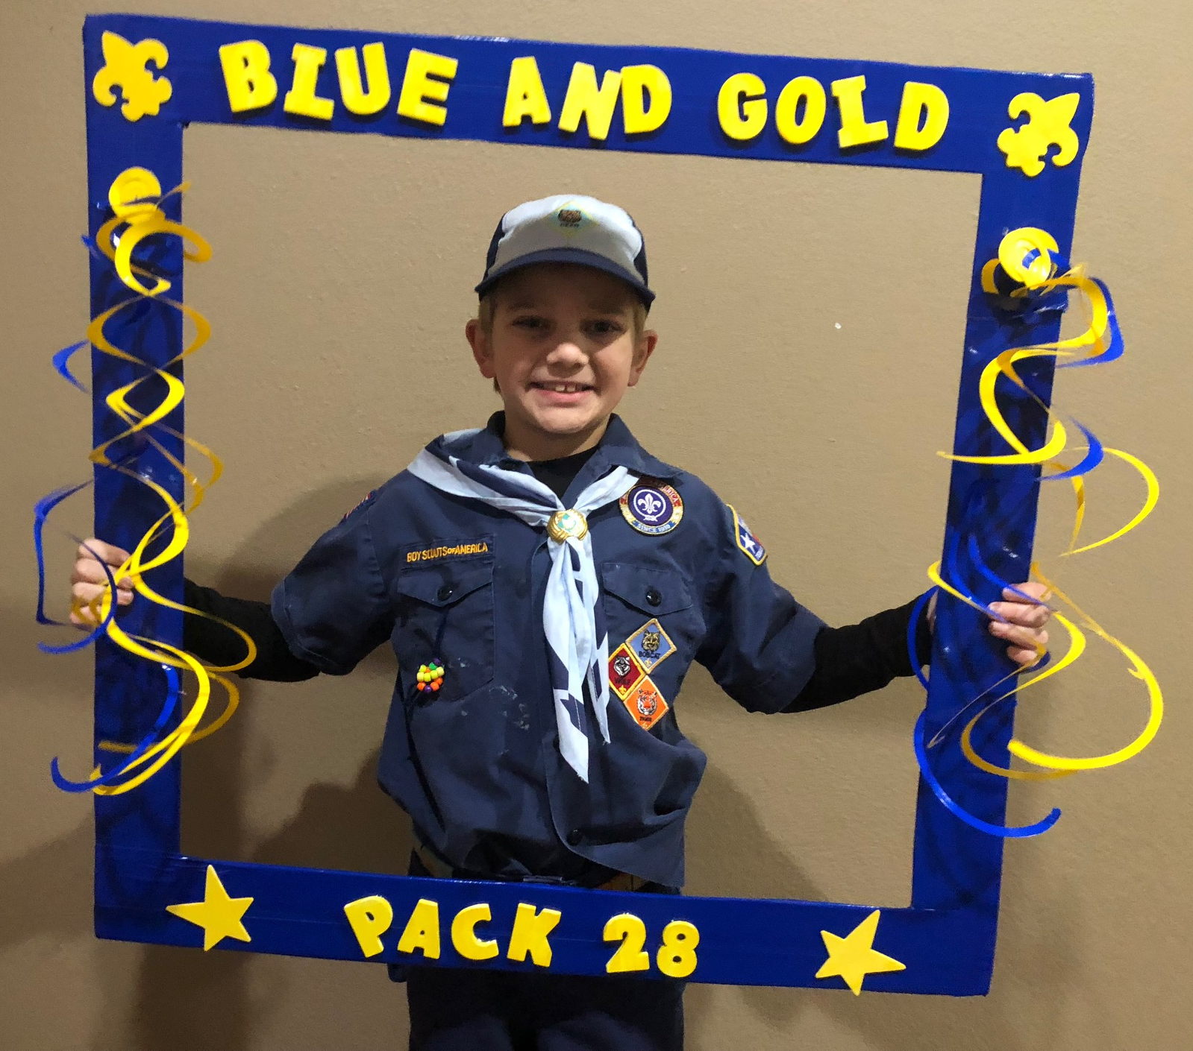

THEME RELATED STUFF

100 Famous Eagle Scouts for 100 Years
My original plan was to choose 100 famous Scouts – but I soon discovered that in Scouts, hundreds of famous people learned to set goals, try new skills, practice and perfect those skills, and persevere to reach their goals – I had to list only Eagle Scouts instead, and edit it down from hundreds of well-known and accomplished people. The list below is just a sample – authors, politicians, athletes, Nobel prize winners, actors and activists used the skills they learned as Scouts to reach other goals as adults.
- Barber B. Conable, Jr. President, World Bank Eagle Scout
- Bill Alexander, U.S. Representative from Arkansas
- Gary Anderson, U.S. Representative from New York
- Charles Bennett, U.S. Representative from Florida
- William Bennett, Former Secretary of Education
- Bill Bradley, Pro basketball star and U.S. Senator from New Jersey
- Milton Caniff, Comic Strip Artist "Steve Canyon"
- William Dannemeyer, U.S. Representative from California
- Arthur Eldred, (First Eagle Scout) Clementon, NJ. Buried in a cemetery in Southern NJ Council territory. http://www.eaglescout.org/history/first_eagle.html
- Gerald Ford, 38th President of the U.S.
- Murphy J. "Mike" Foster, Governor of Louisiana
- Richard Lugar, U.S. Senator from Indiana
- Sam Nunn, U.S. Senator from Georgia
- J.J. Pickle, U.S. Representative from Texas
- Samuel Pierce, Former Secretary of HUD
- Harrison Salisbury, Pulitzer Prize winning Author
- William Sessions, Former FBI Director
- Steven Spielberg, Film Director/Producer
- Wallace Stegner, Pulitzer Prize winning Author
- Percy Sutton, Chairman of CBS
- John Tesh, TV Celebrity, New Age & Christian Musician
- James Stewart - Actor
- James Brady, Former Press Secretary to President Reagan
- William C. DeVries, M.D., Transplanted first artificial heart
- Henry “Hank” Aaron, Home Run King;
- J. Willard Marriott, Jr., President, Marriott Corporation
- H. Ross Perot, Chairman, EDS Corp.
- Daniel J. Evans, Former US Senator & Governor of Washington state
- Sam Walton, Chairman/CEO, Wal-Mart
- Danny Ainge, Suns Head Coach
- Wallace Stegner, Writer, Pulitzer Prize for “Angle of Repose”
- Steve Fossett, Adventurer – went around the world in a balloon
- Sam Skinner, Secretary of Energy, USA
- Peter Agre, Nobel Prize in Chemistry, 2003
- Lamar Alexander, Sect. of Education, Senator & Governor, Tennessee
- Bill Amend, Cartoonist “Fox Trot”
- Marvin J. Ashton, LDS Church, Quorum of the Twelve
- John Edward Anderson, Founder of Topa Equities
- Daniel Carter Beard, Scouting Pioneer, Illustrator
- Michael Bloomberg, Mayor of New York City
- Edgar Cunningham, Earliest known African American Eagle – 1926
- Michael Dukakis, Governor of Massachusettes
- Philo Farnsworth, holder of first patent for television
- Lawrence Ferlinghetti, Poet, Co-owner of City Lights Bookstore
- William H. Gates, Sr., CEO-Bill & Melinda Gates Foundation
- Ernest Green, Civil Rights Activist, one of the Little Rock Nine
- James Van Johnston, Jr., Roman Catholic Bishop
- Jim E. Mora, Sports Commentator, Former Head Coach
- Howard Lincoln, CEO, Seattle Mariners, posed as Cub for Rockwell
- Michael Kahn, Academy Award, Editing - Schindler’s List & others
- Sheldon Leonard, pioneering film & TV producer, director, actor
- Richards Miller, Dentist, one of founders of Venturing program
- Robert McNamara, Sect. of Defense, President of World Bank
- Ozzie Nelson, Actor & Band Leader
- John D. Wahiee III, First native Hawaiian Governor of Hawaii
- William Westmoreland, Chief of Staff of the United States Army
- Paul Theroux, Travel writer and novelist
- T. Gary Rogers, CEO of Dreyer’s Grand Ice Cream
- James D. Rogers, CEO of Kampgrounds of America, brother of T. Gary
- Kevin Rose, Founder of Digg
- Frederick Reines, Nobel Prize in Physics Astronauts & Eagles:
- James C. Adamson
- Neil A. Armstrong, First man to walk on the moon- Apollo 11 Mission
- James P. Bagian
- Guion S. Bluford, Jr.
- Kenneth D. Bowersox
- Charles E. Brady
- Gerald P. Carr
- Manley Lanier “Sonny” Carter Jr.
- Roger B. Chaffee – Died in the Apollo 1 fire on Jan. 27, 1967
- Gregory Errol Chamitoff
- Richard O. Covey
- John O. Creighton
- Charles M. Duke, Jr. – Walked on the moon – Apollo 16 Mission
- Donn F. Eisele
Patrick G. Forrester
- Michael E. Fossum
- Charles G. Fullerton
- William G. Gregory
- S. David Griggs
- Jeffrey A. Hoffman
- Gregory H. Johnson
- Thomas D. Jones
- 8Mark C. Lee
- Don L. Lind
- Steven W. Lindsey
- James A. Lovell, Jr. – Apollo 13 Mission
- William C. McCool – died during re-entry of Columbia, Feb. 1, 2003
- Michael J. McCulley
- Brian T. O’Leary
- Ellison S. Onizuka – died when Challenger exploded, Jan. 28, 1986
- Stephen S. Oswald
- Scott E. Parazynski
- Donald R. Pettit
- Kenneth S. Reightler, Jr.
- Richard A. Searfoss
- Elliot M. See, Jr.
- Joseph R. Tanner
- Richard H. Truly
- David M. Walker
Now look at some other famous people who were Scouts: David Hartman, actor; Richard Gere, actor; Walter Cronkite, beloved TV anchor and journalist; Henry Fonda, actor; Bill Gates, founder of Microsoft (his dad is an Eagle); Bruce Jenner, Olympic Gold Medal – Decathlon; Jim Morrison, Rock Legend; Merlin Olsen, Actor & Sportscaster; Eddie Rabbitt, Country-Western Singer; Richard Roundtree, Actor; Alberto Salazar, 3-time winner New York Marathon; John Schnieder, Actor-Singer; Mark Spitz, Olympic Gold Medal Swimmer; Howard K. Smith, ABC TV Commentator; George Strait, Country-Western Singer; Peter Ueberroth, Commissioner of Baseball; Joe Theisman, Sportscaster, NFL Player; Paul Winfield, Actor; Steve Young, NFL Quarterback; Jimmy Stewart, Actor, WW II hero; Sir David Attenborough, historian; John F. Kennedy, President.

Honor the Founders
Honor the Pioneers of Scouting by following their example:
- Baden-Powell - Play some of the games he used to teach his Scouts, or put together a book of sketches as he often did.
- William D. Boyce - Put out a pack newspaper about the 100th Anniversary to honor him as he was a publisher.
- Ernest Thompson Seton - Learn about animal tracks or how wolves live to honor Ernest Thompson Seton, who began as a bounty hunter and learned to love and protect the wolf. He even added a wolf track to his signature! There’s a great comic book about Seton’s wolf adventures, to download at www.pbs.org/wnet/...comic-book-lobo-king- of.../4360
- James E. West - Read some articles in “Boy’s Life” – he purchased the magazine in 1912 – or earn the new Disability Awareness Belt Loop, since West had one leg permanently shortened by tuberculosis as a child.
- Dan Beard - Practice telling stories about the outdoors (maybe even a folktale!) to honor Dan Beard, who was a beloved storyteller and outdoorsman.

Dan Beard in a Daniel Boone outfit telling a story to a Scout painted by Norman Rockwell in 1931.

Great Events in Scouting

First Scouts
Robert S.S. Baden-Powell, a British hero of the Boer War, conceived the idea of Scouting in the early years of the last century. To test his idea of a new movement for youth, he took 21 English boys and another man to Brownsea Island in a boy off England's southern coast in the summer of 1907.
These 21 boys were the world's first Boy Scouts. In a twoweek encampment, Baden-Powell taught the boy outdoor skills such as tracking, stalking, ropework, plant identification, and campcraft. He devised games and contests to test their knowledge.
Unknown Scout
Baden-Powell formally launched Scouting in 1908. The following year, a Chicago publisher named William D. Boyce was in London on business when he became lost in a pea soup fog. As he groped to find his bearings, a boy materialized out of the murk and asked if he might help. He led Boyce to his destination, and when the publisher offered him a shilling, the boy replied, ¡§Sir, I thank you. I am a Scout. A Scout does not accept tips for courtesies and Good Turns.¡¨ Intrigued, Boyce questioned the boy and learned where Baden-Powell could be found. The next day, he interviewed Scouting's founder and was captured by his dream. On his return to the United States, Boyce was determined to establish Scouting in this country. On February 8, 1910, he filed incorporation papers for the Boy Scouts of America in Washington, D.C.

Seton's Woodcraft Indians
Ernest Thompson Seton, a famous author and illustrator, was one of the fathers of Scouting in America. Eight years before Boy Scouting came to this country, he had started the Tribe of Woodcraft Indians with the aim of promoting outdoor life and woodcraft. Many of the skills and values he taught were incorporated into Scouting.
The Woodcraft Indians had no uniforms, but wore an honor band (like a merit badge sash) to show their awards. The honor band was a red sash 2-1/4 inches wide worn across the right shoulder and fastened to the left hip.

Dan Beard's Sons of Daniel Boone
Another of Scouting's fathers in the United States was Daniel Carter Beard, a noted author and editor. In 1905, he founded the Society of the Sons of Daniel Boone. The purpose was ¡§the elevation of sport, the support of all that tends to healthy, wholesome manliness; the study of woodcraft, outdoor recreation, and fun¡¨ as well as serious work in conservation.
Mainly through correspondence with readers of the Recreation magazine, Beard established local groups of the Sons of Daniel Boone. Boys were organized into groups of eight called stockades, four stockades constituted a fort.

The Tagalong Kids
The early Boy Scout troops were bedeviled by younger boys who wanted to join the fun. Many an exasperated Scoutmaster, tiring of chasing them away, assigned an older Boy Scout to take them off somewhere and keep them occupied. The problem led to the establishment of Cub Scouting in 1930.
The program was similar to today's Cub Scouting, except that the den chief led the den. The den mother (yes, den mother) was in the background, and, in fact, she was not even a registered leader until 1938.

Some Scouting Facts
- During the first World War, Scouts sold more than 2 million Liberty Loan Bonds and over $3 million worth of saving stamps. Scouts also helped with food and conservation and planted Boy Scout war gardens.
- In 1938, a Tulsa oilman, Waite Philips, donated some land in New Mexico to the Boy Scouts of America. Philturn Rocking Mountain Camp is now called Philmont Scout Ranch. It has been enjoyed by Scouts for many years. This is where each summer, thousands of Boy Scouts spend two weeks hiking and camping in the mountains. Philmont is also a wonderful place for a family vacation, and hundreds of Scouting families go there every year, so adult leaders can take part in training conferences.
- In 1938, Irving Berlin donated the royalties from his song "God Bless America," to the Boy Scouts of America. He is one of many famous people who have helped Scouting by their service and contributions.
- During World War II, Scouts again provided service in the war effort. They collected rubber, wastepaper, and aluminum. They also planted victory gardens. Scouting's service help to win the war.
- Scouts have always given help in time of disasters, such as fires, floods, tornadoes, and earthquakes. They help their Scouting brothers in foreign lands through the World Friendship Fund.

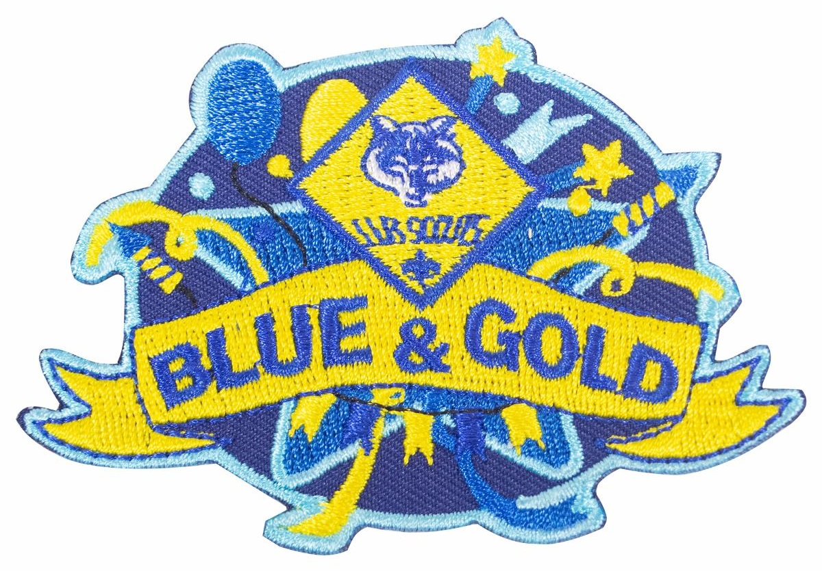
Cub Scout History
- 1930 Cub Scouting officially began in the United States in April 1930. There were, however, unofficial packs established as early as 1916
- 1936 The first Cub Scout dens were run by Den Chiefs. Den Mothers were added in 1936. Their jobs were to help the Den Chiefs.
- 1941 The Webelos Badge was created in 1941 for boys who had already earned their Lion Badge. It was essentially what we now call the Arrow of Light.
- 1943 First "Blue and Gold Banquet." Parent-Cub dinners were being suggested as early as 1933.
- 1945 "Cubbing" changed to "Cub Scouting"
- 1949 At the start of the American Cubbing program, boys had to be ages 9-11 to join. In 1949, eight-year-old boys were allowed to join. Cub Scouting received a boost in enrollment of 150,000 that year.
- 1954 First Pinewood Derby was held; Cub Scouting enrollment reached two million.
- 1964 National Summertime Award was created.
- 1967 Major revisions in all the advancement programs. The biggest change was the addition of Webelos Scouting. The activity badges were initiated, the Lion Badge was changed to the Webelos Badge, and for the first time, boys began earning the Arrow of Light Award. The meaning of Webelos changed from Wolf- Bear-Lion-Scout to We'll Be Loyal Scouts.
- 1968 Cub Scout Day Camps approved.
- 1960 Project SOAR (Save Our American Resources) launched.
- 1971 Cub Scout Promise changed from "to be square" to "to help other people."
- 1973 Achievements and electives updated.
- 1974 Bobcat is now a rank. Safe Bicycle Driving Program and Cub Scout Physical Fitness Program introduced and emphasized.
- 1975 Webelos Transition Program, and the Learn to Swim Program launched. Den Chief's cord repositioned on the uniform. Cub Scout Day Camp School introduced.
- 1976 Women now approved as Cubmaster and Assistant Cubmaster. Cub Scout Family Book prepared.
- 1977 Five ranks established for Cub Scouting: Bobcat, Wolf, Bear, Webelos, Arrow of Light. Family Camping encouraged.
- 1978 Wolf Book rewritten. New Bear neckerchief
- 1980 New designer uniforms for boys and leaders.
- 1981 Cub Scouts visit National Jamboree for the first time.
- 1982 The Tiger Cub program introduced.
- 1983 Extended camping was approved for Webelos Scouts. The Big Bear Cub Scout Book was introduced
- 1985 New sports program for Cub Scouts launched.
- 1986 Cub Scouts expanded to serve all elementary school grades. Webelos Program now two years. Revised Wolf Book introduced.
- 1987 Revised Webelos Book with 5 new activity badges published.
- 1988 Scouting for Food program launched.
- 1991 Cub Scouting introduced two programs: Ethics in Action to promote ethical decision making, and the BSA family program to strengthen the family from within.
- 1992 Cub Scouts Academics program introduced.
- 1996 Tiger Cubs become part of the pack.
- 1997 Cub Scout Academics and Sports program opens to Tiger Cubs.
- 1999 New Webelos Book introduced. Cub Sports and Academics program modified and renamed Cub Scout Academics and Sports program. Garfield (the cat) named as national Cub Scouting 'spokescat.'
- 2000 Pack family camping approved. "Climb on Safely" introduced to allow Cub Scouts to climb and rappel in a controlled environment.
- 2001 Introduction of new Webelos oval badge and Tiger Cub badge. Character Connections and Core Values introduced. Wood Badge for the 21st Century for all leaders in Scouting. Tiger Cub rank introduced.
- 2002 Age-appropriate guidelines adopted. Leave No Trace Frontcountry Guidelines and Leave No Trace Award introduced.
- 2003 Character Connections activities included as part of Cub Scout advancement requirements.
- 2004 National "Good Turn for America" launched. 75th Anniversary Award and Cub Scout Outdoor Activity Award introduced. A new Cub Scout Hispanic outreach initiative known as Soccer and Scouting is launched.
- 2005 Cub Scouting celebrates its 75th Anniversary: "75 Years of Fun, Family, and Friends."
- 2010 Cub Scouts 2010 begins September 2010 changing the delivery method of the Cub Scouting program.
- 2018 Lion program added

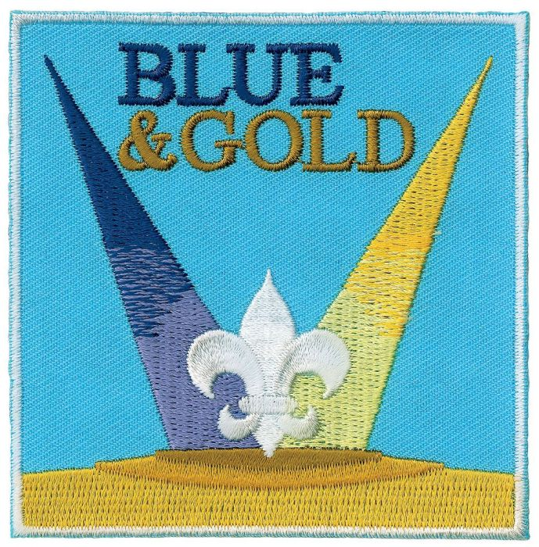

BLUE & GOLD IDEAS

Accordion Table Runner

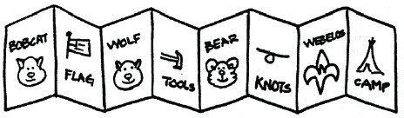
- Use 5” x 7” cards that can be colored.
- Each Cub Scout makes drawing of a certain achievement or even a rank advancement.
- When all are done, then tape together to form an accordion look for the center of the tables.

CUB SCOUT SIGN CENTERPIECE
ϑ Copy a Cub Scout sign picture onto cardstock
ϑ Center it landscape about 1½” from the bottom.
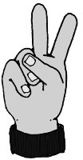
ϑ When you cut out the picture, leave about 1½” of the cardstock all the way across the bottom.
ϑ Wrap this around a clean tuna fish can and glue it.
ϑ Now you can put nuts or candy in the can and set the centerpiece on the table.

3-Dimensional Star Centerpiece
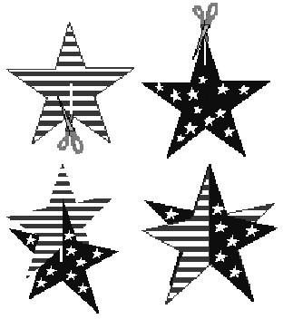
This 3-dimensional star decoration is made from 2 paper stars that are interlaced. These stars stand by themselves on a table, and make a great Blue and Gold Banquet table centerpiece.
Supplies:
Stiff paper (like card stock, oaktag or thin cardboard) or Styrofoam meat trays;
Scissors; Crayons or markers (optional)

Directions:
Two paper stars are needed to make one 3- dimensional star. Either draw two identical stars on a piece of stiff paper or print out a star template.
Decorate the two stars (if you like) on both sides, and then cut them out.
Make one slit in each star.
On one star, the slit goes from an inner corner to the center point of the star;
On the other star, the slit goes from an outer corner to the center point.
Slip the two stars together through the slits you just cut.
For stability, you may have to tape the stars a bit where they intersect.
Cake Bake Contest
The event chair makes sure that families are furnished with the rules, recruits judges and procures prizes. The rules should address how the cakes are to be decorated and who may help each Scout. Have them bring the finished cake to the Blue and Gold Banquet for judging. All cakes should have a title or name, either as part of the decoration or on a card attached to the cake. Cakes should be numbered for judging purposes.
Cakes will be judged and prizes awarded at the pack meeting. Here are some suggested categories for judging:
- Judge’s Choice (Best of Show)
- Most Original Creation
- Best Representation of the Monthly
- Theme
- Most Suitably Named
- Biggest
- Smallest
- Flattest
- Yummiest Looking
After the prizes are awarded, either use the cakes for dessert or you could have a cake auction for a fundraiser. (If you are using this as a fundraiser, be sure to get the proper approval.)

